REVIEW 3

Contents

1. Database Relationship Diagram ............................................................................ 80
2. Table Definition ....................................................................................................... 81
   1. Customers: ........................................................................................................ 81
   2. Categories: ........................................................................................................ 81
   3. Types: ................................................................................................................ 81
   4. Brands: .............................................................................................................. 82
   5. Products: ........................................................................................................... 82
   6. Wishlist:............................................................................................................. 82
   7. Ratings: ............................................................................................................. 83
   8. Orders: .............................................................................................................. 83
   9. OrdersDetails:................................................................................................... 83
   10. Stores: ................................................................................................................ 84
   11. Admins: ............................................................................................................. 84
3. Site Maps ........................................................................................................... 85
   1. Customer site .................................................................................................... 85
   2. Admin site ......................................................................................................... 86
4. Customer’s GUI Design ................................................................................... 87
   1. Template ............................................................................................................ 87
   2. Home .................................................................................................................. 90
   3. Products............................................................................................................. 94
   4. SingleProduct .................................................................................................... 99
   5. Compare .......................................................................................................... 103
   6. Cart .................................................................................................................. 104
   7. Checkout ......................................................................................................... 106
   8. OrderSuccess .................................................................................................. 110
   9. SearchProduct ................................................................................................ 110
   10. Login ................................................................................................................ 113
   11. Sign up ............................................................................................................. 114
   12. Account pages’ side bar ................................................................................. 115
   13. Account Dashboard ........................................................................................ 115
   14. Personal Information ..................................................................................... 117
   15. My Orders ....................................................................................................... 119
   16. SingleOrder ..................................................................................................... 120
   17. Wishlist ............................................................................................................ 122
   18. Stores ............................................................................................................... 124
   19. 404 .................................................................................................................... 126
   20. About ............................................................................................................... 126
   21. PrivacyPolicy .................................................................................................. 127
   22. TermsConditions ............................................................................................ 127
5. Admin’s GUI Design .......................................................................................... 128
   1. Template .......................................................................................................... 128
   2. Recommender System .................................................................................... 130
   3. Reports – Income by Categories ................................................................... 131
   4. Reports – Income by Brands ......................................................................... 132
   5. Reports – Income by Customers ................................................................... 132
   6. Accounts - View .............................................................................................. 133
   7. Accounts – Create........................................................................................... 134
   8. Accounts – Update .......................................................................................... 134
   9. Orders - View .................................................................................................. 135
   10. Orders – Update Status.................................................................................. 136
   11. Orders – Details .............................................................................................. 137
   12. Products - View............................................................................................... 138
   13. Products – Create ........................................................................................... 139
   14. Products – Update .......................................................................................... 140
   15. Categories – View ........................................................................................... 141
   16. Categories – Create ........................................................................................ 141
   17. Categories – Update ....................................................................................... 142
   18. Types – View ................................................................................................... 143
   19. Types – Create ................................................................................................ 144
   20. Types – Update ............................................................................................... 144
   21. Brands – View ................................................................................................. 145
   22. Brands – Create .............................................................................................. 146
   23. Brands – Update ............................................................................................. 146
   24. Stores – View................................................................................................... 147
   25. Stores – Create ................................................................................................ 148
   26. Stores – Update ............................................................................................... 149
   27. 404 .................................................................................................................... 150
   28. Login ................................................................................................................ 150
   29. My Profile........................................................................................................ 151
6. Task Sheet ....................................................................................................... 152

I. Database Relationship Diagram II. Table Definition 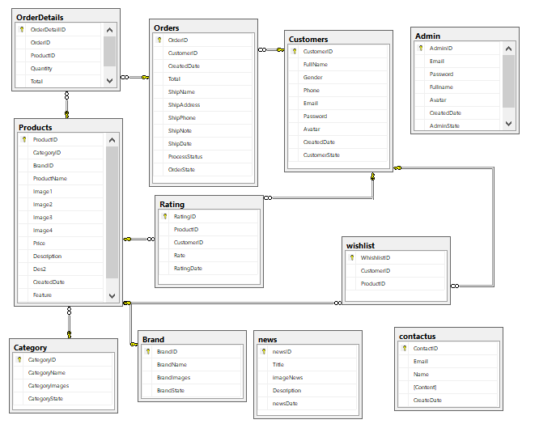

1. Customers:

|  |  |  |  |  |  |  |
| --- | --- | --- | --- | --- | --- | --- |
| Key | Field Name | Data Type | Null | Default | Table-  Field-Ref | Description |
| PK | Email | varchar(100) | No |  |  | Customers’ emails |
|  | Password | varchar(20) | No |  |  | Password to log in as member |
|  | FirstName | nvarchar(50) | No |  |  | Customers’ first names |
|  | LastName | nvarchar(50) | No |  |  | Customers’ last names |
|  | Gender | bit | No | 1 |  | Customers’ genders |
|  | Phone | varchar(20) | Yes |  |  | Customers’ phones |
|  | Avatar | varchar(200) | No |  |  | Customers’ avatars |
|  | CreatedDate | Date | No | getDate() |  | Date which account is created |
|  | CustomerState | bit | No | 1 |  | Status of accounts’ activation |

1. Categories:

|  |  |  |  |  |  |  |
| --- | --- | --- | --- | --- | --- | --- |
| Key | Field Name | Data Type | Null | Default | Table-  Field-Ref | Description |
| PK | CategoryID | varchar(10) | No |  |  | Categories’ IDs |
|  | CategoryName | nvarchar(100) | No |  |  | Categories’ names |
|  | CategoryImage | varchar(max) | No |  |  | Categories’ images |
|  | CategoryState | bit | No | 1 |  | Status of categories’ activation |

1. Types:

|  |  |  |  |  |  |  |
| --- | --- | --- | --- | --- | --- | --- |
| Key | Field Name | Data Type | Null | Default | Table-  Field-Ref | Description |
| PK | TypeID | varchar(10) | No |  |  | Types’ IDs |
|  | TypeName | nvarchar(100) | No |  |  | Types’ names |
|  | Descriptions | varchar(max) | Yes |  |  | Types’ descriptions |
|  | TypeState | bit | No | 1 |  | Status of types’ activations |

1. Brands:

|  |  |  |  |  |  |  |
| --- | --- | --- | --- | --- | --- | --- |
| Key | Field Name | Data Type | Null | Default | Table-  Field-Ref | Description |
| PK | BrandID | varchar(10) | No |  |  | Brands’ ID |
|  | BrandName | nvarchar(100) | No |  |  | Brands’ names |
|  | BrandImages | varchar(max) | Yes |  |  | Brands’ images |
|  | Descriptions | nvarchar(max) | Yes |  |  | Brands’ descriptions |
|  | BrandState | bit | No | 1 |  | Status of types’ activations |

1. Products:

|  |  |  |  |  |  |  |
| --- | --- | --- | --- | --- | --- | --- |
| Key | Field Name | Data Type | Null | Default | Table-Field-Ref | Description |
| PK | ProductID | varchar(10) | No |  |  | Products’ ID |
|  | ProductName | nvarchar(100) | No |  |  | Products’ names |
|  | Price | decimal(18,2) | No |  |  | Products’ prices |
| FK | CategoryID | varchar(10) | No |  | Categories (CategoryID) | Products’ categories |
| FK | BrandID | varchar(10) | No |  | Brands (BrandID) | Products’ brands |
| FK | TypeID | varchar(10) | No |  | Types (TypeID) | Products’ types |
|  | ProductImages | varchar(max) | No |  |  | Products’ images |
|  | Descriptions | nvarchar(max) | Yes |  |  | Products’ descriptions |
|  | Feature | nvarchar(100) | Yes |  |  | Products’ feature |
|  | ProductState | bit | No | 1 |  | Status of products’ activations |

1. Wishlist:

|  |  |  |  |  |  |  |
| --- | --- | --- | --- | --- | --- | --- |
| Key | Field Name | Data Type | Null | Default | Table-Field-Ref | Description |
| PK | WishlistID | int identity(1,1) | No |  |  | Wishlist’s ID |
| FK | CustomerEmail | varchar(100) | No |  | Customers (Email) | Customers’ emails |
| FK | ProductID | varchar(10) | No |  | Products(ProductID) | Added products’ IDs |
|  | Quantity | int | No |  |  | Products’ quantities |

1. Ratings:

|  |  |  |  |  |  |  |
| --- | --- | --- | --- | --- | --- | --- |
| Key | Field Name | Data Type | Null | Default | Table-Field-Ref | Description |
| PK | RatingID | int identity(1,1) | No |  |  | Ratings’ IDs |
| FK | CustomerEmail | varchar(100) | No |  | Customers (Email) | Customers’ emails |
| FK | ProductID | varchar(10) | No |  | Products(ProductID) | Rated products’ IDs |
|  | Rate | int | No |  |  | Ratings’ values |
|  | RatingDate | date | No | getdate() |  | Rating dates |

1. Orders:

|  |  |  |  |  |  |  |
| --- | --- | --- | --- | --- | --- | --- |
| Key | Field Name | Data Type | Null | Default | Table-Field-Ref | Description |
| PK | OrderID | varchar(10) | No |  |  | Orders’ IDs |
| FK | CustomerEmail | varchar(100) | No |  | Customers (Email) | Customers’ emails |
|  | Total | decimal(18,2) | No |  |  | Total payment |
|  | ShipName | nvarchar(100) | No |  |  | Receivers’ names |
|  | ShipPhone | varchar(20) | No |  |  | Receivers’ phones |
|  | ShipAddress | nvarchar(200) | No |  |  | Receivers’s address |
|  | ShipDate | date | No |  |  | Shipping date |
|  | ShipNote | nvarchar(max) | Yes |  |  | Note for shipping |
|  | OrderDate | date | No | getdate() |  | Date order was made |
|  | PaymentMethod | nvarchar(100) | No |  |  | Payment method |
|  | ProcessStatus | nvarchar(50) | No |  |  | Orders’ status |
|  | OrderState | bit | No | 1 |  | Status of orders’ activations |

1. OrdersDetails:

|  |  |  |  |  |  |  |
| --- | --- | --- | --- | --- | --- | --- |
| Key | Field Name | Data Type | Null | Default | Table-Field-Ref | Description |
| PK | OdID | int identity(1,1) | No |  |  | Orders details’ IDs |
| FK | OrderID | varchar(10) | No |  | Orders (OrderID) | Orders’ IDs |
| FK | ProductID | varchar(10) | No |  | Products(ProductID) | Products’ IDs |
|  | SellingPrice | decimal(18,2) | No |  |  | Products’ selling prices |
|  | Quantity | int | No |  |  | Products’ selling quantities |
|  | OdState | bit | No | 1 |  | Status of orders details’ activations |

1. Stores:

|  |  |  |  |  |  |  |
| --- | --- | --- | --- | --- | --- | --- |
| Key | Field Name | Data Type | Null | Default | Table-Field-Ref | Description |
| PK | StoreID | varchar(10) | No |  |  | Stores’ IDs |
|  | StoreName | nvarchar(100) | No |  |  | Stores’ names |
|  | Longitude | varchar(20) | No |  |  | Stores’ longitudes |
|  | Latitude | varchar(20) | No |  |  | Stores’ latitudes |
|  | StoreAddress | nvarchar(max) | No |  |  | Stores’ addresses |
|  | City | nvarchar(100) | No |  |  | Cities stores locate in |
|  | ContactPerson | nvarchar(100) | No |  |  | Names of contact person |
|  | Phone | nvarchar(20) | No |  |  | Stores’ phones |
|  | StoreImages | varchar(max) | No |  |  | Stores’ images |
|  | Descriptions | nvarchar(max) | No |  |  | Stores’ description |
|  | StoreState | bit | No | 1 |  | Status of stores’ activations |

1. Admins:

|  |  |  |  |  |  |  |
| --- | --- | --- | --- | --- | --- | --- |
| Key | Field Name | Data Type | Null | Default | Table-  Field-Ref | Description |
| PK | Email | varchar(100) | No |  |  | Admins’ emails |
|  | Password | varchar(20) | No |  |  | Password to log in as admins |
|  | FullName | nvarchar(100) | No |  |  | Admins’ full names |
|  | AdminRole | nvarchar(100) | No |  |  | Admins’ roles |
|  | Avatar | varchar(200) | No |  |  | Admins’ avatars |
|  | CreatedDate | Date | No | getDate() |  | Date account is created |
|  | AdminState | bit | No | 1 |  | Status of accounts’ activation |

III. Site Maps

1. Customer site 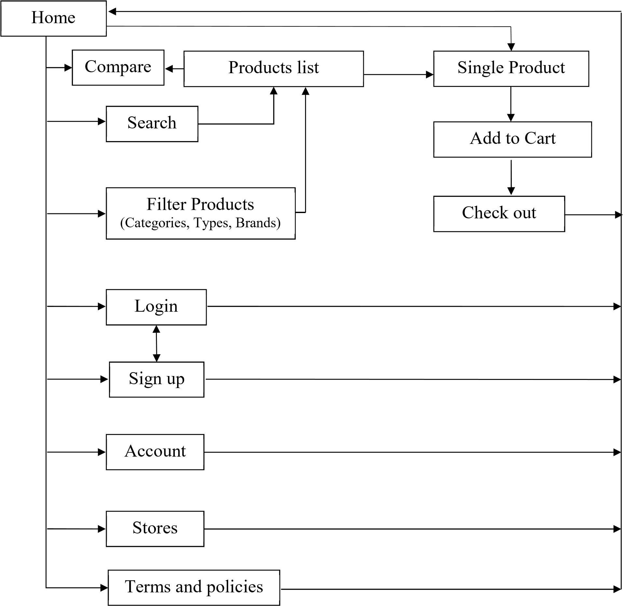
2. Admin site 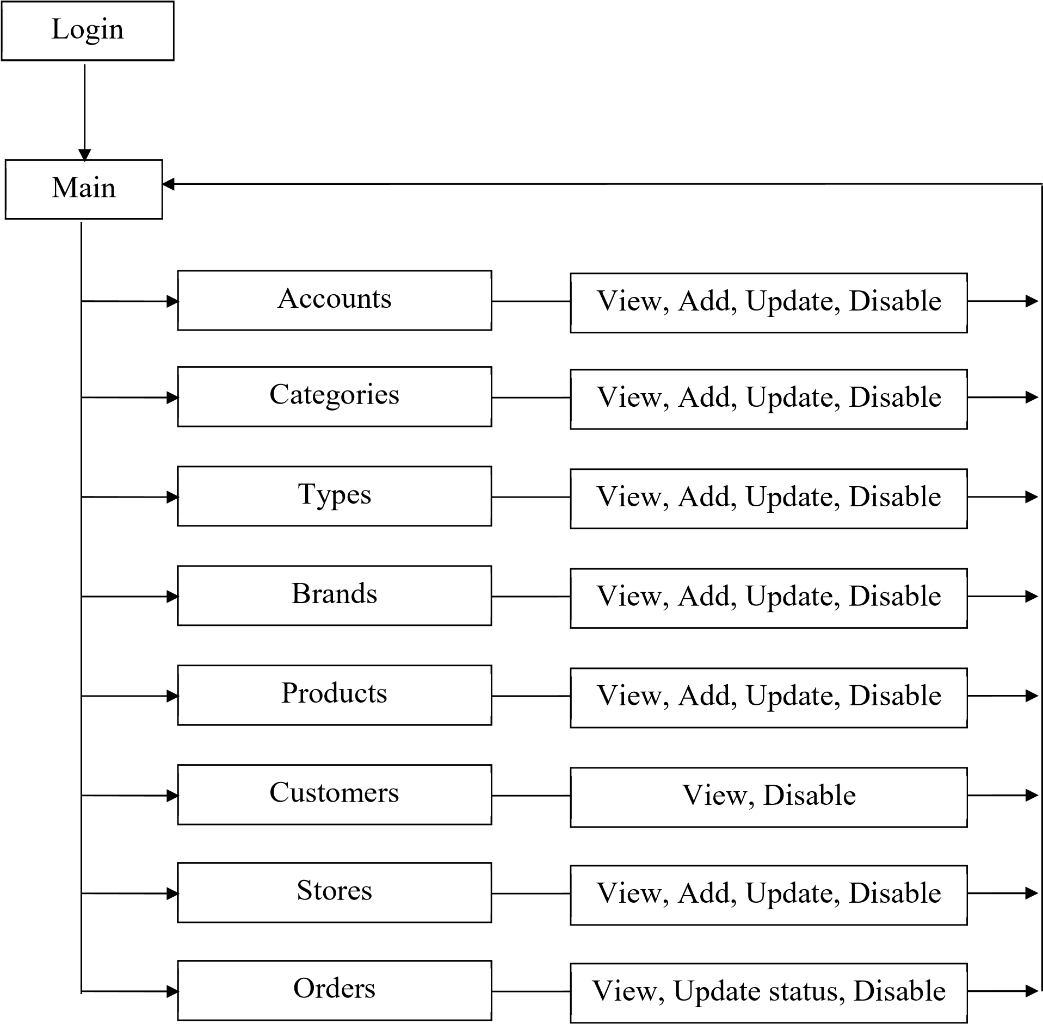IV. Customer’s
3. GUI Design

1. Template

This is the template of all user page.

* 1. Header

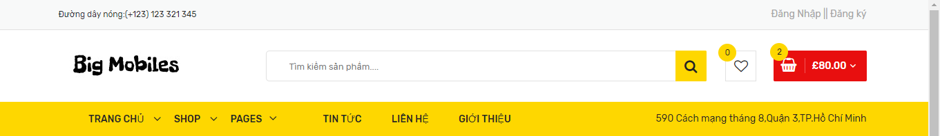

|  |  |  |  |  |  |
| --- | --- | --- | --- | --- | --- |
| No. | Name | Type | Validation | Event | Description |
| 1 | Logo | Link |  | Click | Redirect to Home page |
| 2 | Compare | Link |  | Click | Redirect to Compare page |
| 3 | Checkout | Link |  | Click | Redirect to Checkout page |
| 4 | Wishlist | Link |  | Click | Redirect to Wishlist page |
| 5 | My account | Link |  | Click | Redirect to Account page |
| 6 | Login | Link |  | Click | Redirect to Login page |
| 7 | Logout | Link |  | Click | To log customers out |
| 8 | Home | Link |  | Click | Redirect to Home page |

+ Others components:

* Our Products dropdown list: contains all links of types in every

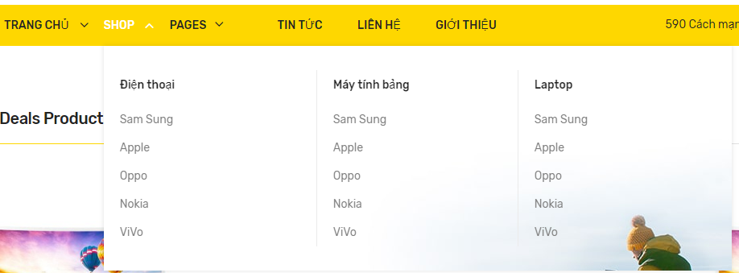

|  |  |  |  |  |  |
| --- | --- | --- | --- | --- | --- |
| No. | Name | Type | Validation | Event | Description |
| 1 | Types | Link |  | Click | Redirect to Products page |

* Our stores dropdown list: contains all links of stores in every city

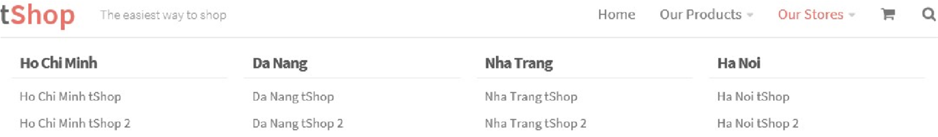

|  |  |  |  |  |  |
| --- | --- | --- | --- | --- | --- |
| No. | Name | Type | Validation | Event | Description |
| 1 | Stores | Link |  | Click | Redirect to Stores page |

* Dropdown Cart: a mini cart for customers quick view

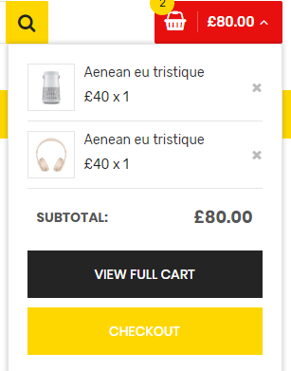

|  |  |  |  |  |  |
| --- | --- | --- | --- | --- | --- |
| No. | Name | Type | Validation | Event | Description |
| 1 | Products Image | Image |  |  |  |
| 2 | Product Name | Link |  | Click | Redirect to Product Details |
| 3 | Quantity and Price | Text |  |  |  |
| 4 | View Cart | Button |  | Click | Redirect to Cart page |
| 5 | Checkout | Button |  | Click | Redirect to Checkout page |

* Search:

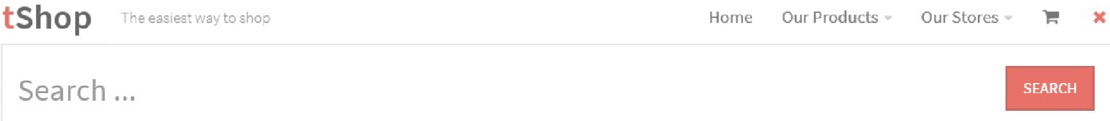

|  |  |  |  |  |  |
| --- | --- | --- | --- | --- | --- |
| No. | Name | Type | Validation | Event | Description |
| 1 | Search field | Input Text |  | Change | Auto complete using  AJAX with search string |
| 2 | Search | Button |  | Click | Redirect to Search page |

* 1. Footer

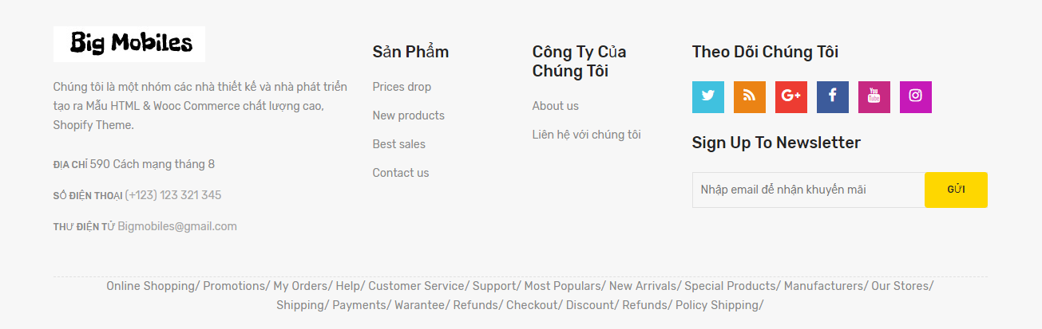

|  |  |  |  |  |  |
| --- | --- | --- | --- | --- | --- |
| No. | Name | Type | Validation | Event | Description |
| 1 | About Shop | Link |  | Click | Redirect to About page |
| 2 | Out Stores | Link |  | Click | Redirect to Stores page |
| 3 | Terms &  Conditions | Link |  | Click | Redirect to Term & Conditions page |
| 4 | Privacy Policy | Link |  | Click | Redirect to Privacy Policy page |
| 5 | My account | Lin |  | Click | Redirect to account page |

1. Home

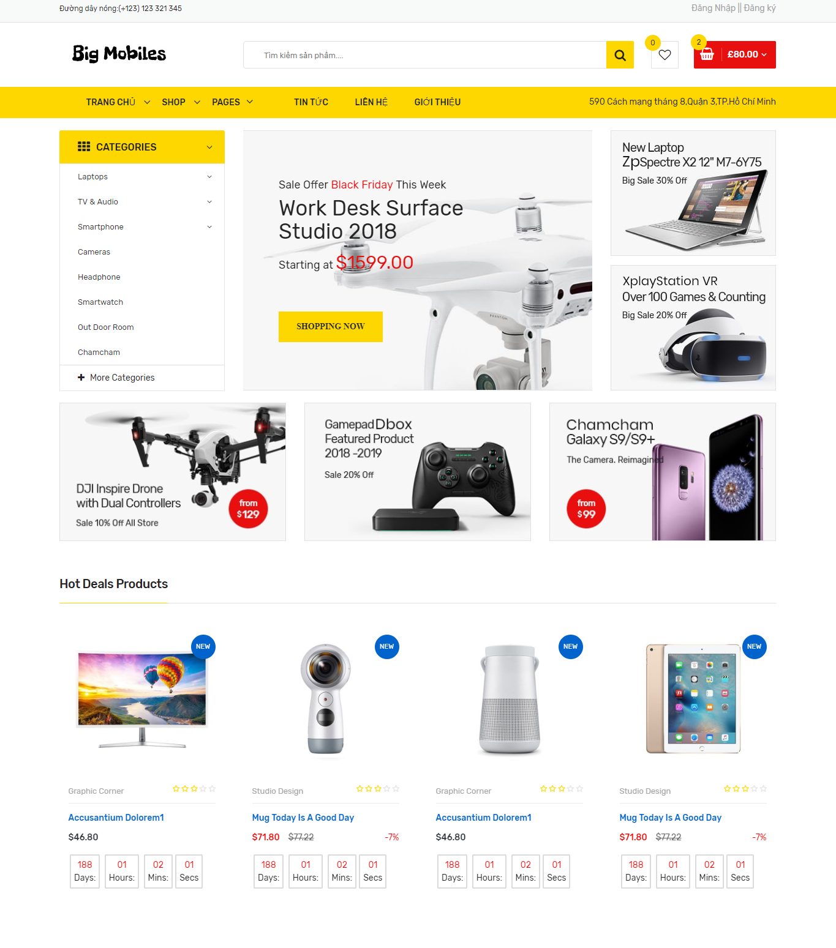

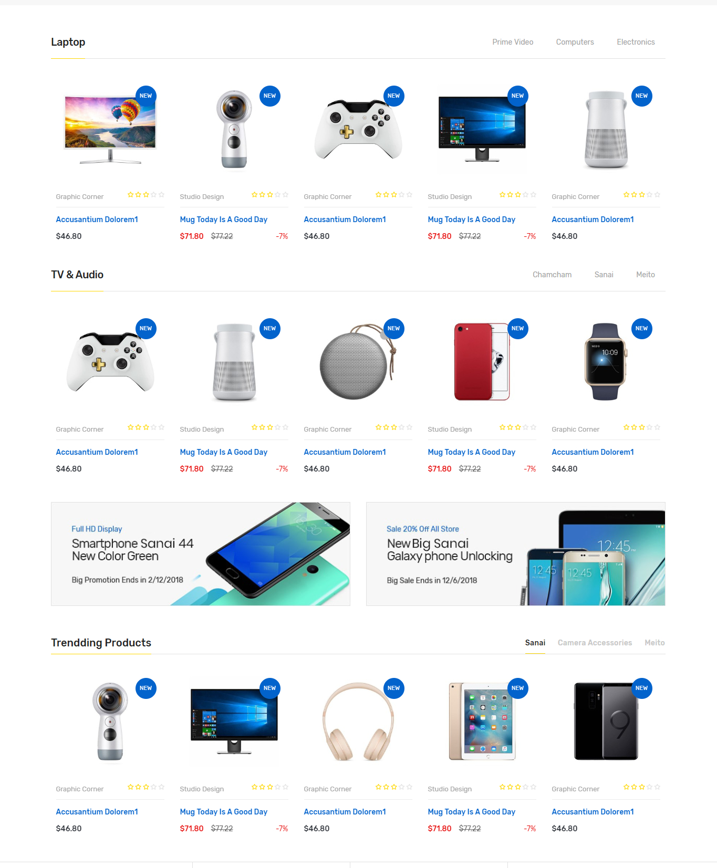

* 1. Slider: 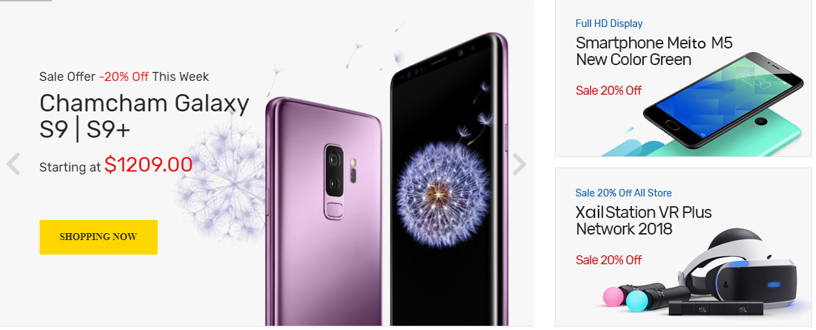

|  |  |  |  |  |  |
| --- | --- | --- | --- | --- | --- |
| No. | Name | Type | Validation | Event | Description |
| 1 | Sliders | Bootstrap Carousel |  | Click | Change images and promotion text |

* 1. Suggested Products:

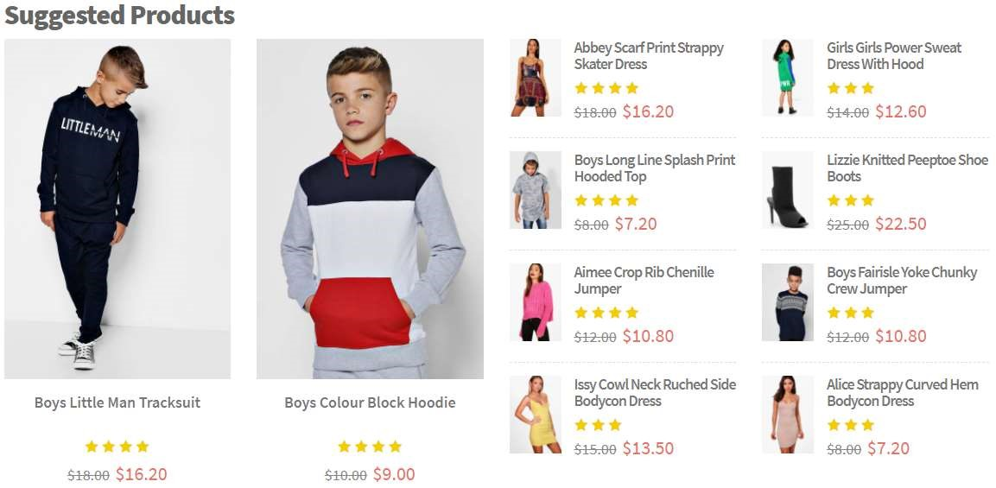

|  |  |  |  |  |  |
| --- | --- | --- | --- | --- | --- |
| No. | Name | Type | Validation | Event | Description |
| 1 | Product Image | Image |  |  |  |
| 2 | Product Name | Link |  | Click | Redirect to Product Details page |
| 3 | Product Ratings | Bootstrap Font Awesome |  |  |  |
| 4 | Product Price | Text |  |  |  |

* 1. Categories:



|  |  |  |  |  |  |
| --- | --- | --- | --- | --- | --- |
| No. | Name | Type | Validation | Event | Description |
| 1 | Category Image | Image |  | Click | Redirect to Products page |
| 2 | Category  Name | Text |  |

* 1. Brands:

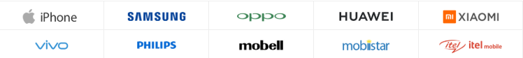

|  |  |  |  |  |  |
| --- | --- | --- | --- | --- | --- |
| No. | Name | Type | Validation | Event | Description |
| 1 | Brands’ image sliders | Bootstrap Carousel |  | Click | Redirect to Products page |

* 1. Featured Products:

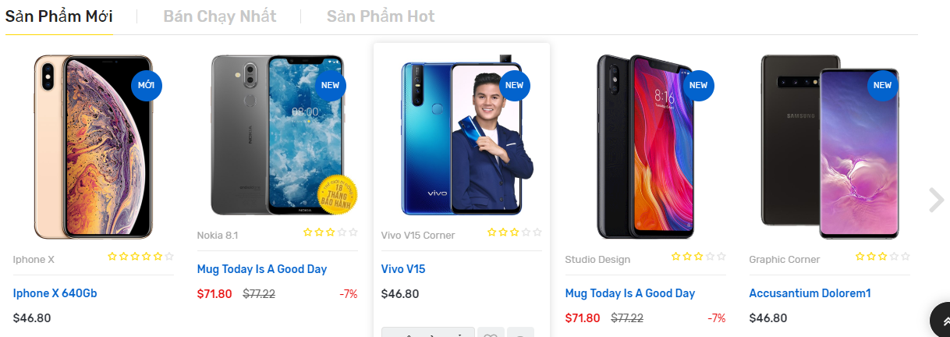

|  |  |  |  |  |  |
| --- | --- | --- | --- | --- | --- |
| No. | Name | Type | Validation | Event | Description |
| 1 | Product Image | Image |  |  |  |
| 2 | Product Name | Link |  | Click | Redirect to Product Details page |
| 3 | Product Ratings | Bootstrap Font Awesome |  |  |  |
| 4 | Product Price | Text |  |  |  |

* 1. Stores:

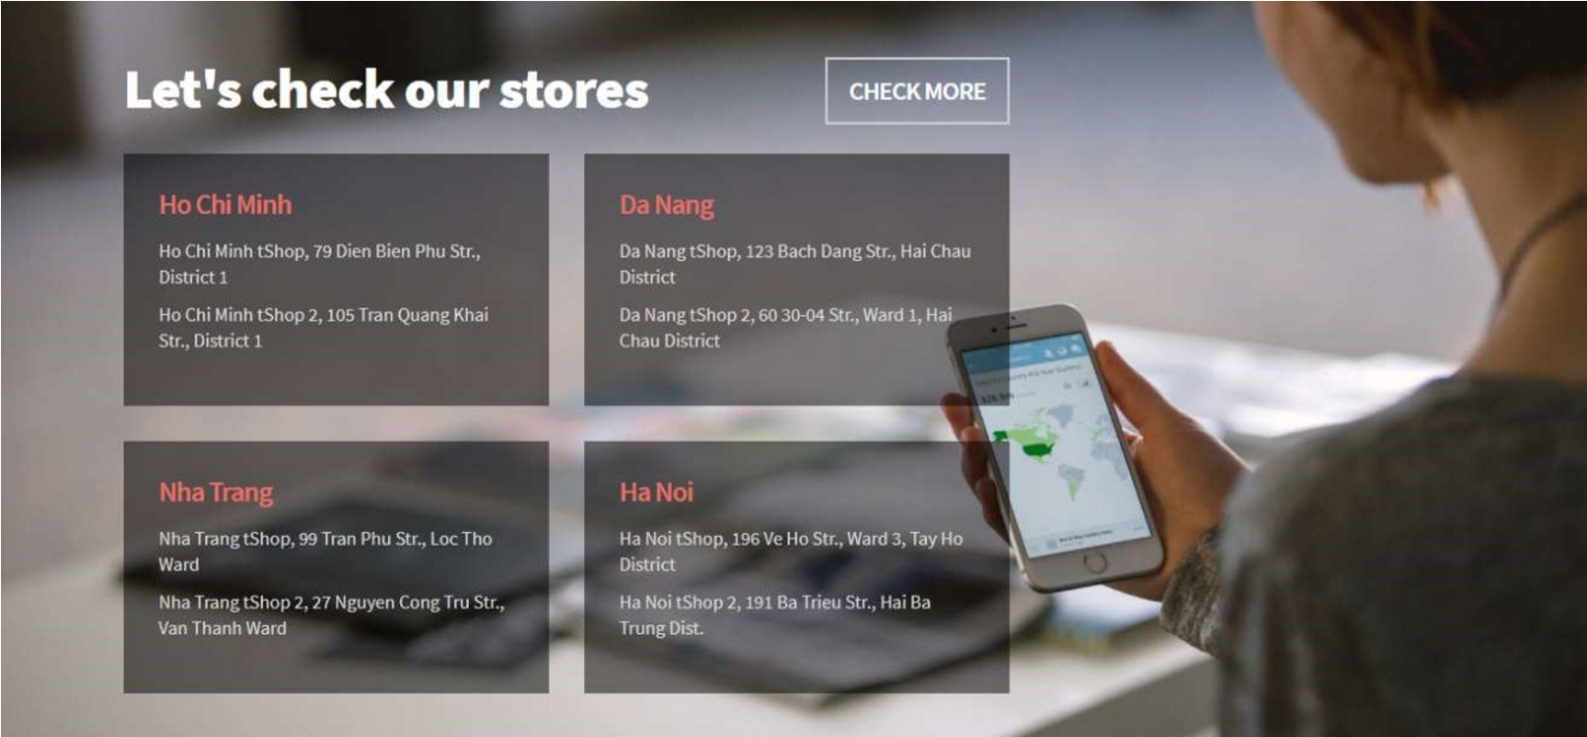

|  |  |  |  |  |  |
| --- | --- | --- | --- | --- | --- |
| No. | Name | Type | Validation | Event | Description |
| 1 | Stores’ info | Text |  |  |  |
| 2 | Check More | Button |  | Click | Redirect to Stores page |

1. Products

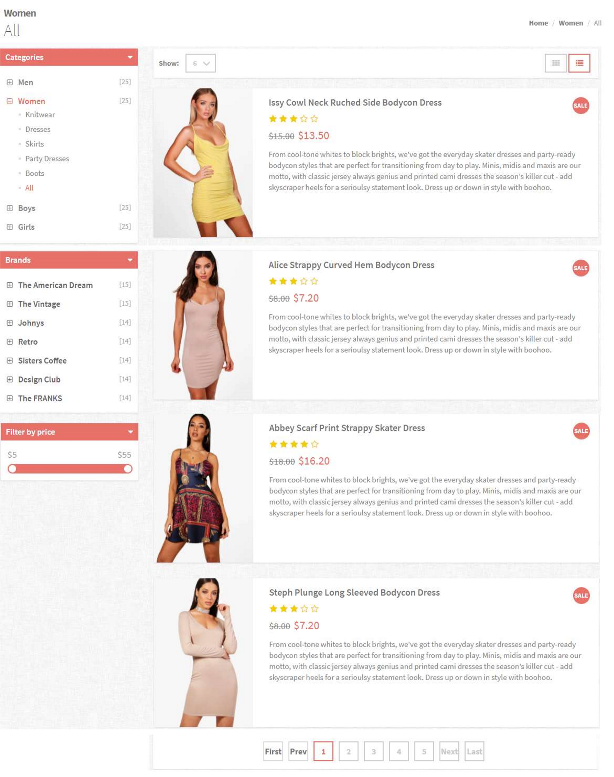

* 1. Breadcum:



|  |  |  |  |  |  |
| --- | --- | --- | --- | --- | --- |
| No. | Name | Type | Validation | Event | Description |
| 1 | Home | Link |  | Click | Redirect to Index page |
| 2 | Women | Link |  | Click | Redirect to Products page |

* 1. Filter panel:

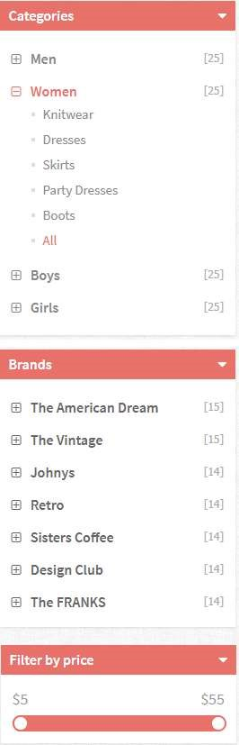

|  |  |  |  |  |  |
| --- | --- | --- | --- | --- | --- |
| No. | Name | Type | Validation | Event | Description |
| 1 | Categories Panel | Dropdown Panel |  | Click | Show all Categories |
| 2 | Categories link | Dropdown link |  | Click | Show all types in categories |
| 3 | Types link | Link |  | Click | Redirect to Products page |
| 4 | Brands Panel | Dropdown Panel |  | Click | Show all Brands |
| 5 | Brands link | Link |  | Click | Redirect to Products page |

* 1. Products list:

Customer can change view mode between List view and Grid view - List view:

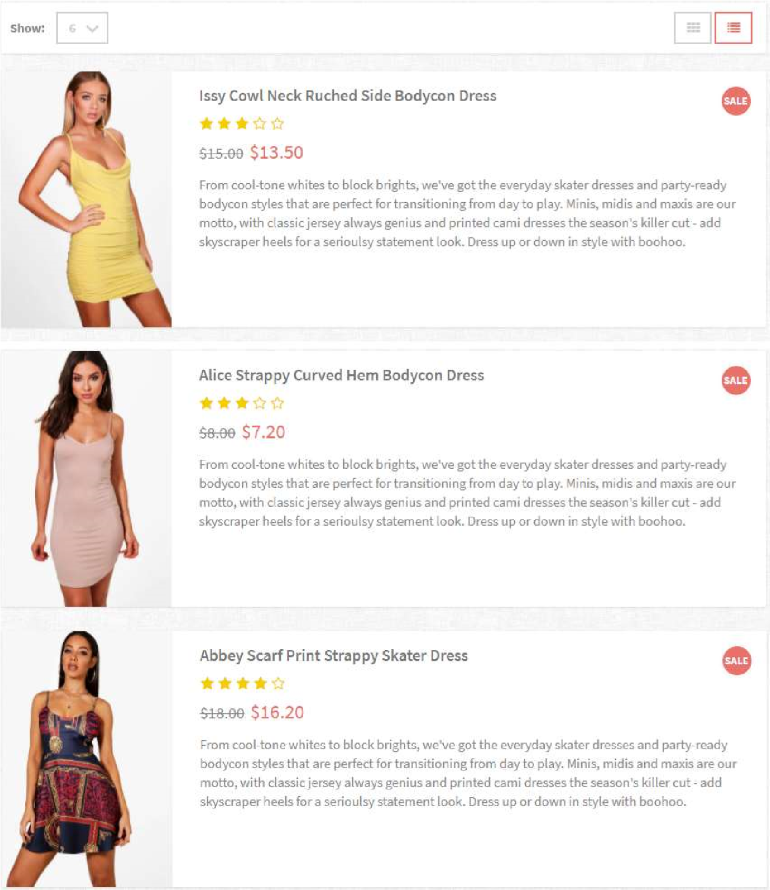

|  |  |  |  |  |  |
| --- | --- | --- | --- | --- | --- |
| No. | Name | Type | Validation | Event | Description |
| 1 | Product Image | Image |  |  |  |
| 2 | Product Name | Link |  | Click | Redirect to Product Details page |
| 3 | Product Ratings | Bootstrap Font Awesome |  |  |  |
| 4 | Product Price | Text |  |  |  |
| 5 | Descriptions | Text |  |  |  |

* Grid view:

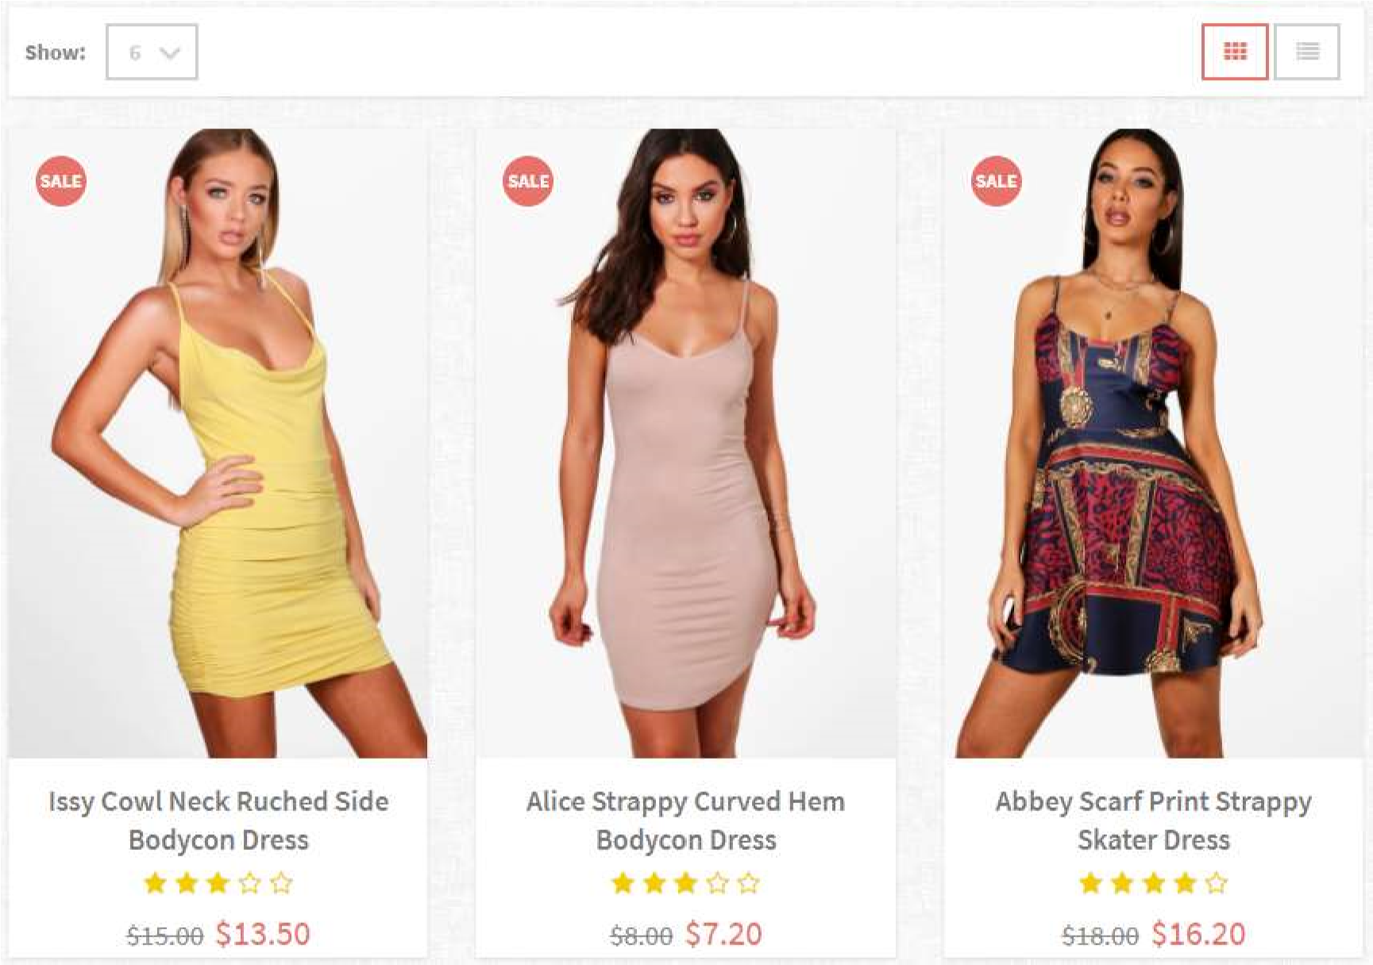

|  |  |  |  |  |  |
| --- | --- | --- | --- | --- | --- |
| No. | Name | Type | Validation | Event | Description |
| 1 | Product Image | Image |  |  |  |
| 2 | Product Name | Link |  | Click | Redirect to Product Details page |
| 3 | Product Ratings | Bootstrap Font Awesome |  |  |  |
| 4 | Product Price | Text |  |  |  |

* View mode and page size



|  |  |  |  |  |  |
| --- | --- | --- | --- | --- | --- |
| No. | Name | Type | Validation | Event | Description |
| 1 | Page size | Dropdown list |  | Change | Contains values: 6, 12, 18, 24, All. Change number of products display on page. |
| 2 | View mode | Button |  | Click | Change view mode of page: List view or Grid view |

d. Pagination:



|  |  |  |  |  |  |
| --- | --- | --- | --- | --- | --- |
| No. | Name | Type | Validation | Event | Description |
| 1 | Pagination | Jquery UI pagination |  | Click | Change the page of displayed products |

1. SingleProduct

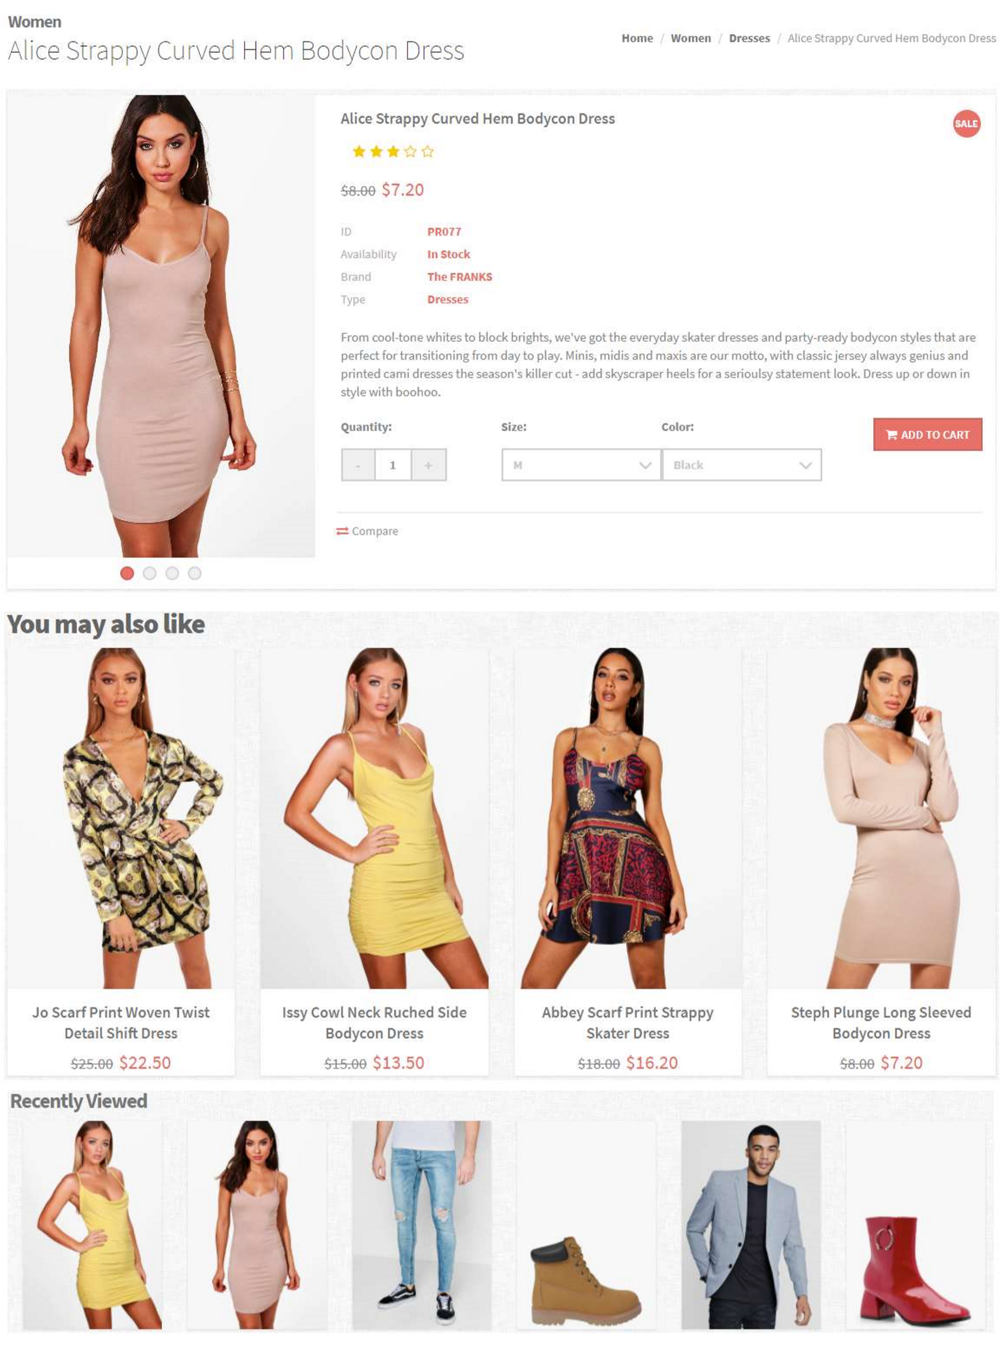

* 1. Breadcum:



|  |  |  |  |  |  |
| --- | --- | --- | --- | --- | --- |
| No. | Name | Type | Validation | Event | Description |
| 1 | Home | Link |  | Click | Redirect to Index page |
| 2 | Categories name | Link |  | Click | Redirect to Products page with products in selected Categories |
| 3 | Types name | Link |  | Click | Redirect to Products page with products in Types Types |

* 1. Products Details:

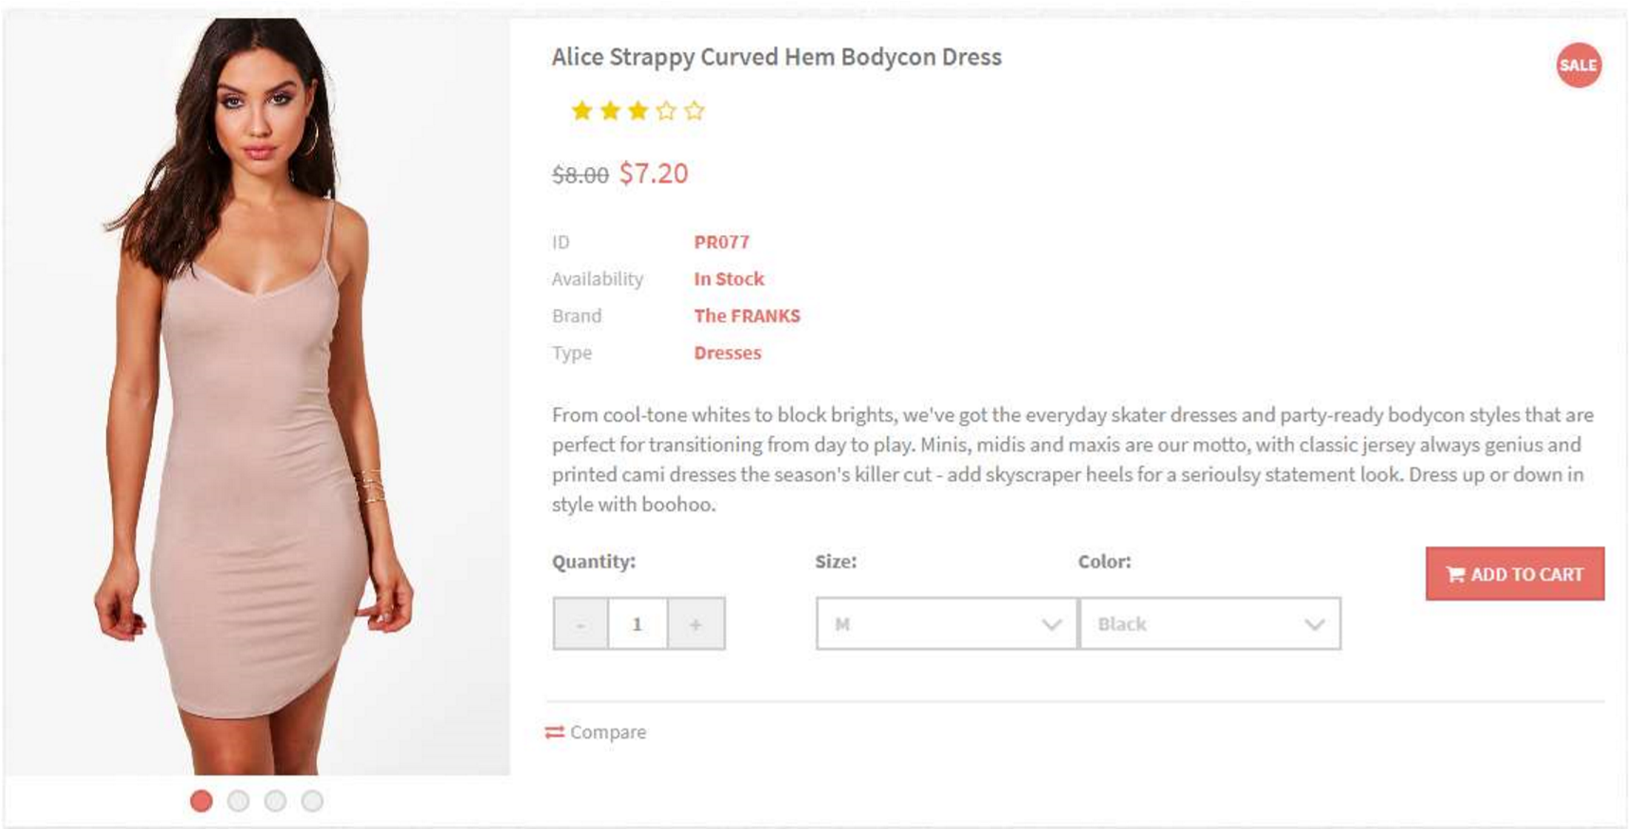

|  |  |  |  |  |  |
| --- | --- | --- | --- | --- | --- |
| No. | Name | Type | Validation | Event | Description |
| 1 | Product Image | Sliders |  | Click | Display next image |
| 2 | Product Name | Link |  | Click | Redirect to Product Details page |
| 3 | Product Ratings | Bootstrap Font Awesome |  | Click | Display Rating Panel |
| 4 | Product Price | Text |  |  |  |
| 5 | Quantity | Input number |  | Click | Change the quantity, min value = 1 |
| 6 | Size | Combo box |  |  | Contains: XS, S, M, L,  XL, XXL |
| 7 | Color | Combo box |  |  | Contains: Black, White, Red, Color |
| 8 | Compare | Link |  | Click | Add and redirect to Compare page |

* 1. Rating panel:

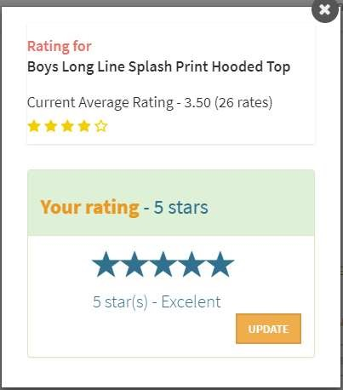

|  |  |  |  |  |  |
| --- | --- | --- | --- | --- | --- |
| No. | Name | Type | Validation | Event | Description |
| 1 | Product Image | Sliders |  |  |  |
| 2 | Product Name | Text |  |  |  |
| 3 | Product Ratings | Bootstrap Font Awesome |  | Click | Rating |
| 4 | Submit | Button |  | Click | Submit rating |
| 5 | Rating  Descriptions | Text |  |  | Contains: Really Bad,  Bad, Fair, Good, Excellent |

* 1. You may also like:

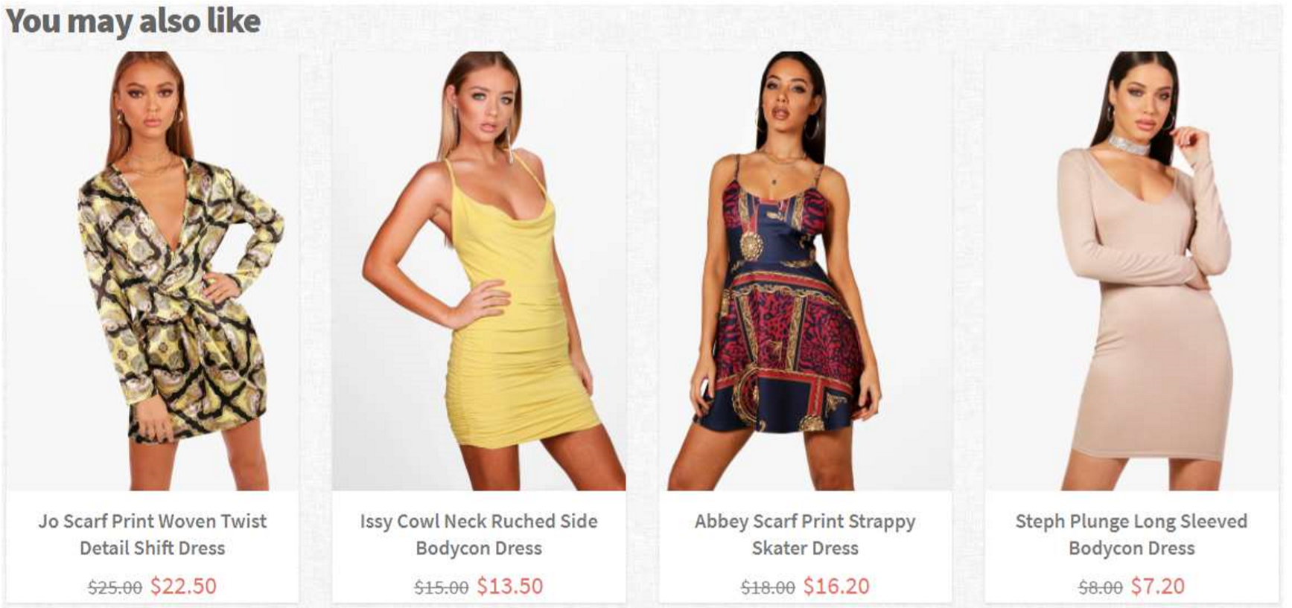

|  |  |  |  |  |  |
| --- | --- | --- | --- | --- | --- |
| No. | Name | Type | Validation | Event | Description |
| 1 | Product Image | Image |  |  |  |
| 2 | Product Name | Link |  | Click | Redirect to Product Details page |
| 3 | Product Ratings | Bootstrap Font Awesome |  |  |  |
| 4 | Product Price | Text |  |  |  |

* 1. Recently viewed:

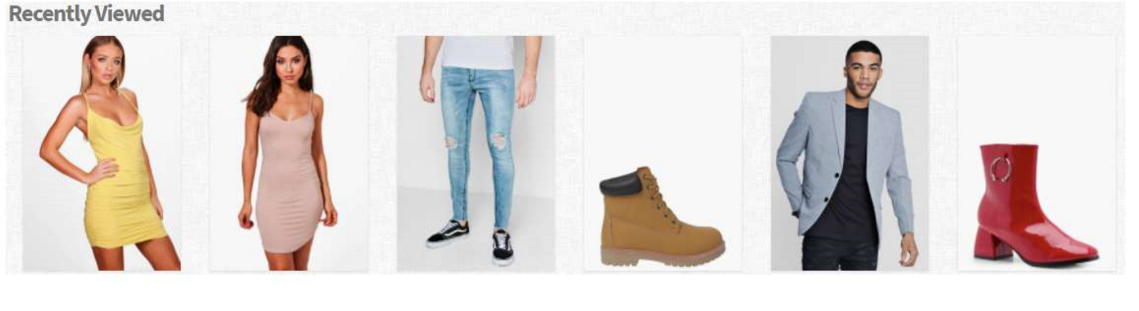

|  |  |  |  |  |  |
| --- | --- | --- | --- | --- | --- |
| No. | Name | Type | Validation | Event | Description |
| 1 | Product Image | Image |  | Click | Redirect to Product Details page |
| 2 | Product Name | Link |  |
| 3 | Product Ratings | Bootstrap Font Awesome |  |
| 4 | Product Price | Text |  |

1. Compare

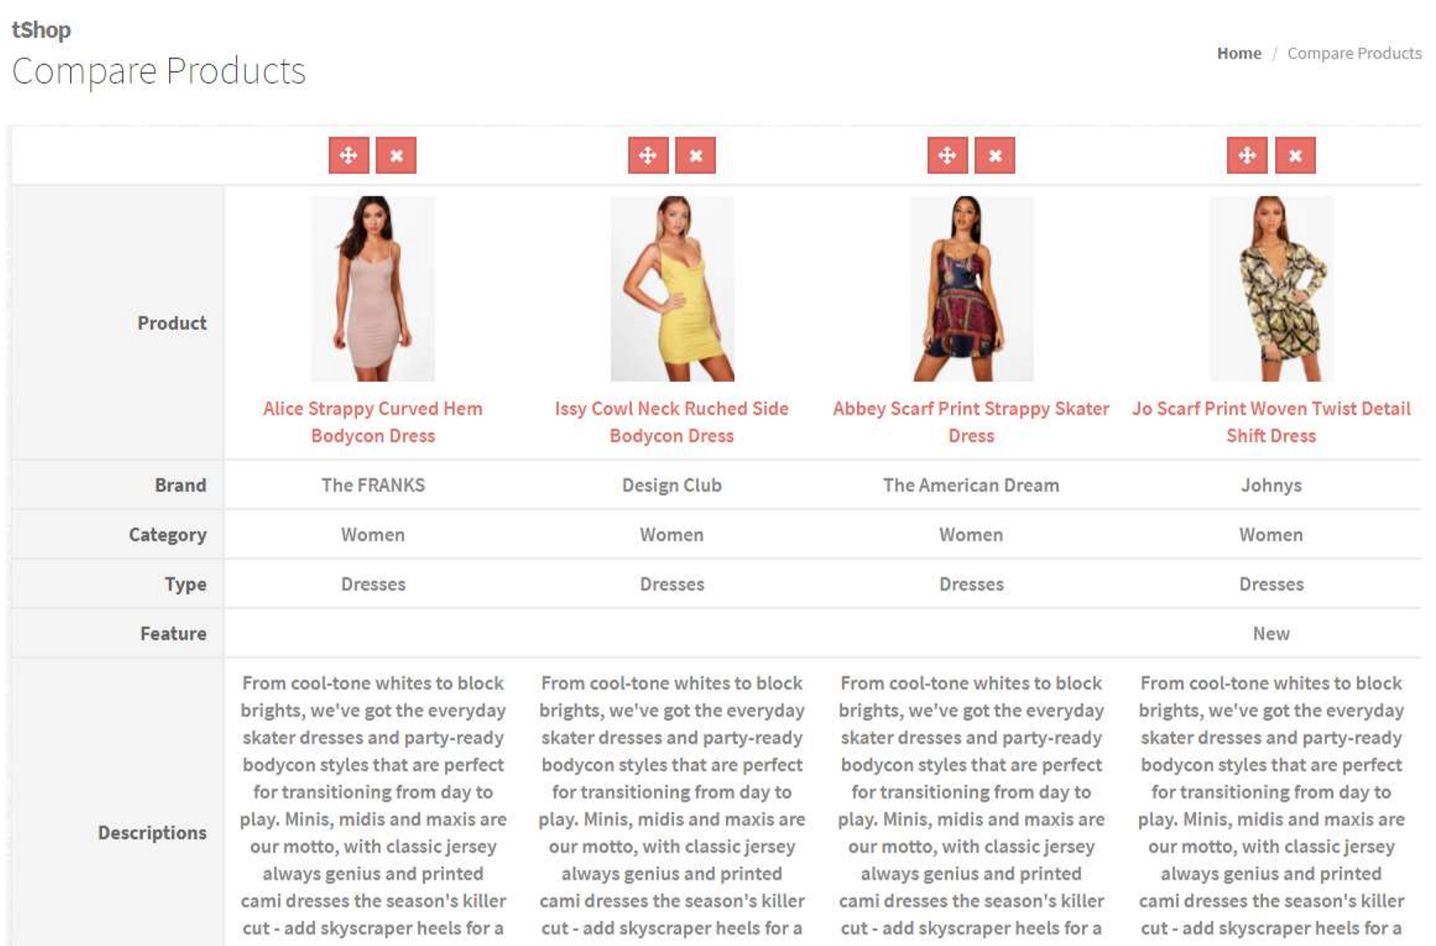

* 1. Breadcum:



|  |  |  |  |  |  |
| --- | --- | --- | --- | --- | --- |
| No. | Name | Type | Validation | Event | Description |
| 1 | Home | Link |  | Click | Redirect to Index page |

* 1. Compare:

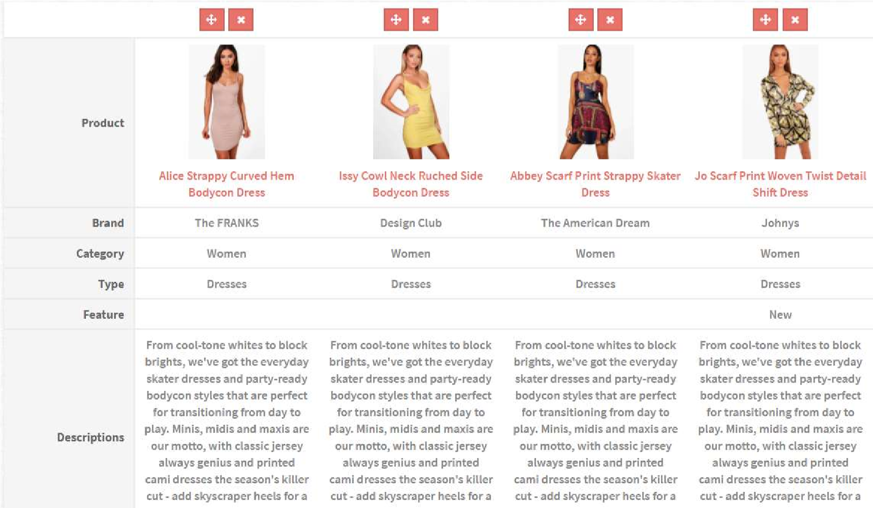

|  |  |  |  |  |  |
| --- | --- | --- | --- | --- | --- |
| No. | Name | Type | Validation | Event | Description |
| 1 | Product Image | Image |  |  |  |
| 2 | Product Name | Link |  | Click | Redirect to Product Details page |
| 3 | Product Ratings | Bootstrap Font Awesome |  |  |  |
| 4 | Product Price | Text |  |  |  |

1. Cart

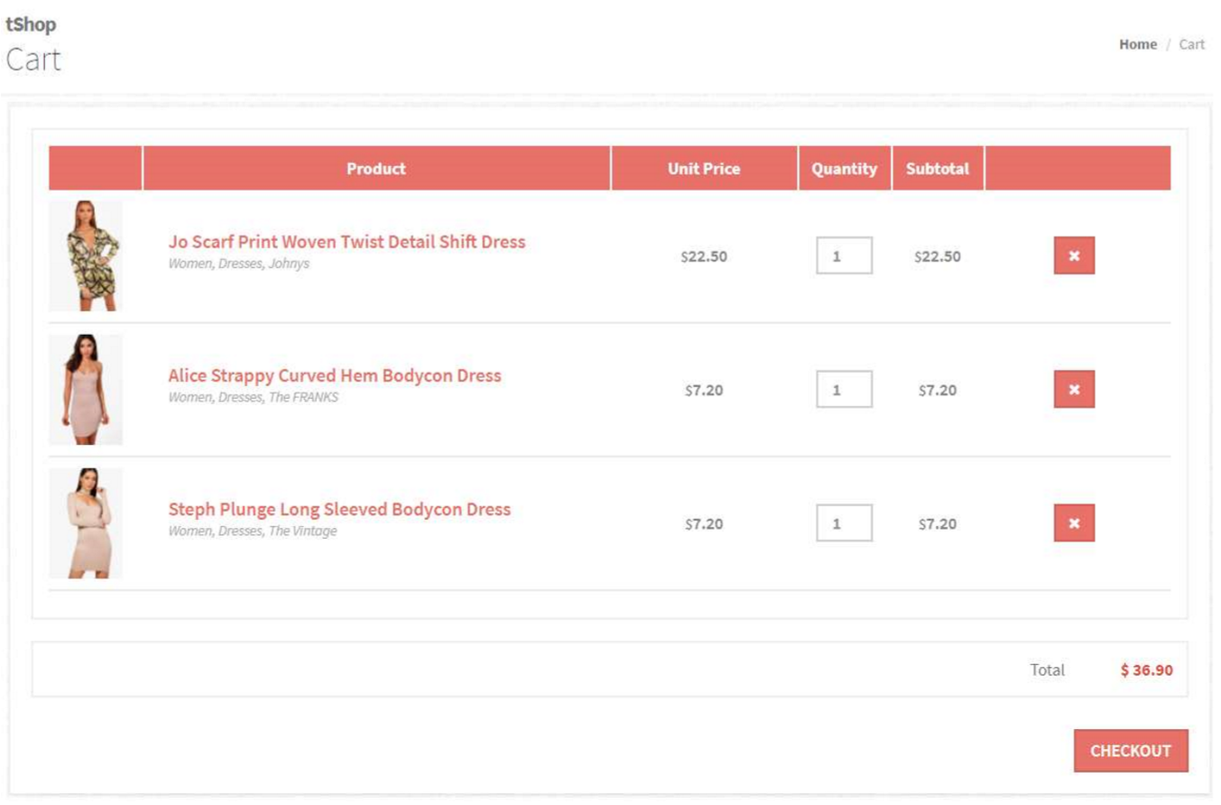

* 1. Breadcum:



|  |  |  |  |  |  |
| --- | --- | --- | --- | --- | --- |
| No. | Name | Type | Validation | Event | Description |
| 1 | Home | Link |  | Click | Redirect to Index page |

* 1. Cart:

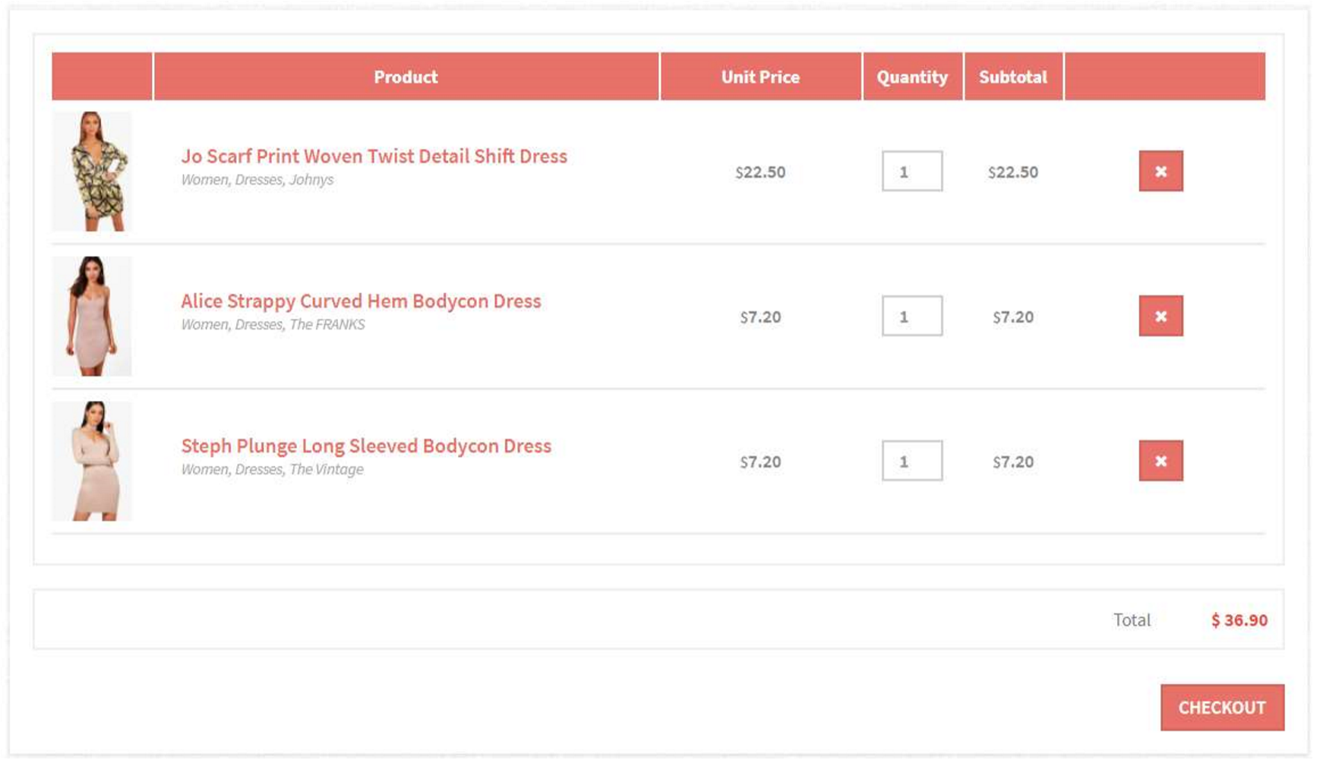

|  |  |  |  |  |  |
| --- | --- | --- | --- | --- | --- |
| No. | Name | Type | Validation | Event | Description |
| 1 | Product Image | Image |  |  |  |
| 2 | Product Name | Link |  | Click | Redirect to Product Details page |
| 3 | Product Price | Text |  |  |  |
| 4 | Quantity | Input number |  | Change | Update quantities of cart items |
| 5 | Remove | Button |  | Click | Remove cart items |
| 6 | Total | Text |  |  | Total payment of cart items |
| 7 | Checkout | Button |  | Click | Redirect to Checkout page |

1. Checkout
   1. Shipping Information:

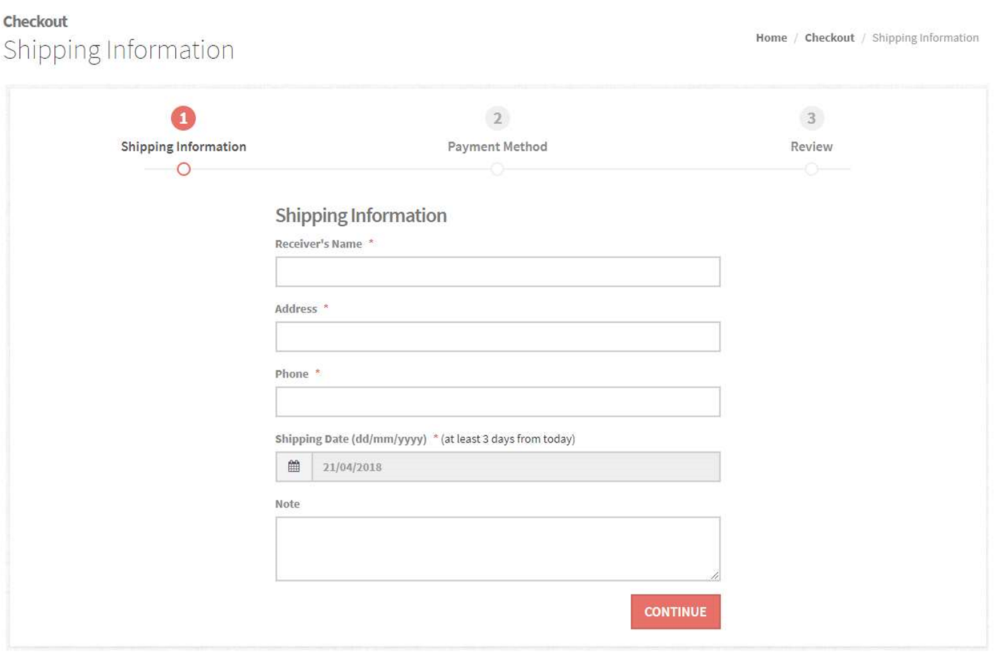

|  |  |  |  |  |  |
| --- | --- | --- | --- | --- | --- |
| No. | Name | Type | Validation | Event | Description |
| 1 | Receiver’s name | Input text | Not null |  |  |
| 2 | Address | Input text | Not null |  |  |
| 3 | Phone | Input text | Not null |  |  |
| 4 | Shipping Date | Datepicker | Not null |  | At least 3 days from current date |
| 5 | Note | Text Area |  |  |  |
| 6 | Continue | Button |  | Click | Redirect to Payment Method page |

* 1. Payment Method

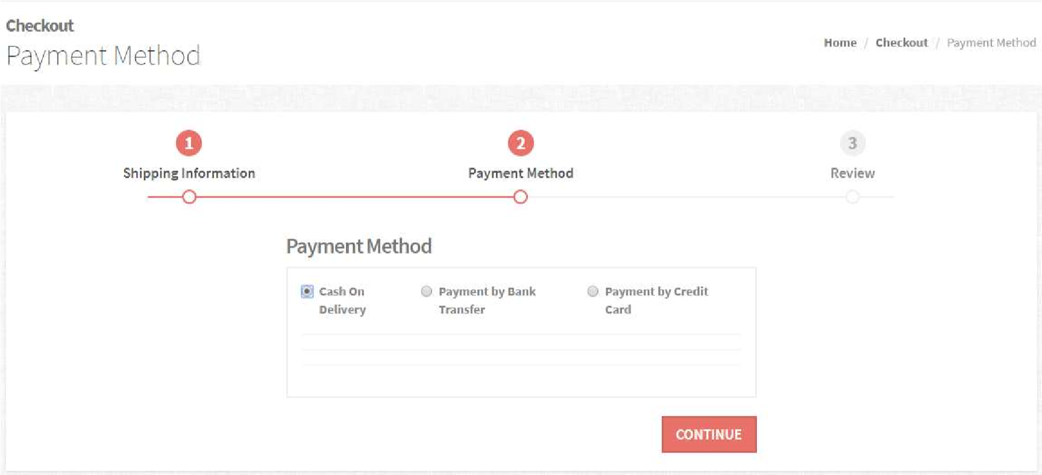

|  |  |  |  |  |  |
| --- | --- | --- | --- | --- | --- |
| No. | Name | Type | Validation | Event | Description |
| 1 | Payment Method | Radio Button |  | Click | Display method info |

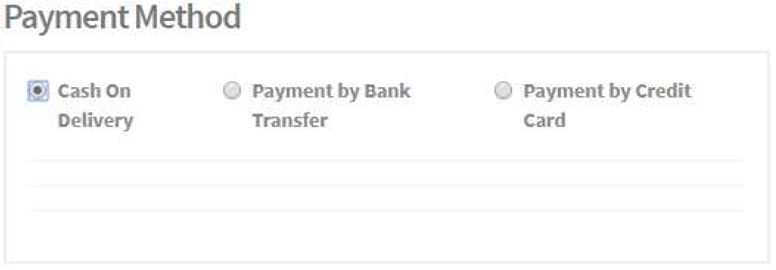

|  |  |  |  |  |  |
| --- | --- | --- | --- | --- | --- |
| No. | Name | Type | Validation | Event | Description |
| 1 | Cash On Delevry | Radio Button |  | Click | Select payment by cash |

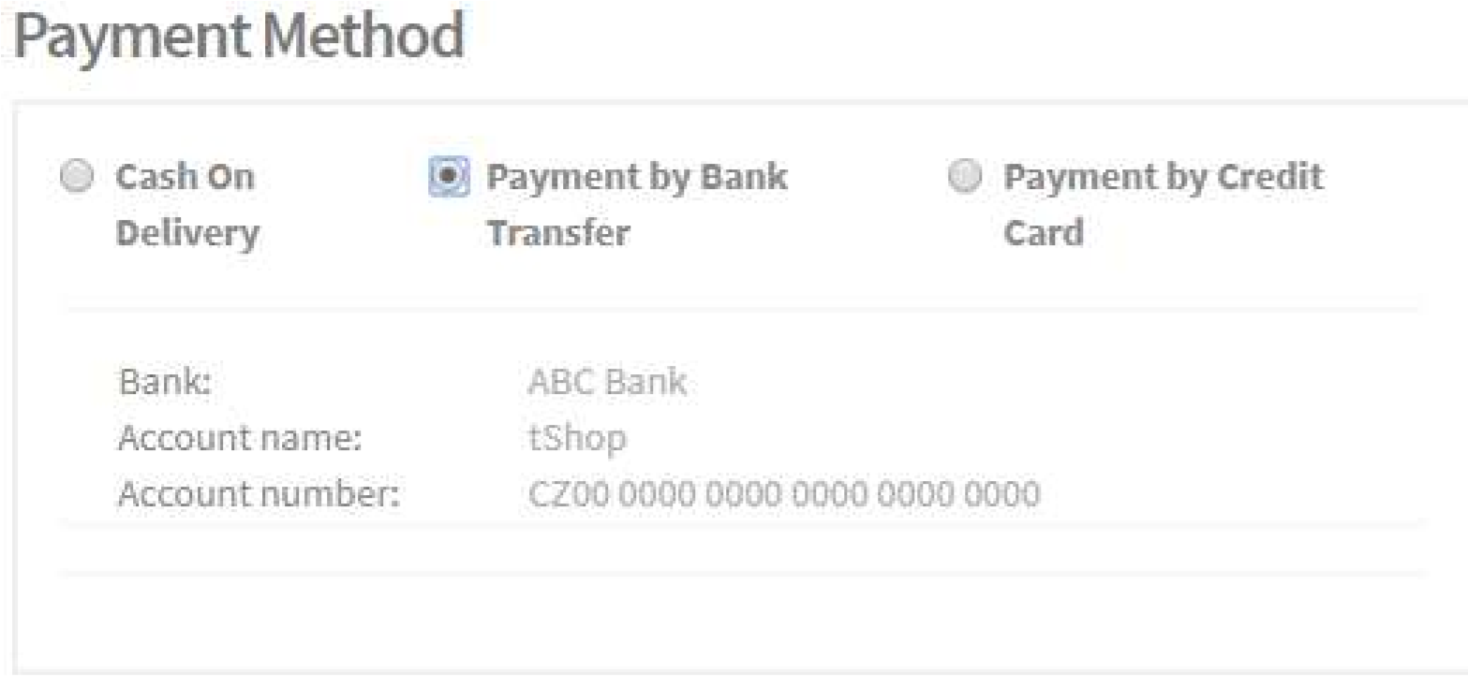

|  |  |  |  |  |  |
| --- | --- | --- | --- | --- | --- |
| No. | Name | Type | Validation | Event | Description |
| 1 | Bank Transfer | Radio Button |  | Click | Select payment by bank transfer and display account’s info |

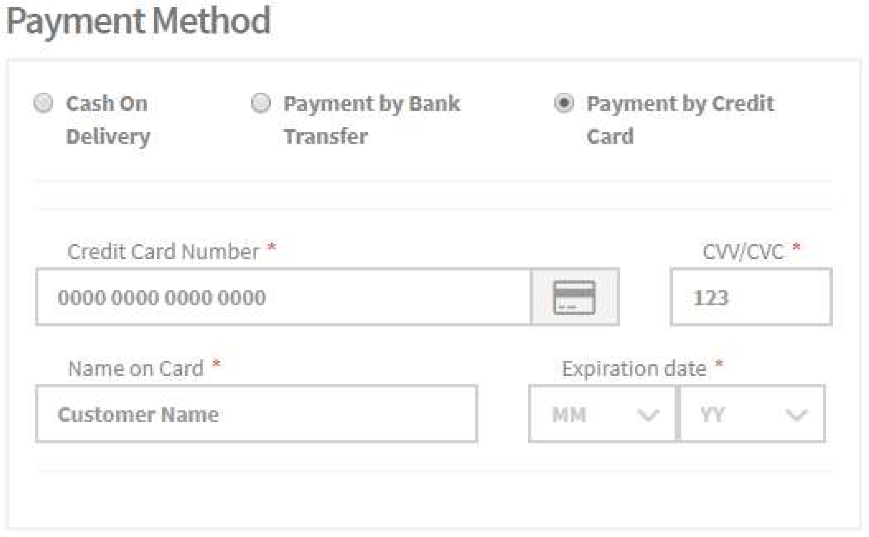

|  |  |  |  |  |  |
| --- | --- | --- | --- | --- | --- |
| No. | Name | Type | Validation | Event | Description |
| 1 | Credit Card | Radio Button |  | Click | Select payment by Credit Card and display input fields for card’s info |
| 2 | Card Number | Input text | Not null |  |  |
| 3 | CVV/CVC | Input text | Not null |  |  |
| 4 | Name | Input text | Not null |  |  |
| 5 | Expriration Date | Dropdown list |  |  |  |

* 1. Review

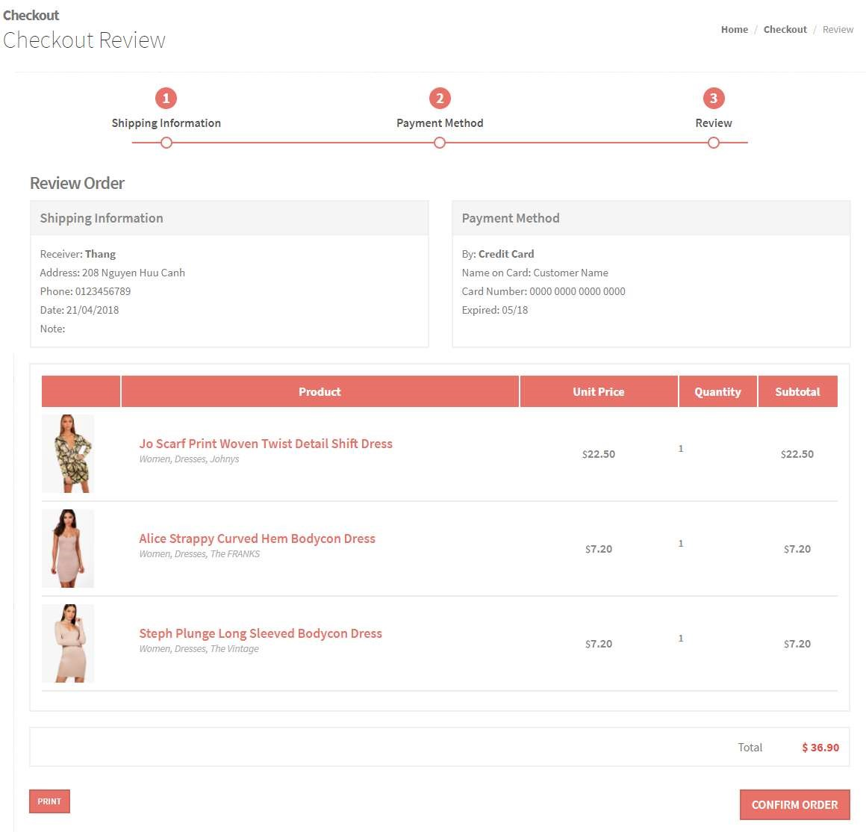

|  |  |  |  |  |  |
| --- | --- | --- | --- | --- | --- |
| No. | Name | Type | Validation | Event | Description |
| 1 | Shipping  Information | Text |  |  | Contains all shipping infor |
| 2 | Payment Method | Text |  |  | Contains all payment info |
| 3 | Cart Items | Table |  |  | Contains all cart items info |

1. OrderSuccess

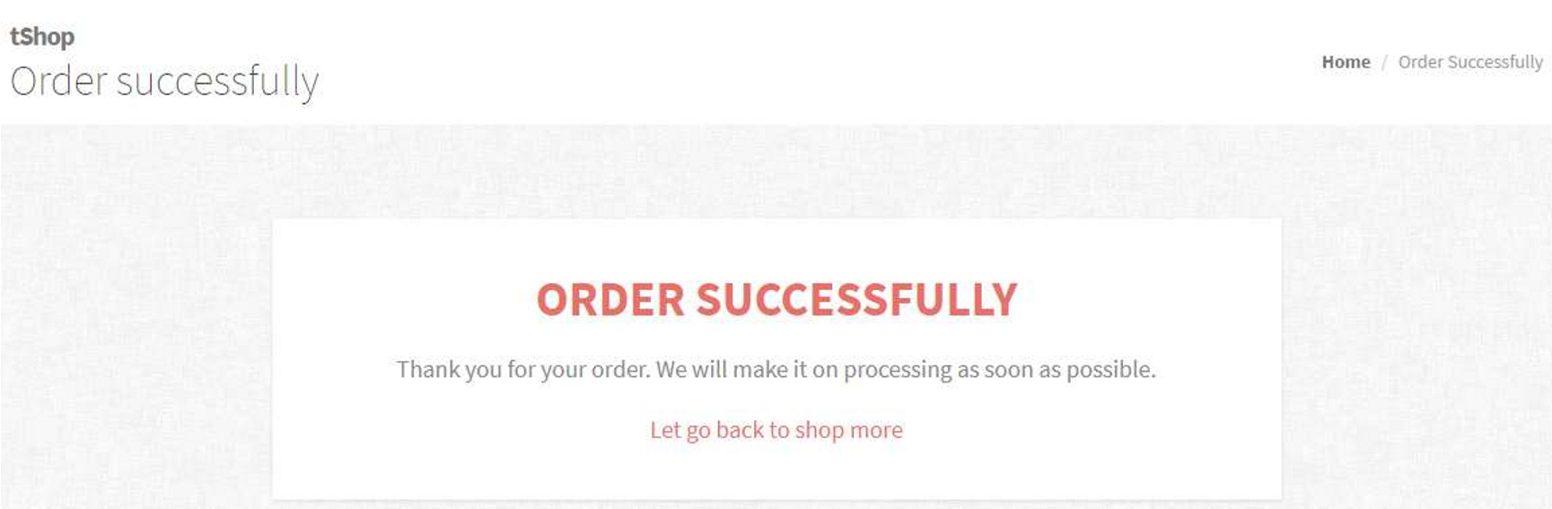

|  |  |  |  |  |  |
| --- | --- | --- | --- | --- | --- |
| No. | Name | Type | Validation | Event | Description |
| 1 | Shop more | Link |  | Click | Redirect to Index page |

1. SearchProduct

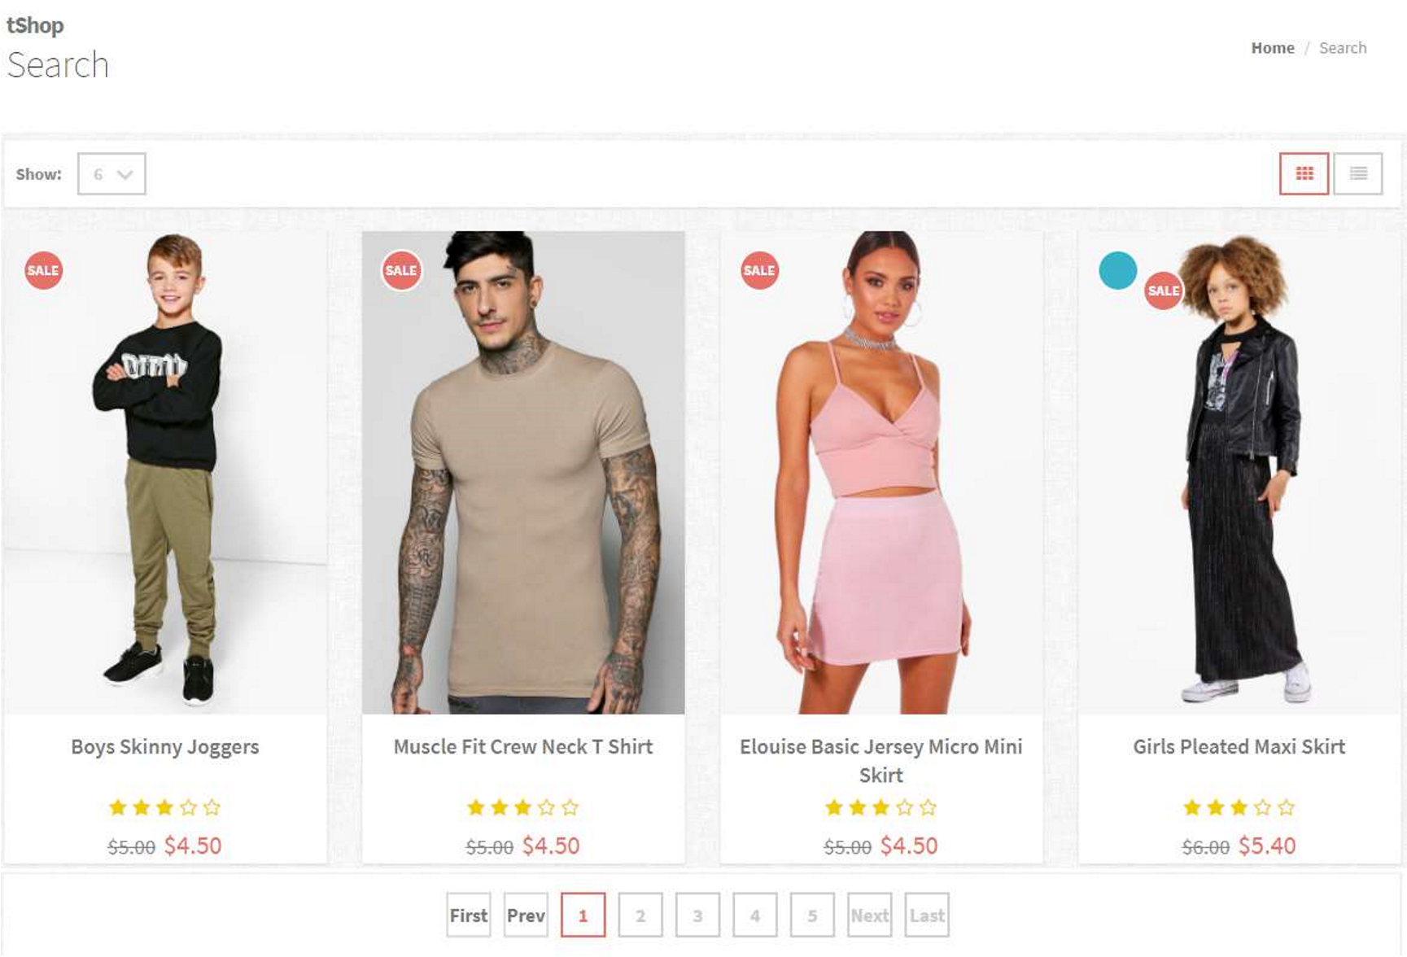

* 1. Breadcum:



|  |  |  |  |  |  |  |
| --- | --- | --- | --- | --- | --- | --- |
| No. | Name | Type | Validation | | Event | Description |
| 1 | Home | Link |  | | Click | Redirect to Index page |
| Prepared by: All Members | | | | Approved by: Mr. Ngo Phuoc Nguyen | | |
| Project Group No: 1 | | | |  | | |
|  | | | |  | | |
|  | | | |  | | |

* 1. Search result:

Customer can change view mode between List view and Grid view.

* View mode and page size



|  |  |  |  |  |  |
| --- | --- | --- | --- | --- | --- |
| No. | Name | Type | Validation | Event | Description |
| 1 | Page size | Dropdown list |  | Change | Contains values: 6, 12, 18, 24, All. Change number of products display on page. |
| 2 | View mode | Button |  | Click | Change view mode of page: List view or Grid view |

* List view:

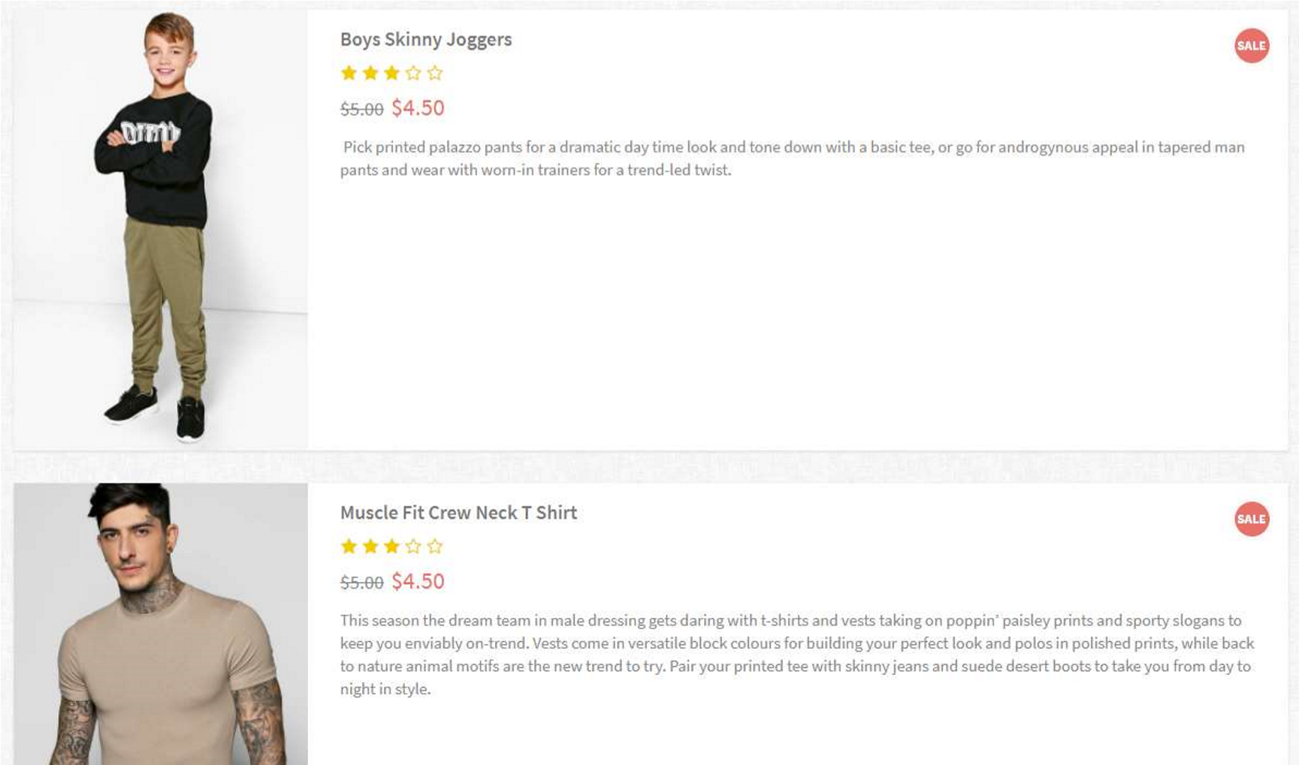

|  |  |  |  |  |  |
| --- | --- | --- | --- | --- | --- |
| No. | Name | Type | Validation | Event | Description |
| 1 | Product Image | Image |  |  |  |
| 2 | Product Name | Link |  | Click | Redirect to Product Details page |
| 3 | Product Ratings | Bootstrap Font Awesome |  |  |  |
| 4 | Product Price | Text |  |  |  |
| 5 | Descriptions | Text |  |  |  |

* Grid view:

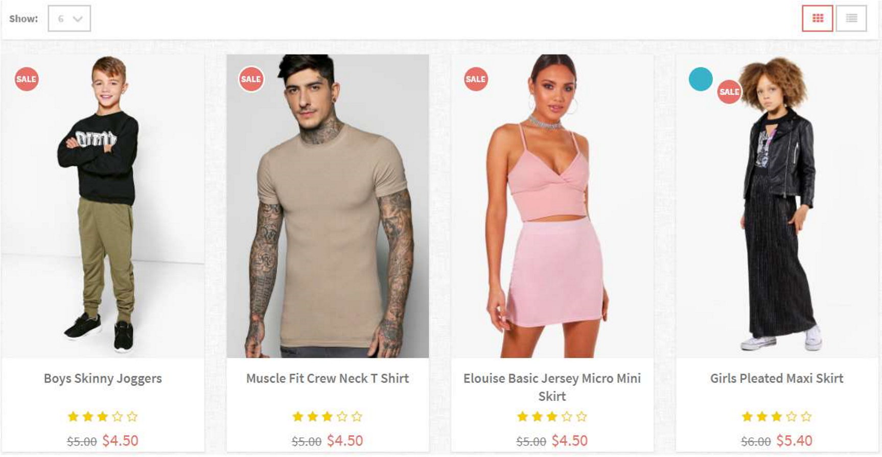

|  |  |  |  |  |  |
| --- | --- | --- | --- | --- | --- |
| No. | Name | Type | Validation | Event | Description |
| 1 | Product Image | Image |  |  |  |
| 2 | Product Name | Link |  | Click | Redirect to Product Details page |
| 3 | Product Ratings | Bootstrap Font Awesome |  |  |  |
| 4 | Product Price | Text |  |  |  |

c. Pagination:

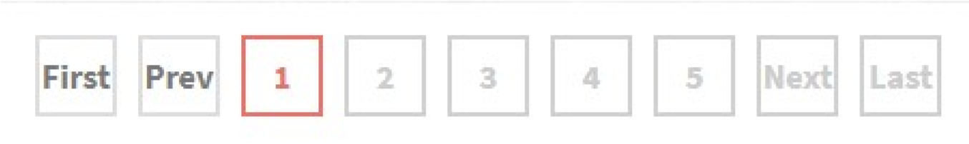

|  |  |  |  |  |  |
| --- | --- | --- | --- | --- | --- |
| No. | Name | Type | Validation | Event | Description |
| 1 | Pagination | Jquery UI pagination |  | Click | Change the page of displayed products |

10.Login and Register

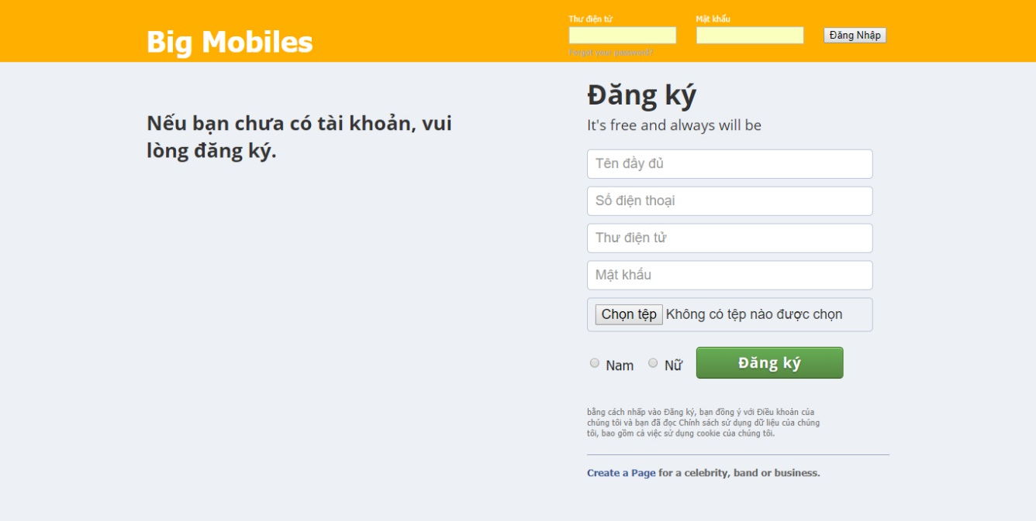

|  |  |  |  |  |  |
| --- | --- | --- | --- | --- | --- |
| No. | Name | Type | Validation | Event | Description |
| 1 | Email | Input text | Not null |  |  |
| 2 | Password | Input password | Not null |  |  |
| 3 | Remember | Checkbox |  | Checked | Save the login info |
| 4 | Submit | Button |  | Click | Check login and redirect to Account page |
| 5 | Sign up | Link |  | Click | Redirect to Signup page |

|  |  |  |  |  |  |
| --- | --- | --- | --- | --- | --- |
| No. | Name | Type | Validation | Event | Description |
| 1 | First name | Input text | Not null |  |  |
| 2 | Last name | Input text | Not null |  |  |
| 3 | Phone | Input text | Not null |  |  |
| 4 | Gender | Combo box |  | Change | Select customer’s gender |
| 5 | Email | Input text | Email format |  |  |
| 6 | Password | Input password | Not null |  |  |
| 7 | Confirm password | Input password | Not null |  |  |
| 8 | Avatar | Image |  |  | Preview chosen image |
| 9 | Change avatar | Input file |  | Click | Browse image file to upload |
| 10 | Submit | Button |  | Click | Submit new user’s info |

12.Account pages’ side bar

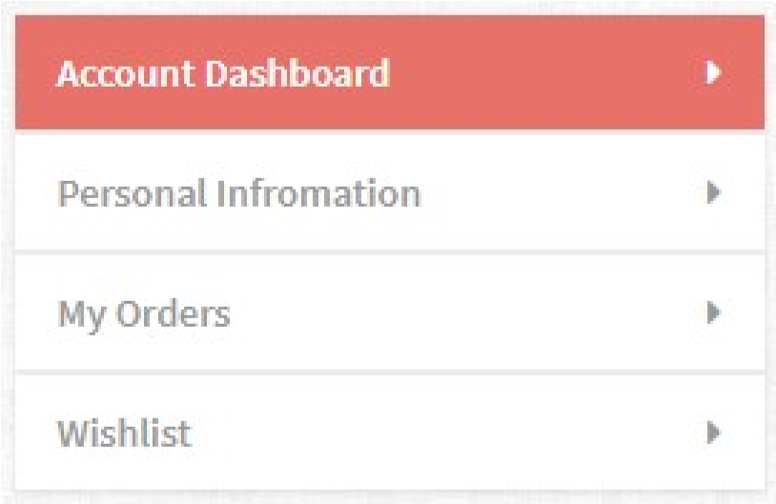

|  |  |  |  |  |  |
| --- | --- | --- | --- | --- | --- |
| No. | Name | Type | Validation | Event | Description |
| 1 | Account  Dashboard | Link |  | Click | Redirect to Account page |
| 2 | Personal  Information | Link |  | Click | Redirect to Profile page |
| 3 | My orders | Link |  | Click | Redirect to Orders page |
| 4 | Wishlist | Link |  | Click | Rederect to Wishlist page |

13. Account Dashboard

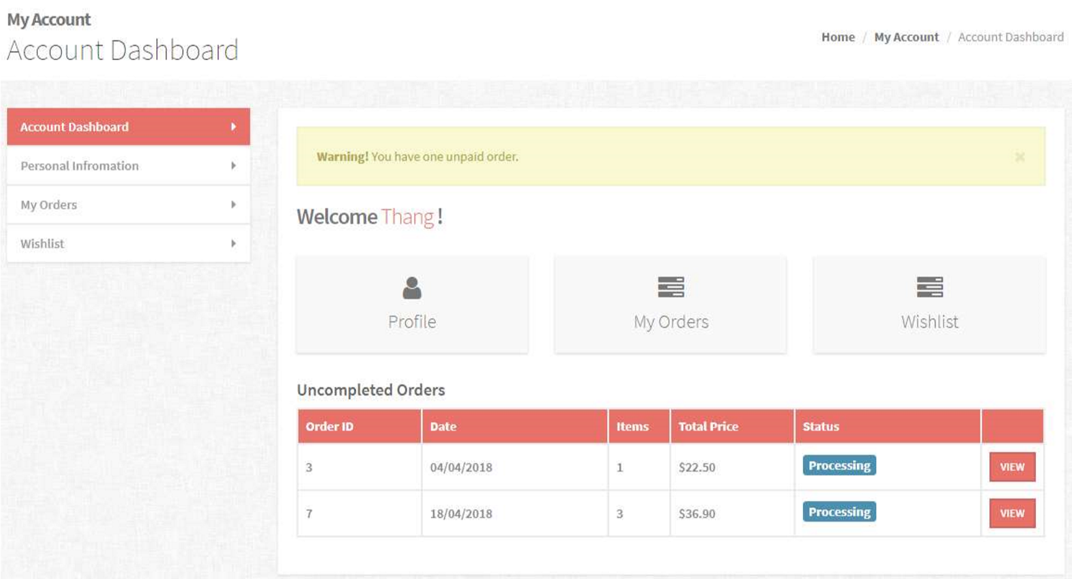

1. Breadcum:



|  |  |  |  |  |  |
| --- | --- | --- | --- | --- | --- |
| No. | Name | Type | Validation | Event | Description |
| 1 | Home | Link |  | Click | Redirect to Index page |
| 2 | My Account | Link |  | Click | Redirect to Account page |

1. Dashboard:

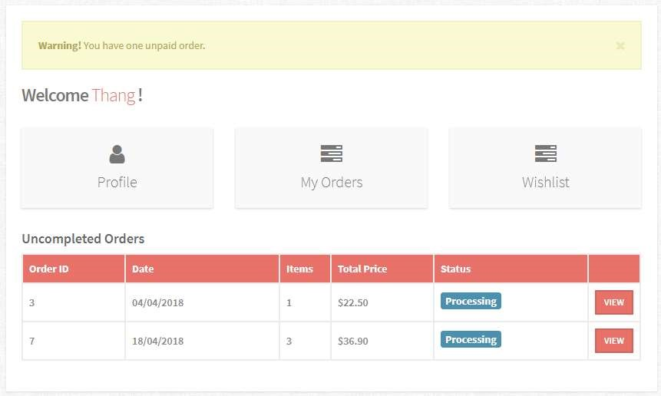

|  |  |  |  |  |  |
| --- | --- | --- | --- | --- | --- |
| No. | Name | Type | Validation | Event | Description |
| 1 | Profile | Link |  | Click | Redirect to Profile page |
| 2 | Orders | Link |  | Click | Redirect to Orders page |
| 3 | Wishlist | Link |  | Click | Redirect to Wishlist page |
| 4 | Uncompleted orders | Table |  |  | All customers’ uncompleted orders info: ID, Order Date, Quantity, Total payment, Status |
| 5 | View | Button |  | Click | Redirect to Orders Details page |

14.Personal Information

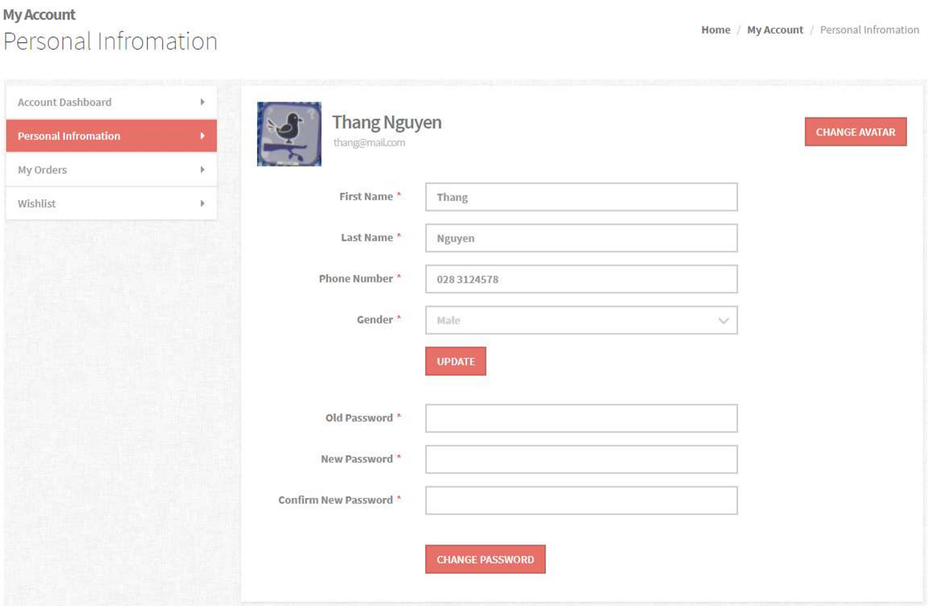

1. Breadcum:



|  |  |  |  |  |  |
| --- | --- | --- | --- | --- | --- |
| No. | Name | Type | Validation | Event | Description |
| 1 | Home | Link |  | Click | Redirect to Index page |
| 2 | My Account | Link |  | Click | Redirect to Account page |

1. Information:

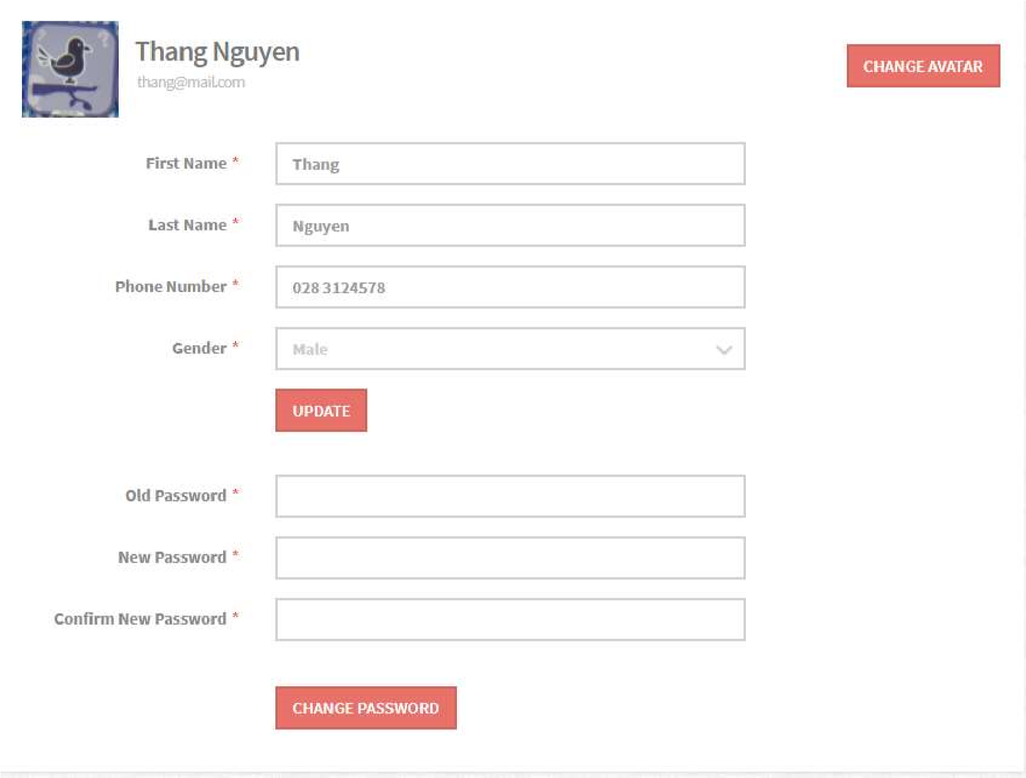

|  |  |  |  |  |  |
| --- | --- | --- | --- | --- | --- |
| No. | Name | Type | Validation | Event | Description |
| 1 | Customer Avatar | Image |  |  | Change when customer select new image |
| 2 | Change avatar | Input file |  | Click | Browse image file to upload |
| 3 | First name | Input text | Not null |  |  |
| 4 | Last name | Input text | Not null |  |  |
| 5 | Phone | Input text | Not null |  |  |
| 6 | Gender | Combo box |  | Change | Select customer’s gender |
| 7 | Update | Button |  | Click | Update customer info and redirect to Profile page |
| 8 | Old Password | Input password | Not null |  |  |
| 9 | New Password | Input password | Not null |  |  |
| 10 | Confirm password | Input password | Not null |  |  |
| 11 | Change password | Button |  | Click | Check if correct: Old password, matched Confirm Password. And update customer’s password then redirect to Profile page |

15.My Orders

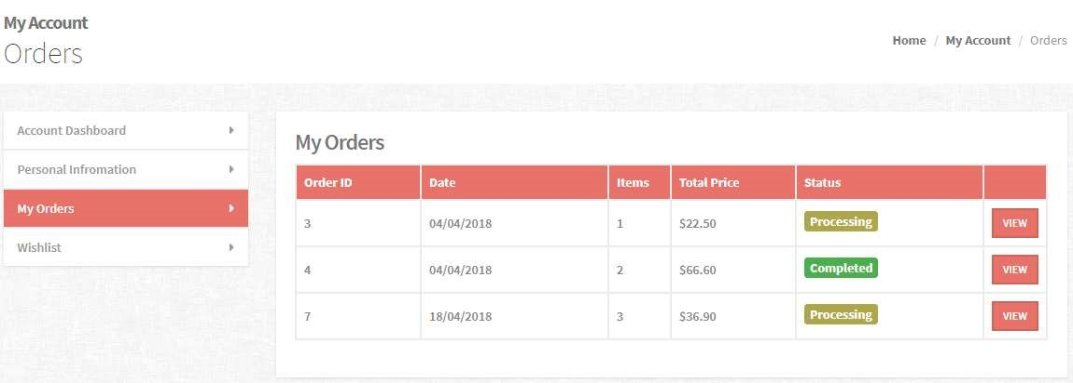

* 1. Breadcum:



|  |  |  |  |  |  |
| --- | --- | --- | --- | --- | --- |
| No. | Name | Type | Validation | Event | Description |
| 1 | Home | Link |  | Click | Redirect to Index page |
| 2 | My Account | Link |  | Click | Redirect to Account page |

* 1. Orders:

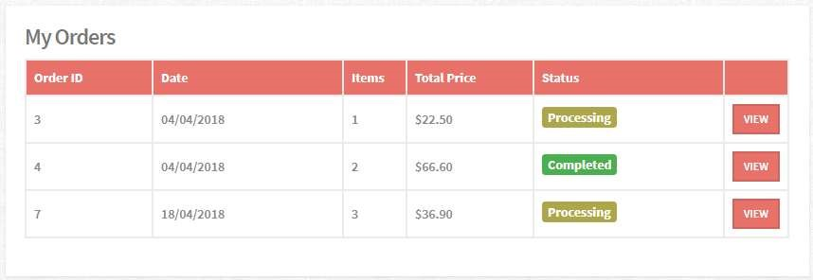

|  |  |  |  |  |  |
| --- | --- | --- | --- | --- | --- |
| No. | Name | Type | Validation | Event | Description |
| 1 | All customer’s orders | Table |  |  | All customer’s orders info: ID, Order Date, Quantity, Total payment, Status |
| 2 | View | Button |  | Click | Redirect to Orders Details page |

16.SingleOrder

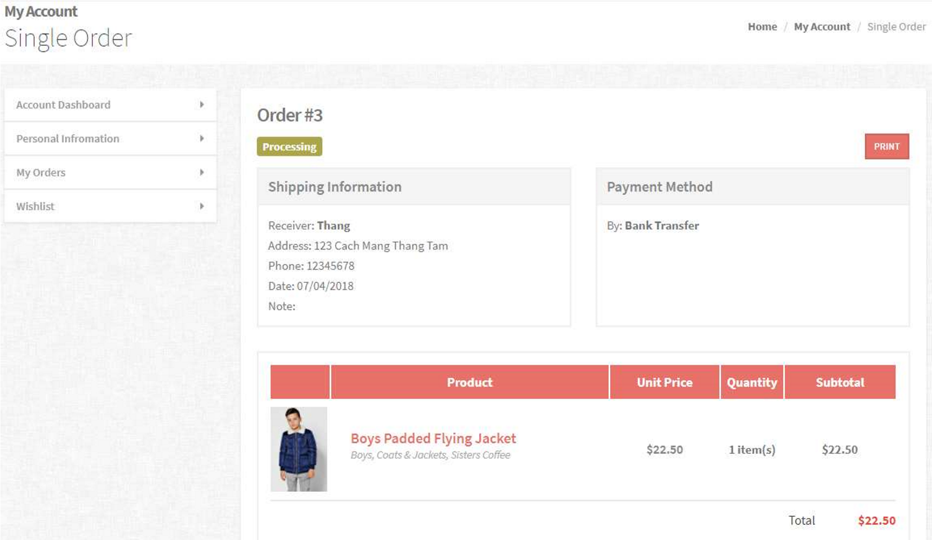

a. Breadcum:



|  |  |  |  |  |  |
| --- | --- | --- | --- | --- | --- |
| No. | Name | Type | Validation | Event | Description |
| 1 | Home | Link |  | Click | Redirect to Index page |
| 2 | My Account | Link |  | Click | Redirect to Account page |

Order Details:

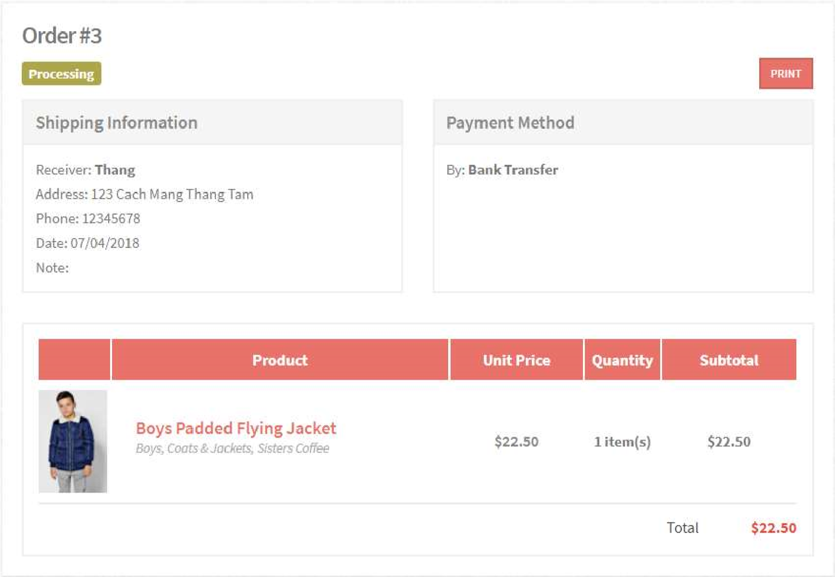

|  |  |  |  |  |  |
| --- | --- | --- | --- | --- | --- |
| No. | Name | Type | Validation | Event | Description |
| 1 | Shipping  Information | Text |  |  | Contains all shipping infor |
| 2 | Payment Method | Text |  |  | Contains all payment info |
| 3 | Order’s Items | Table |  |  | Contains all order’s items info |

17.Wishlist

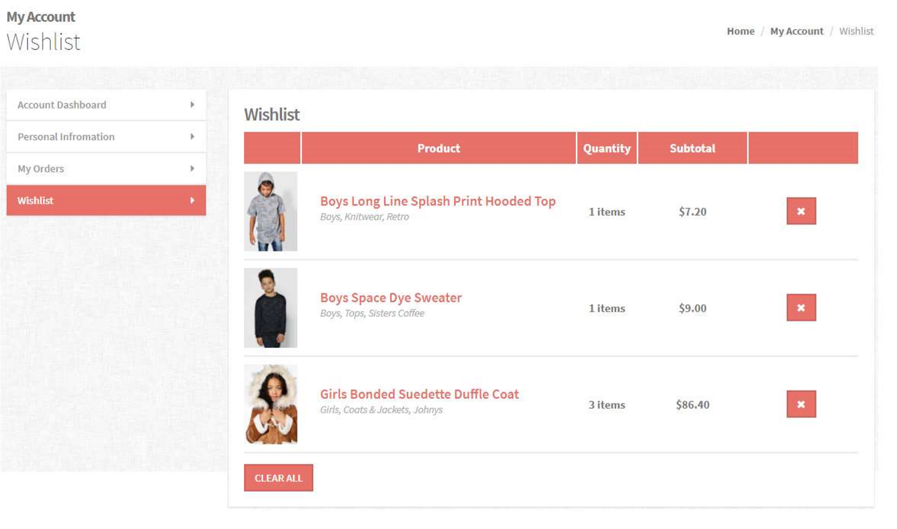

a. Breadcum:



|  |  |  |  |  |  |
| --- | --- | --- | --- | --- | --- |
| No. | Name | Type | Validation | Event | Description |
| 1 | Home | Link |  | Click | Redirect to Index page |
| 2 | My Account | Link |  | Click | Redirect to Account page |

Wishilst:

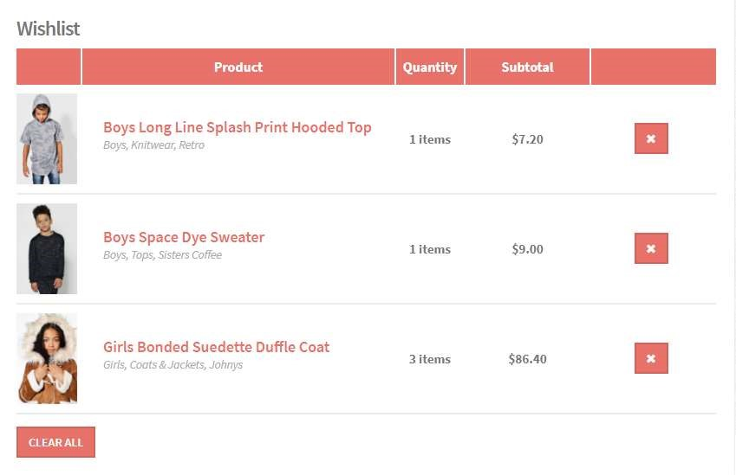

|  |  |  |  |  |  |
| --- | --- | --- | --- | --- | --- |
| No. | Name | Type | Validation | Event | Description |
| 1 | Product Image | Image |  |  |  |
| 2 | Product Name | Link |  | Click | Redirect to Product Details page |
| 3 | Product Price | Text |  |  |  |
| 4 | Quantity | Input number |  | Change | Update quantities of cart items |
| 5 | Remove | Button |  | Click | Remove wishilist item |
| 6 | Clear all | Button |  | Click | Clear all Wishlist items |

18.Stores

a.

Breadcum:

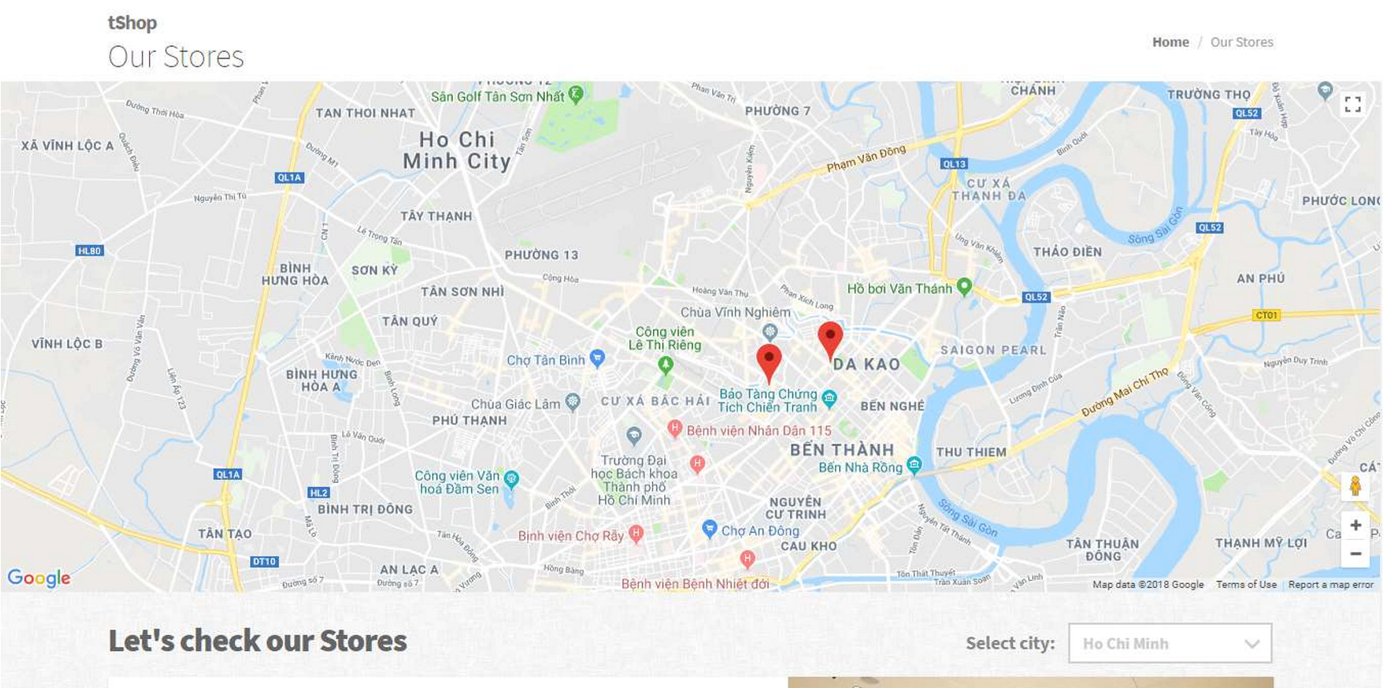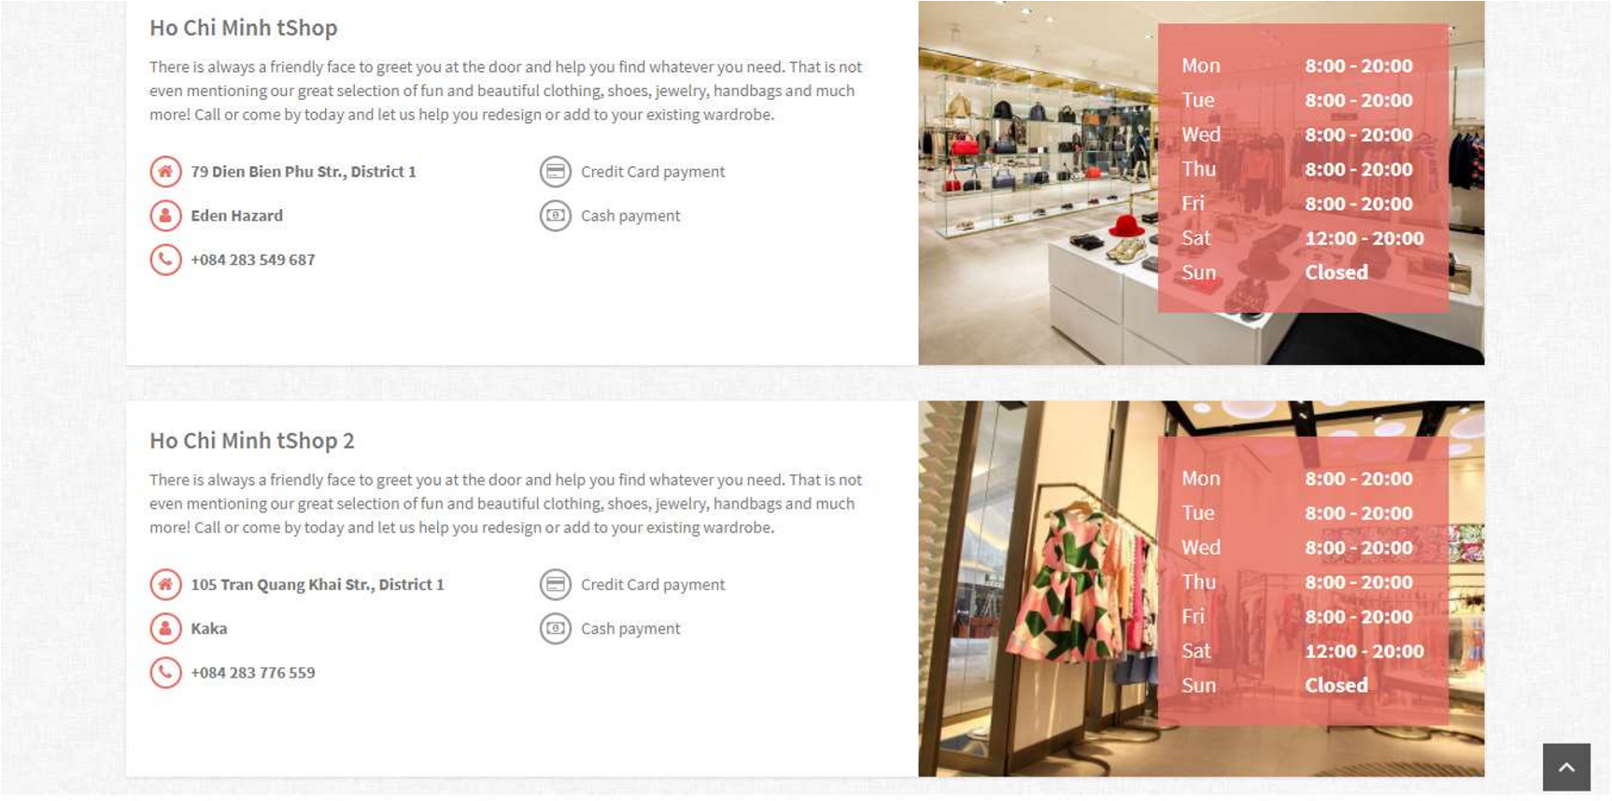

|  |  |  |  |  |  |
| --- | --- | --- | --- | --- | --- |
| No. | Name | Type | Validation | Event | Description |
| 1 | Home | Link |  | Click | Redirect to Index page |

Map:

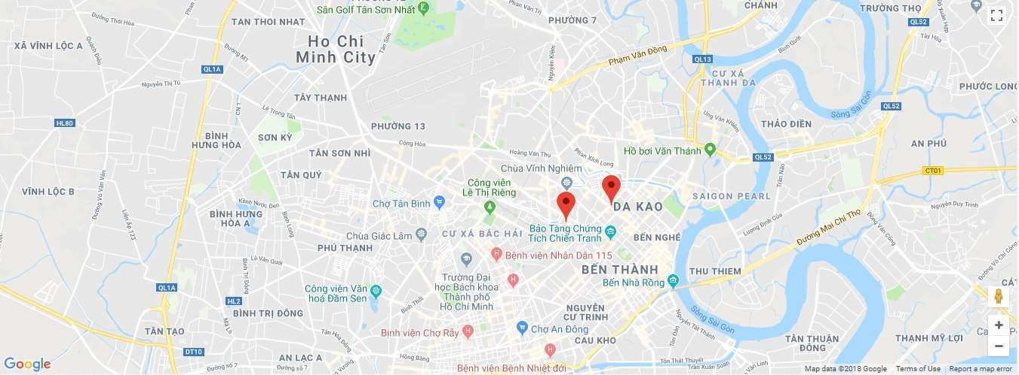

|  |  |  |  |  |  |
| --- | --- | --- | --- | --- | --- |
| No. | Name | Type | Validation | Event | Description |
| 1 | Map | Google Map |  |  | Google Map api with stores’ loacations markers |

1. Stores’ Information:

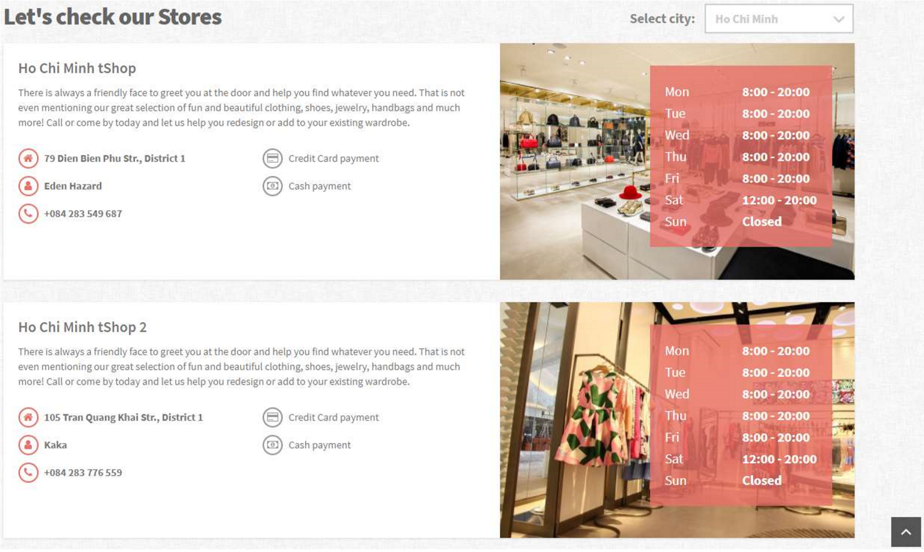

|  |  |  |  |  |  |
| --- | --- | --- | --- | --- | --- |
| No. | Name | Type | Validation | Event | Description |
| 1 | Store name | Text |  |  |  |
| 2 | Address | Text |  |  |  |
| 3 | Contact person | Text |  |  |  |
| 4 | Store Image | Image |  |  |  |
| 5 | Cities | Combo box |  | Change | Display stores in the selecte city |

19.404

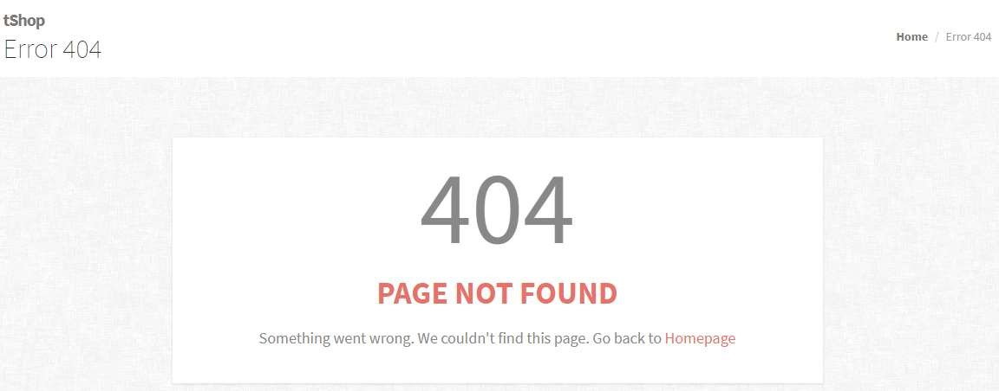

|  |  |  |  |  |  |
| --- | --- | --- | --- | --- | --- |
| No. | Name | Type | Validation | Event | Description |
| 1 | Homepage | Link |  | Click | Redirect to Index page |

1. About

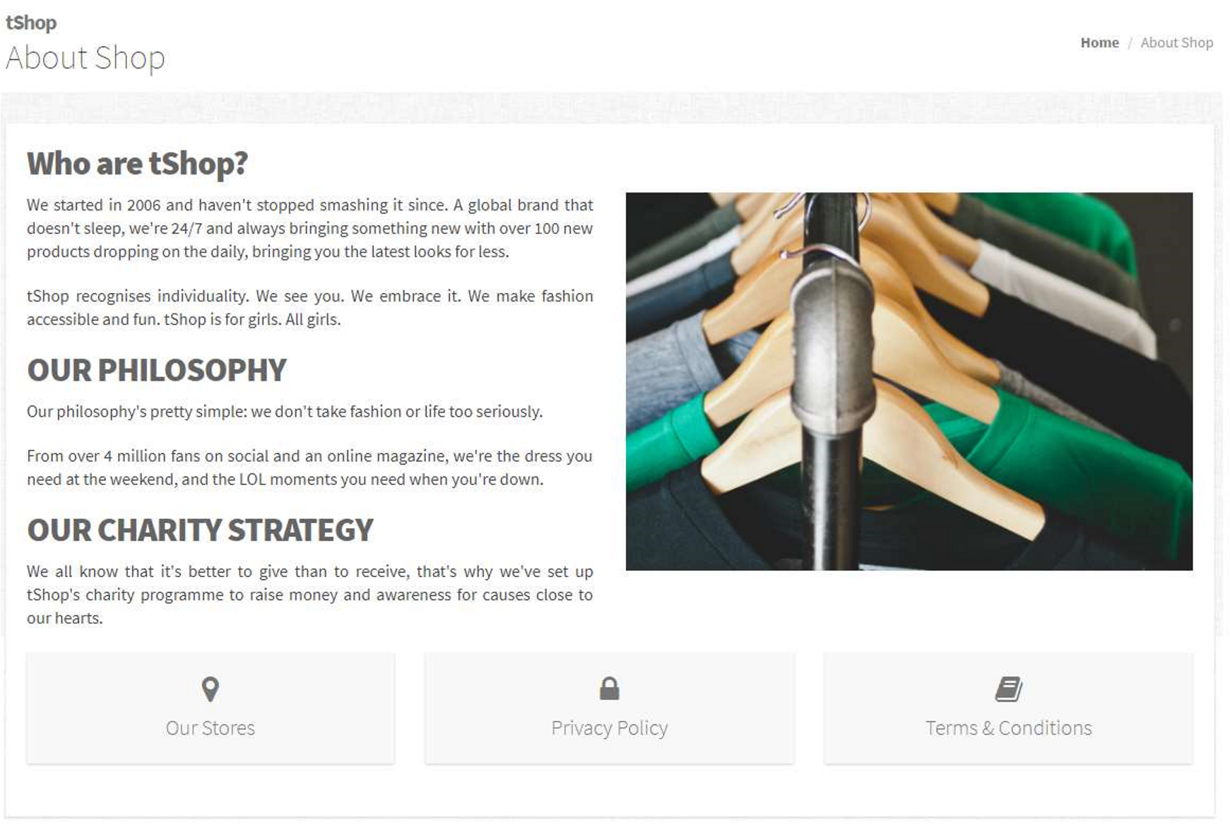

|  |  |  |  |  |  |  |
| --- | --- | --- | --- | --- | --- | --- |
| No. | Name | Type | Validation | | Event | Description |
| 1 | Our Stores | Link |  | | Click | Redirect to Stores page |
| 2 | Privacy Policy | Link |  | | Click | Redirect to Policy page |
| 3 | Terms &  Conditions | Link |  | | Click | Redirect to Terms & Conditions page |
| Prepared by: All Members | | | | Approved by: Mr. Ngo Phuoc Nguyen | | |
| Project Group No: 1 | | | |  | | |
|  | | | |  | | |
|  | | | |  | | |

1. PrivacyPolicy

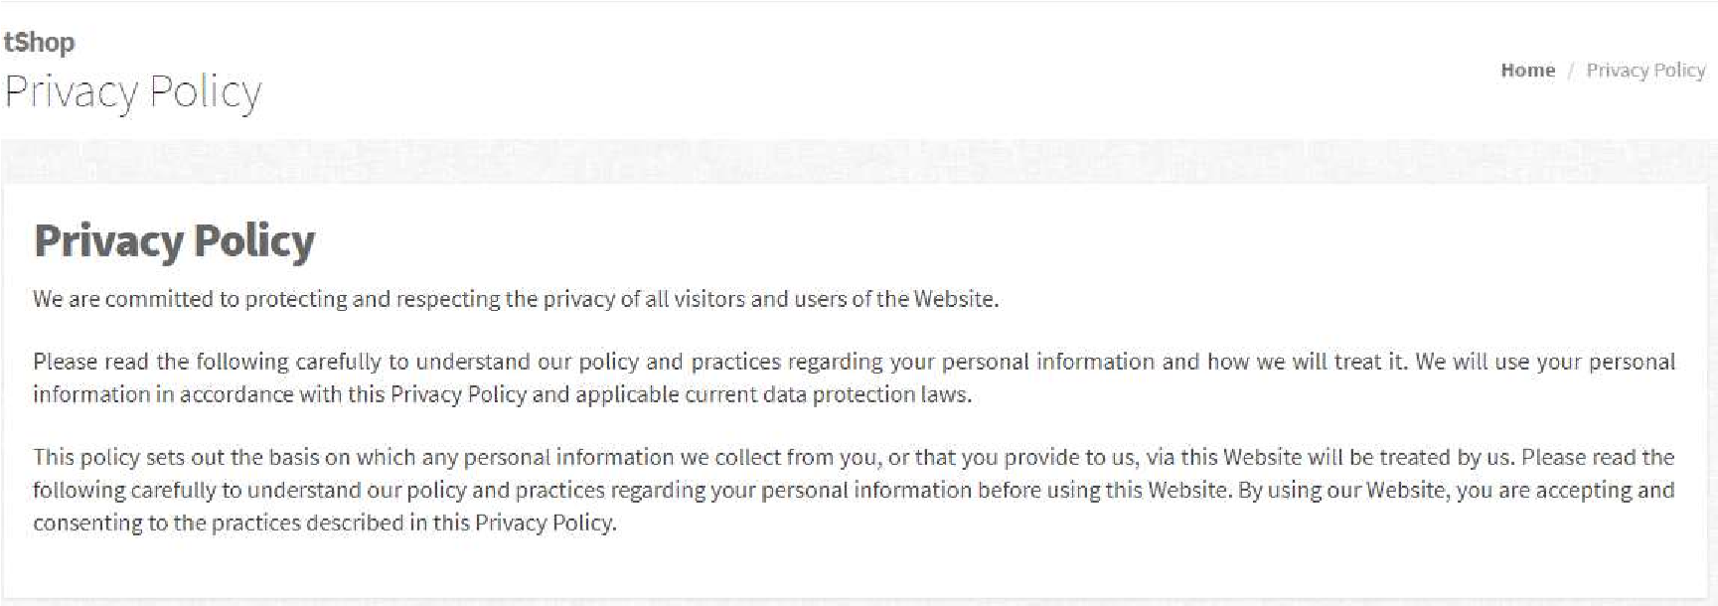

|  |  |  |  |  |  |
| --- | --- | --- | --- | --- | --- |
| No. | Name | Type | Validation | Event | Description |
| 1 | Privacy policy | Text |  |  |  |

1. TermsConditions

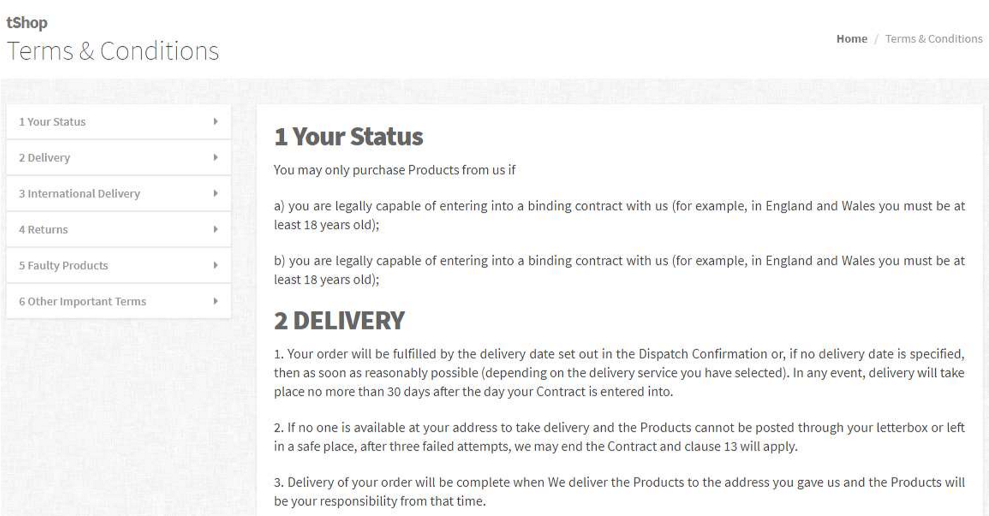

|  |  |  |  |  |  |
| --- | --- | --- | --- | --- | --- |
| No. | Name | Type | Validation | Event | Description |
| 1 | Sidebar | Link |  | Click | Scroll page to the selected section |

1. Admin’s GUI Design
   1. Template

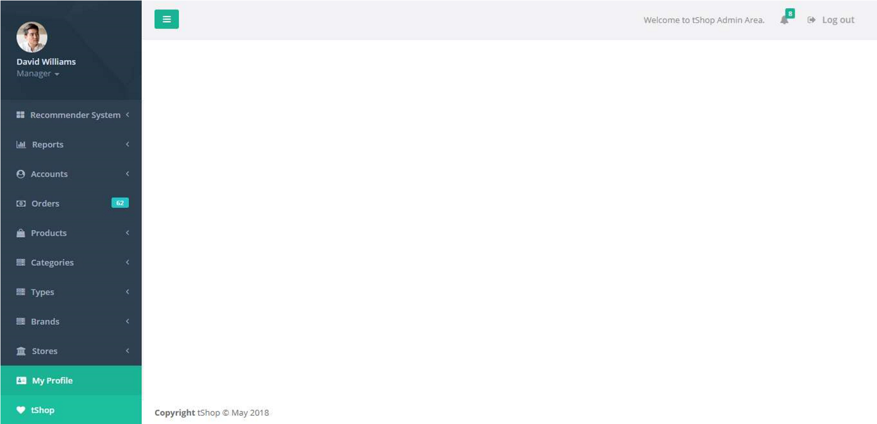

* 1. Header:



|  |  |  |  |  |  |
| --- | --- | --- | --- | --- | --- |
| No. | Name | Type | Validation | Event | Description |
| 1 | Resize button | Button |  | Click | Minimize the sidebar |
| 2 | Notificaitons | Dropdown  list |  |  | Contains notifications about new orders and on shipping orders |
| 3 | Logout | Link |  | Click | Log admin out |

* 1. Footer:



|  |  |  |  |  |  |
| --- | --- | --- | --- | --- | --- |
| No. | Name | Type | Validation | Event | Description |
| 1 | Copyright | Text |  |  |  |

* 1. Sidebar:

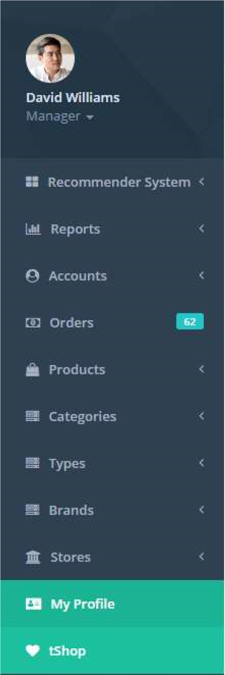

|  |  |  |  |  |  |
| --- | --- | --- | --- | --- | --- |
| No. | Name | Type | Validation | Event | Description |
| 1 | Recommender System | Link |  | Click | Redirect to Recommend System page |
| 2 | Reports | Dropdown  list |  |  | Contains reports link |
| 3 | Accounts | Dropdown  list |  |  | Contains: view and create link |
| 4 | Orders | Link |  | Click | Redirect to Orders page |
| 5 | Products | Dropdown  list |  |  | Contains: view and create link |
| 6 | Categories | Dropdown  list |  |  | Contains: view and create link |
| 7 | Types | Dropdown  list |  |  | Contains: view and create link |
| 8 | Brands | Dropdown  list |  |  | Contains: view and create link |
| 9 | Stores | Dropdown  list |  |  | Contains: view and create link |
| 10 | My profile | Link |  | Click | Redirect to My Profile page |
| 11 | tShop | Link |  | Click | Redirect to Index page |

* 1. Recommender System

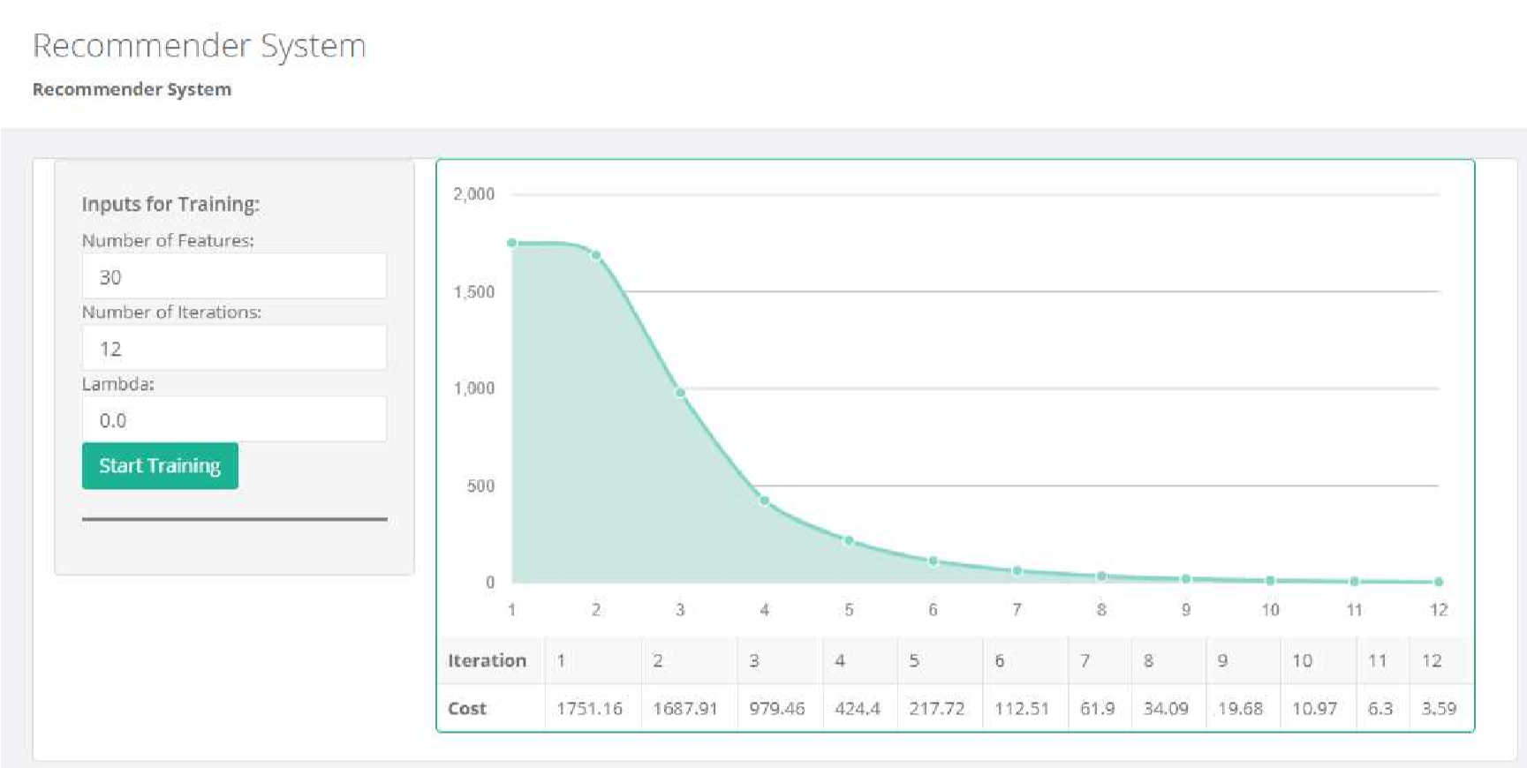

|  |  |  |  |  |  |
| --- | --- | --- | --- | --- | --- |
| No. | Name | Type | Validation | Event | Description |
| 1 | Features | Input number | Not null, > 0 |  |  |
| 2 | Iterations | Input number | Not null, > 0 |  |  |
| 3 | Lambda | Input number | Not null, >= 0 |  |  |
| 4 | Start Training | Button |  | Click | Start the process to train  Recommender System with inputs. |
| 5 | Cost Function Chart | Morris Area Chart |  |  | Chart of Cost Function values after training |

* 1. Reports – Income by Categories

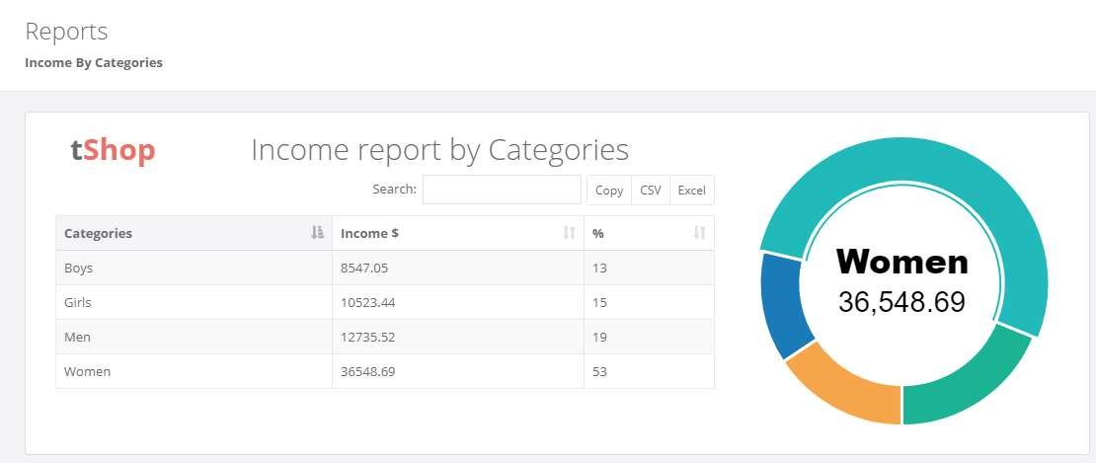

|  |  |  |  |  |  |
| --- | --- | --- | --- | --- | --- |
| No. | Name | Type | Validation | Event | Description |
| 1 | Data | Bootstrap DataTable |  |  |  |
| 2 | Pie Chart | Morris Pie Chart |  |  |  |

* 1. Reports – Income by Brands

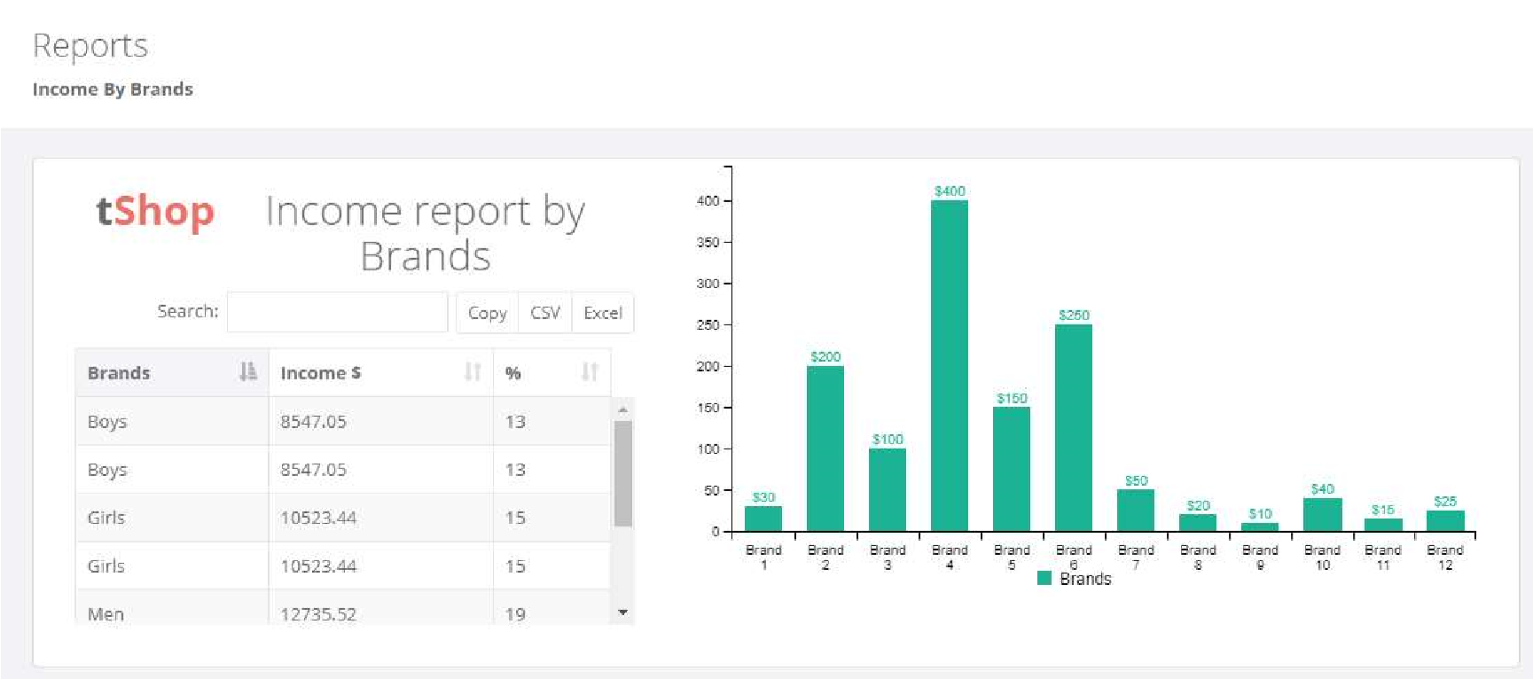

|  |  |  |  |  |  |
| --- | --- | --- | --- | --- | --- |
| No. | Name | Type | Validation | Event | Description |
| 1 | Data | Bootstrap DataTable |  |  |  |
| 2 | Chart | C3 Stacked Chart |  |  |  |

* 1. Reports – Income by Customers

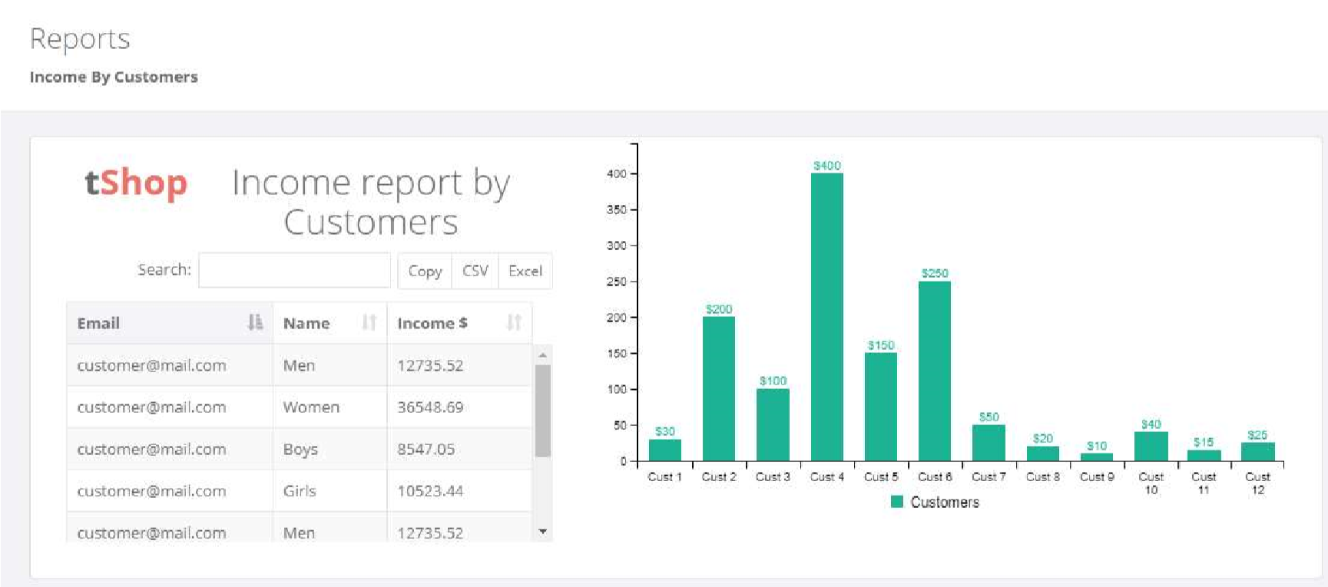

|  |  |  |  |  |  |
| --- | --- | --- | --- | --- | --- |
| No. | Name | Type | Validation | Event | Description |
| 1 | Data | Bootstrap DataTable |  |  |  |
| 2 | Chart | C3 Stacked Chart |  |  |  |

* 1. Accounts - View

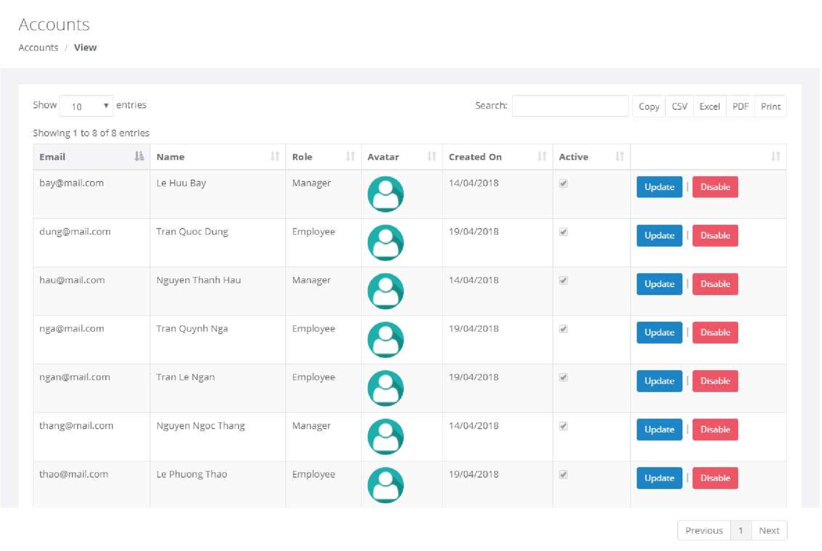

|  |  |  |  |  |  |
| --- | --- | --- | --- | --- | --- |
| No. | Name | Type | Validation | Event | Description |
| 1 | Admins  Account list | Bootstrap Datatable |  |  | Contains all field of Admins table. Use bootstrap datatable libraries with buttons to export data to files |
| 2 | Update | Button |  | Click | Redirect to Update Account page |
| 3 | Disable | Button |  | Click | Disable the account |

* 1. Accounts – Create

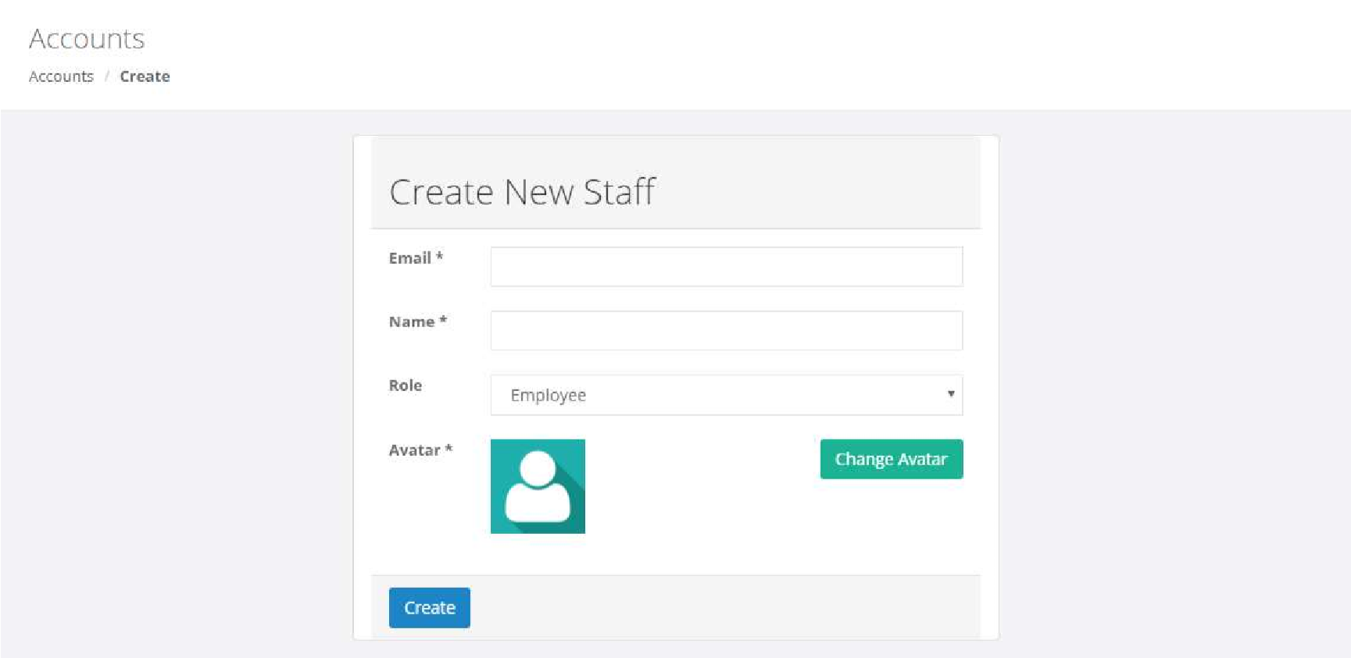

|  |  |  |  |  |  |
| --- | --- | --- | --- | --- | --- |
| No. | Name | Type | Validation | Event | Description |
| 1 | Email | Input Text | Email format |  |  |
| 2 | Name | Input Text | Not null |  |  |
| 3 | Change Avatar | Input File | Image, size < 1Mb |  |  |
| 4 | Avatar | Image |  |  |  |
| 5 | Create | Button |  | Click | Create admin account |

* 1. Accounts – Update

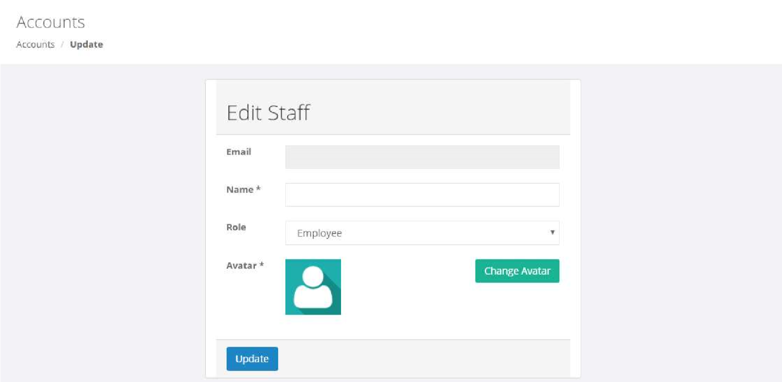

|  |  |  |  |  |  |
| --- | --- | --- | --- | --- | --- |
| No. | Name | Type | Validation | Event | Description |
| 1 | Email | Text |  |  | Admin’s email, read only |
| 2 | Name | Input Text | Not null |  |  |
| 3 | Change Avatar | Input File | Image, size < 1Mb |  |  |
| 4 | Avatar | Image |  |  |  |
| 5 | Update | Button |  | Click | Update admin account |

* 1. Orders - View

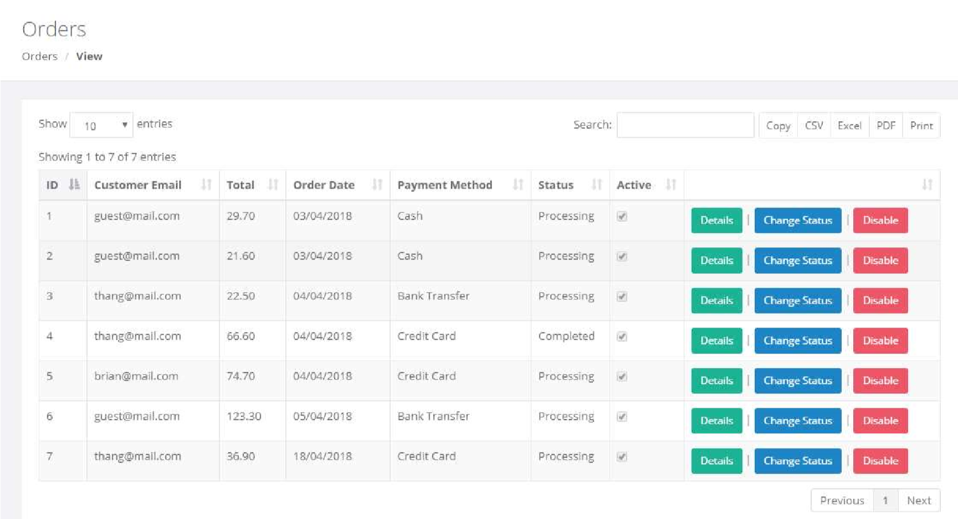

|  |  |  |  |  |  |
| --- | --- | --- | --- | --- | --- |
| No. | Name | Type | Validation | Event | Description |
| 1 | Orders list | Bootstrap Datatable |  |  | Contains all field of Orders table. Use bootstrap datatable libraries with buttons to export data to files |
| 2 | Details | Button |  | Click | Redirect to Order Details page |
| 3 | Disable | Button |  | Click | Disable the account |
| 4 | Change Status | Button |  | Click | Redirect to Order Status page |

10.Orders – Update Status

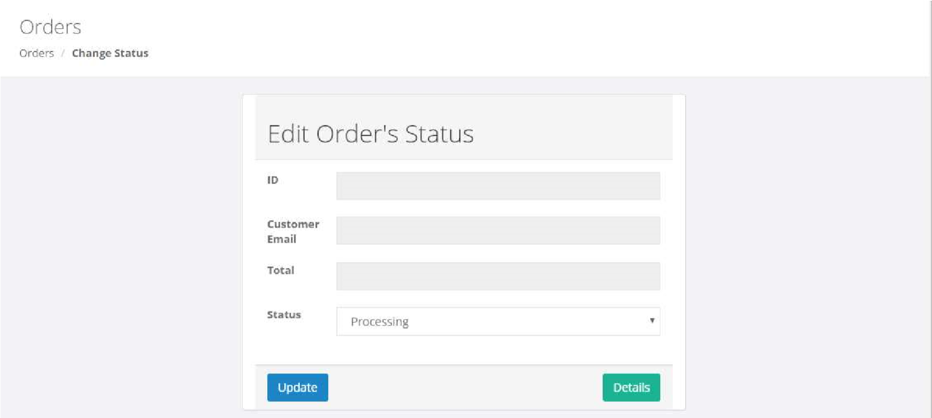

|  |  |  |  |  |  |
| --- | --- | --- | --- | --- | --- |
| No. | Name | Type | Validation | Event | Description |
| 1 | ID | Text |  |  | Read only |
| 2 | Customer Email | Text |  |  | Read only |
| 3 | Total | Text |  |  | Read only |
| 4 | Status | Combo box |  |  |  |
| 5 | Update | Button |  | Click | Update Orders’ status |
| 6 | Details | Button |  | Click | Redirect to Orders Details |

11.Orders – Details

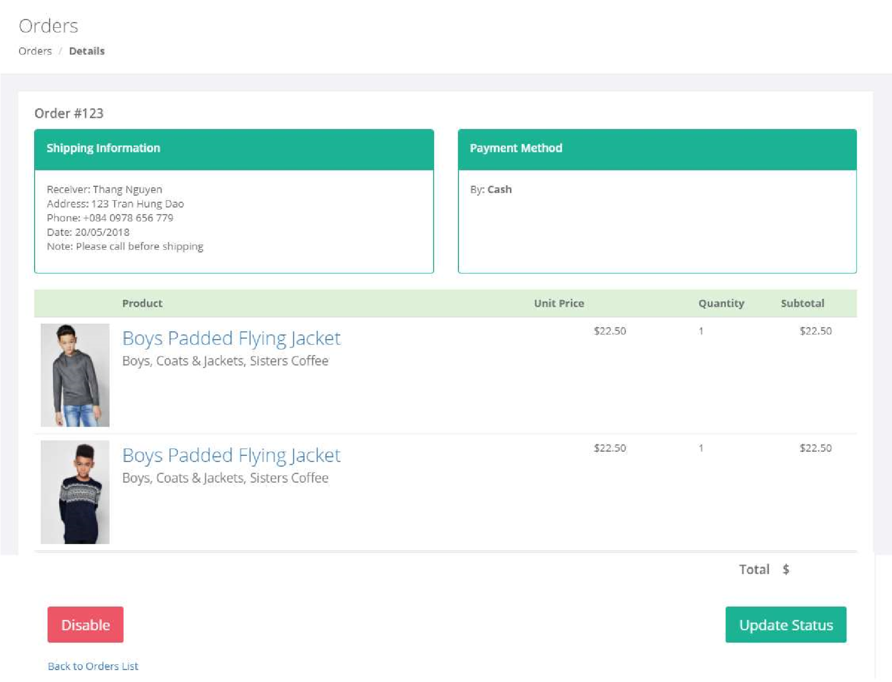

|  |  |  |  |  |  |
| --- | --- | --- | --- | --- | --- |
| No. | Name | Type | Validation | Event | Description |
| 1 | Shipping  Information | Text |  |  | Contains all shipping infor |
| 2 | Payment Method | Text |  |  | Contains all payment info |
| 3 | Order’s Items | Table |  |  | Contains all order’s items info |
| 4 | Disable | Button |  | Click | Disable the order |
| 5 | Update Status | Button |  | Click | Redirect to Order Status page |
| 6 | Back to Orders  List | Link |  | Click | Redirect to Orders Views page |

12.Products - View

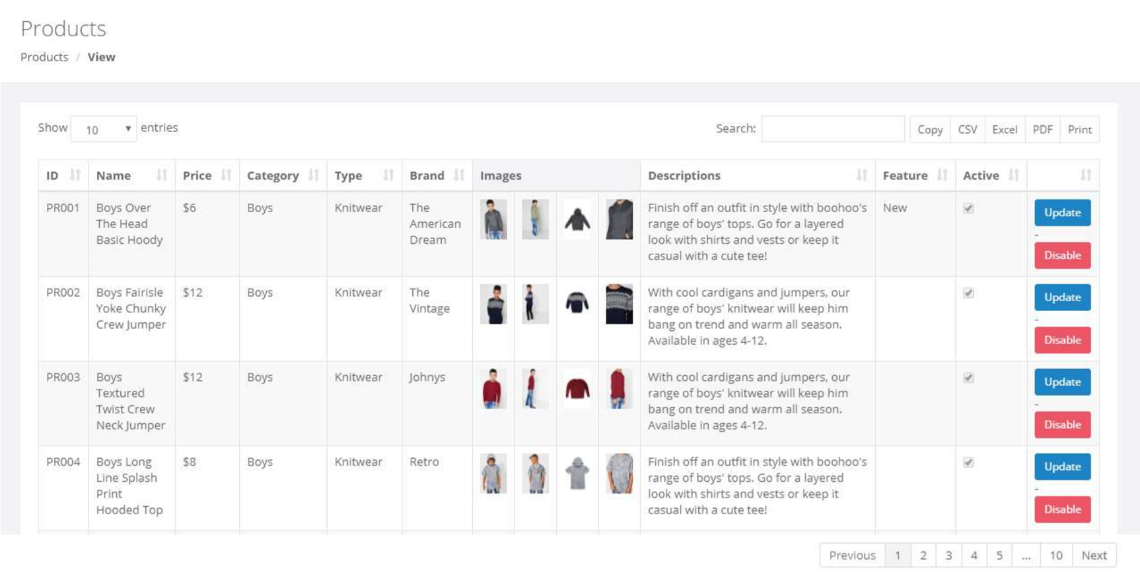

|  |  |  |  |  |  |
| --- | --- | --- | --- | --- | --- |
| No. | Name | Type | Validation | Event | Description |
| 1 | Products list | Bootstrap Datatable |  |  | Contains all field of Products table. Use bootstrap datatable libraries with buttons to export data to files |
| 2 | Update | Button |  | Click | Redirect to Update Product page |
| 3 | Disable | Button |  | Click | Disable the product |

13.Products – Create

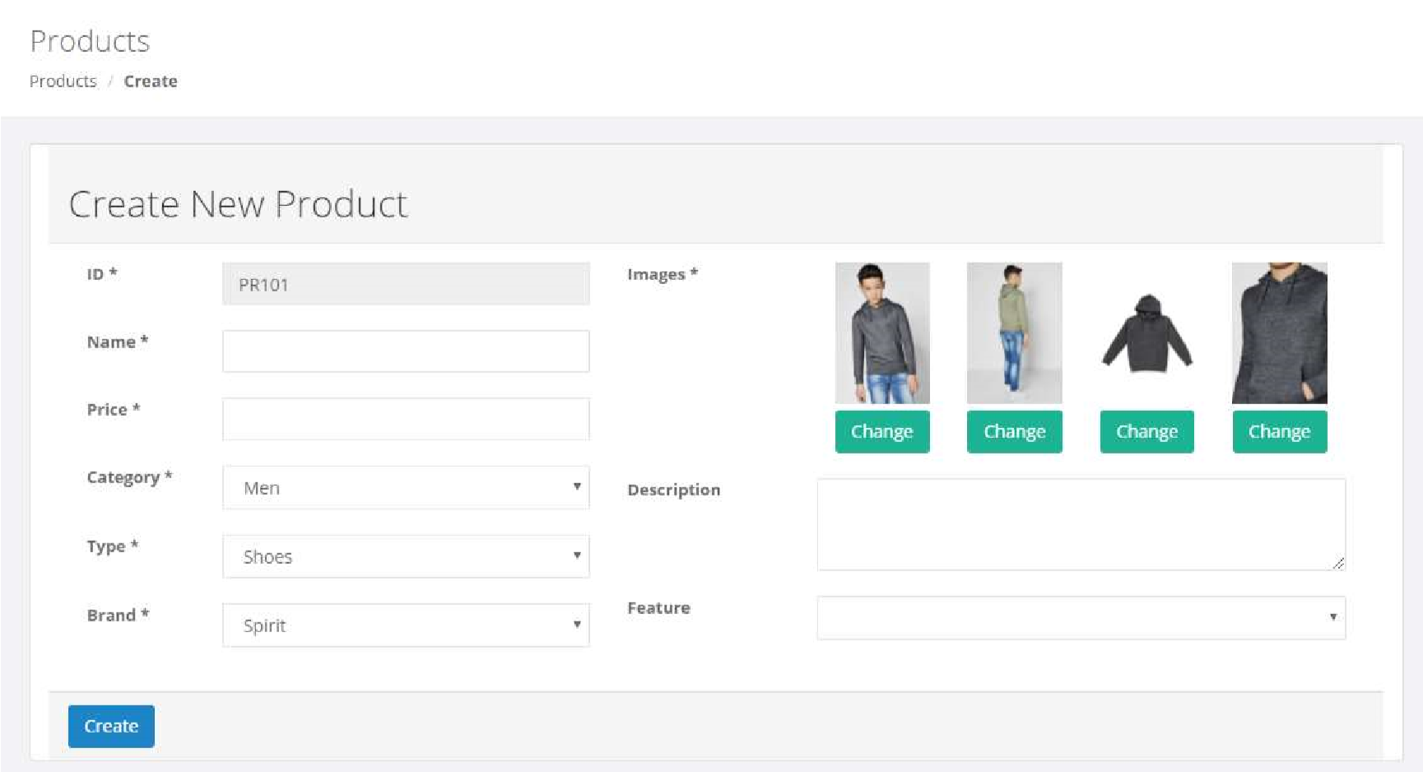

|  |  |  |  |  |  |
| --- | --- | --- | --- | --- | --- |
| No. | Name | Type | Validation | Event | Description |
| 1 | ID | Input Text |  |  | Read only, auto generate value |
| 2 | Name | Input Text | Not null |  |  |
| 3 | Price | Input number | Not null, > 0 |  |  |
| 4 | Category | Combo box |  |  | Values from Categories table |
| 5 | Type | Combo box |  |  | Values from Types table |
| 6 | Brand | Combo box |  |  | Values from Brands table |
| 7 | Images | 4 Input file | Images, size < 1MB |  |  |
| 8 | Description | Input Textarea |  |  |  |
| 9 | Feature | Combo box |  |  | Values: Hot, New, Sale |
| 10 | Create | Button |  | Click | Create new product |

14.Products – Update

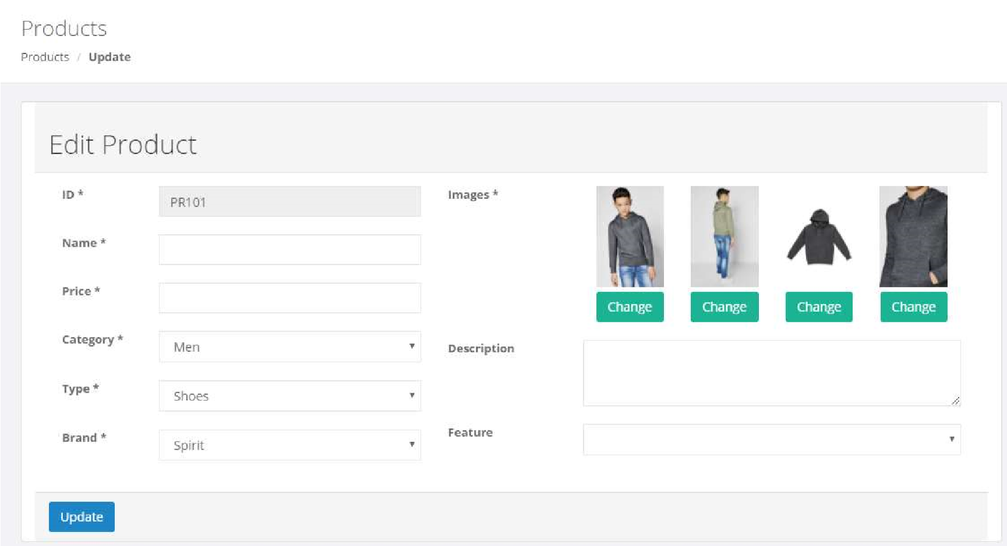

|  |  |  |  |  |  |
| --- | --- | --- | --- | --- | --- |
| No. | Name | Type | Validation | Event | Description |
| 1 | ID | Input Text |  |  | Read only |
| 2 | Name | Input Text | Not null |  |  |
| 3 | Price | Input number | Not null, > 0 |  |  |
| 4 | Category | Combo box |  |  | Values from Categories table |
| 5 | Type | Combo box |  |  | Values from Types table |
| 6 | Brand | Combo box |  |  | Values from Brands table |
| 7 | Images | 4 Input file | Images, size < 1MB |  |  |
| 8 | Description | Input Textarea |  |  |  |
| 9 | Feature | Combo box |  |  | Values: Hot, New, Sale |
| 10 | Update | Button |  | Click | Update the product’s info |

15.Categories – View

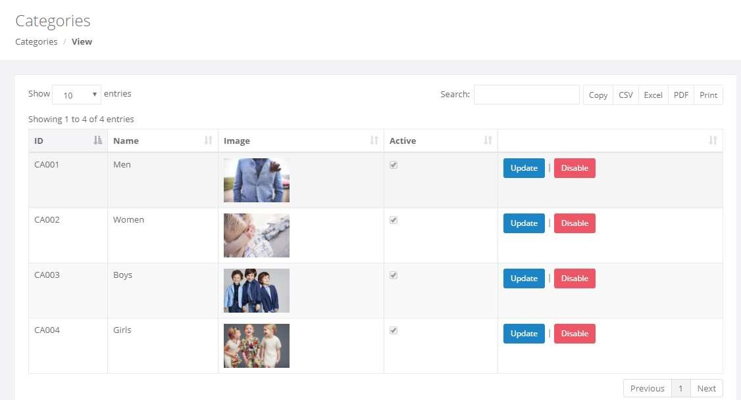

|  |  |  |  |  |  |
| --- | --- | --- | --- | --- | --- |
| No. | Name | Type | Validation | Event | Description |
| 1 | Categories list | Bootstrap Datatable |  |  | Contains all field of Categories table. Use bootstrap datatable libraries with buttons to export data to files |
| 2 | Update | Button |  | Click | Redirect to Update Category page |
| 3 | Disable | Button |  | Click | Disable the category |

* 1. Categories – Create

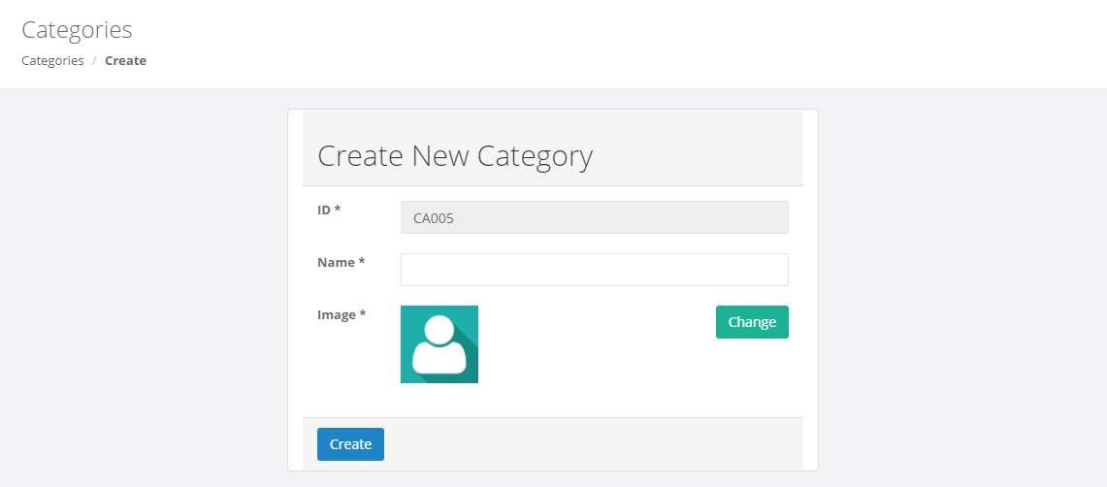

|  |  |  |  |  |  |
| --- | --- | --- | --- | --- | --- |
| No. | Name | Type | Validation | Event | Description |
| 1 | ID | Input Text |  |  | Read only, auto generate value |
| 2 | Name | Input Text | Not null |  |  |
| 3 | Image | Input file | Images, size < 1MB |  |  |
| 4 | Create | Button |  | Click | Create new Categories |

* 1. Categories – Update

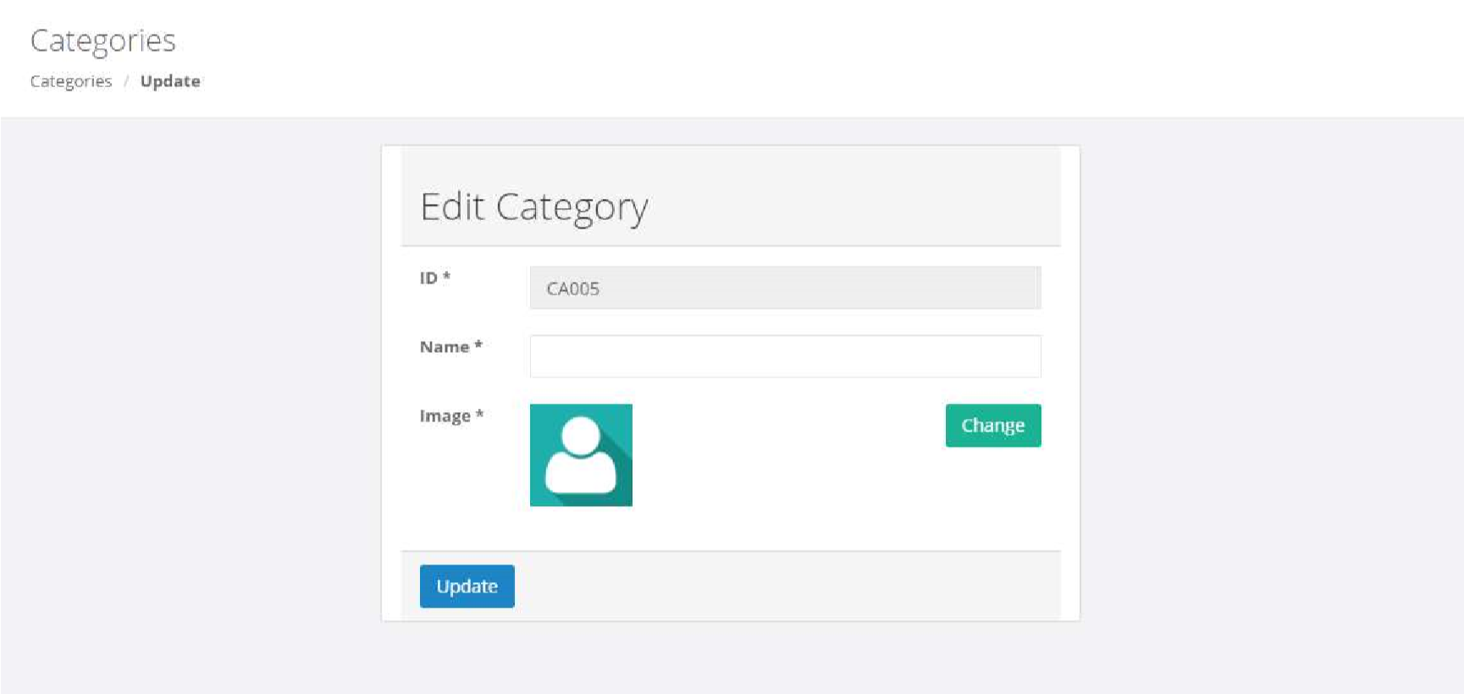

|  |  |  |  |  |  |
| --- | --- | --- | --- | --- | --- |
| No. | Name | Type | Validation | Event | Description |
| 1 | ID | Input Text |  |  | Read only |
| 2 | Name | Input Text | Not null |  |  |
| 3 | Image | Input file | Images, size < 1MB |  |  |
| 4 | Update | Button |  | Click | Update the category’s info |

* 1. Types – View

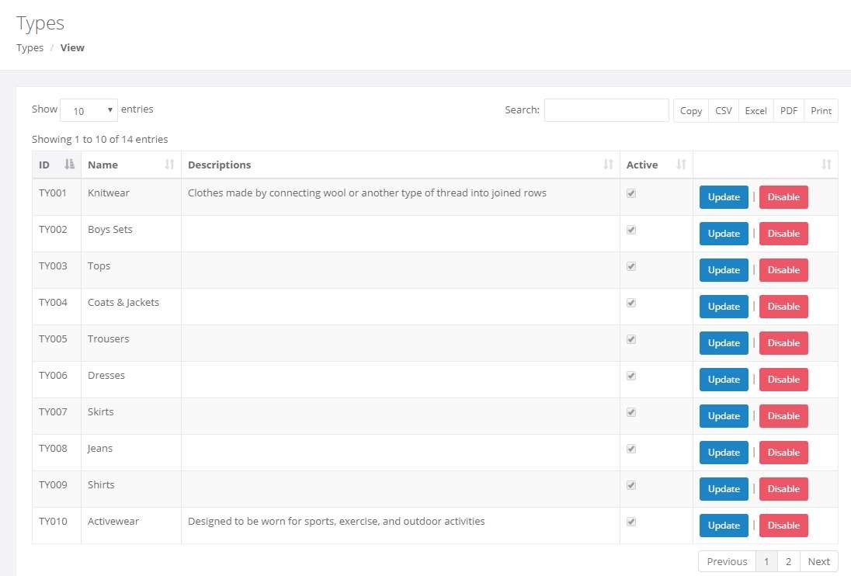

|  |  |  |  |  |  |
| --- | --- | --- | --- | --- | --- |
| No. | Name | Type | Validation | Event | Description |
| 1 | Types list | Bootstrap Datatable |  |  | Contains all field of Types table. Use bootstrap datatable libraries with buttons to export data to files |
| 2 | Update | Button |  | Click | Redirect to Update Type page |
| 3 | Disable | Button |  | Click | Disable the type |

* 1. Types – Create

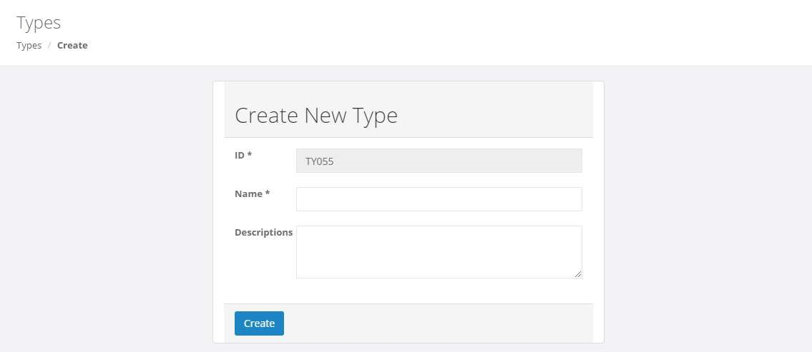

|  |  |  |  |  |  |
| --- | --- | --- | --- | --- | --- |
| No. | Name | Type | Validation | Event | Description |
| 1 | ID | Input Text |  |  | Read only, auto generate value |
| 2 | Name | Input Text | Not null |  |  |
| 3 | Description | Input Textarea |  |  |  |
| 4 | Create | Button |  | Click | Create new Type |

* 1. Types – Update

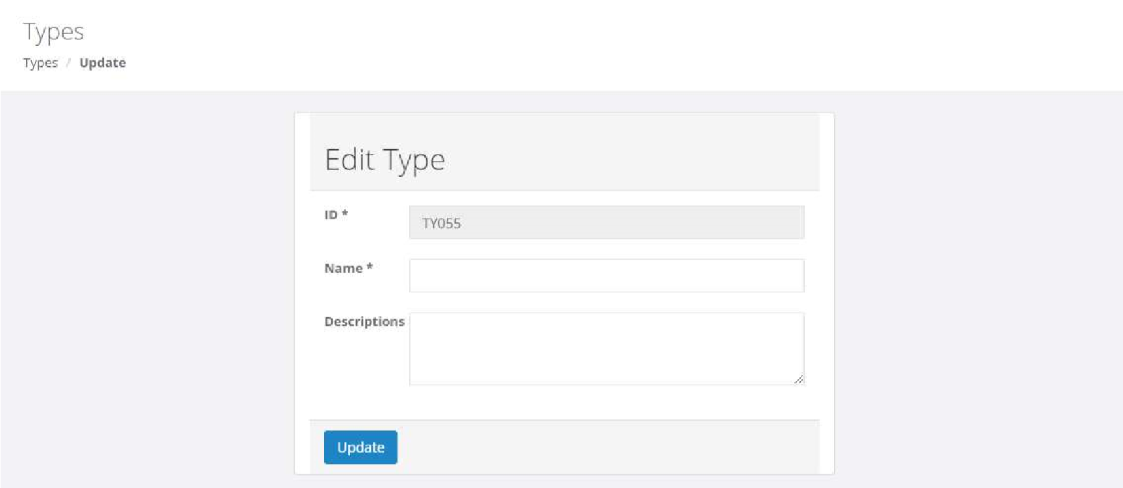

|  |  |  |  |  |  |
| --- | --- | --- | --- | --- | --- |
| No. | Name | Type | Validation | Event | Description |
| 1 | ID | Input Text |  |  | Read only |
| 2 | Name | Input Text | Not null |  |  |
| 3 | Description | Input Textarea |  |  |  |
| 4 | Update | Button |  | Click | Update the type’s info |

* 1. Brands – View

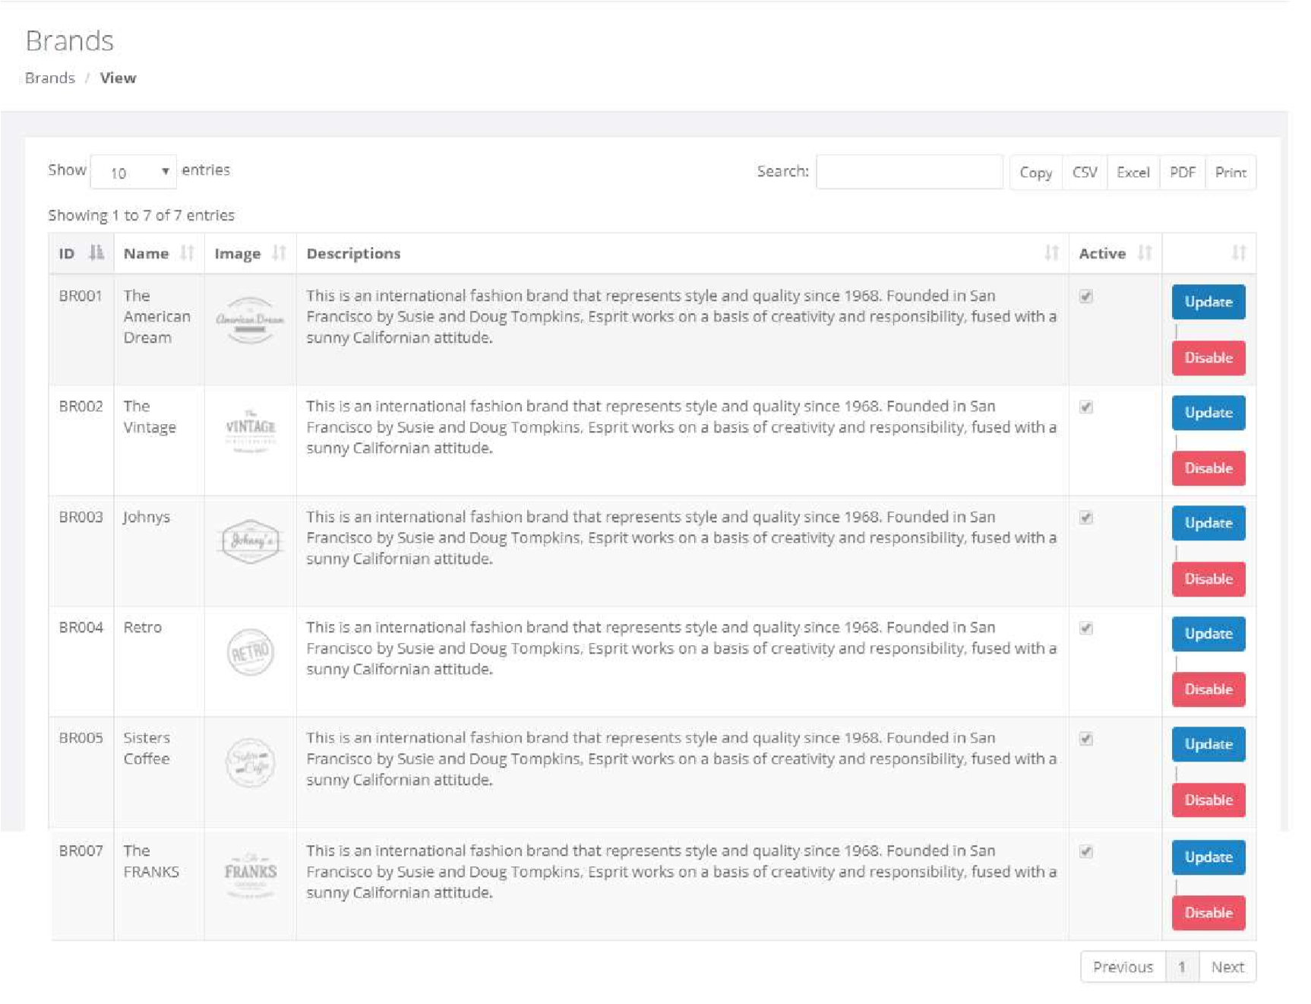

|  |  |  |  |  |  |
| --- | --- | --- | --- | --- | --- |
| No. | Name | Type | Validation | Event | Description |
| 1 | Brands list | Bootstrap Datatable |  |  | Contains all field of Admins table. Use bootstrap datatable libraries with buttons to export data to files |
| 2 | Update | Button |  | Click | Redirect to Update Brand page |
| 3 | Disable | Button |  | Click | Disable the brand |

* 1. Brands – Create

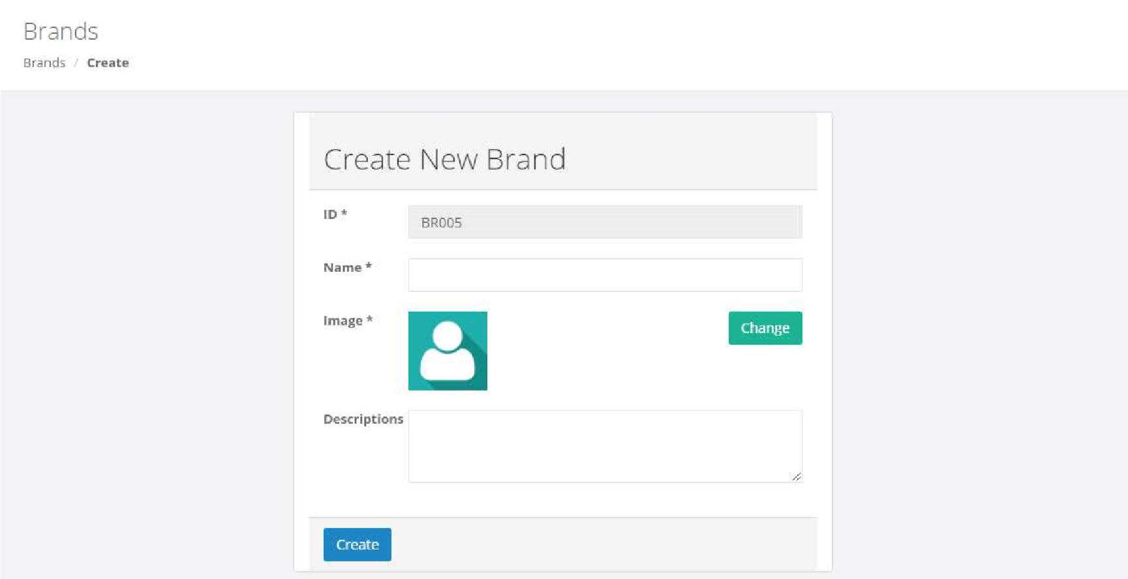

|  |  |  |  |  |  |
| --- | --- | --- | --- | --- | --- |
| No. | Name | Type | Validation | Event | Description |
| 1 | ID | Input Text |  |  | Read only, auto generate value |
| 2 | Name | Input Text | Not null |  |  |
| 3 | Image | Input file | Images, size < 1MB |  |  |
| 4 | Create | Button |  | Click | Create new Brand |

* 1. Brands – Update

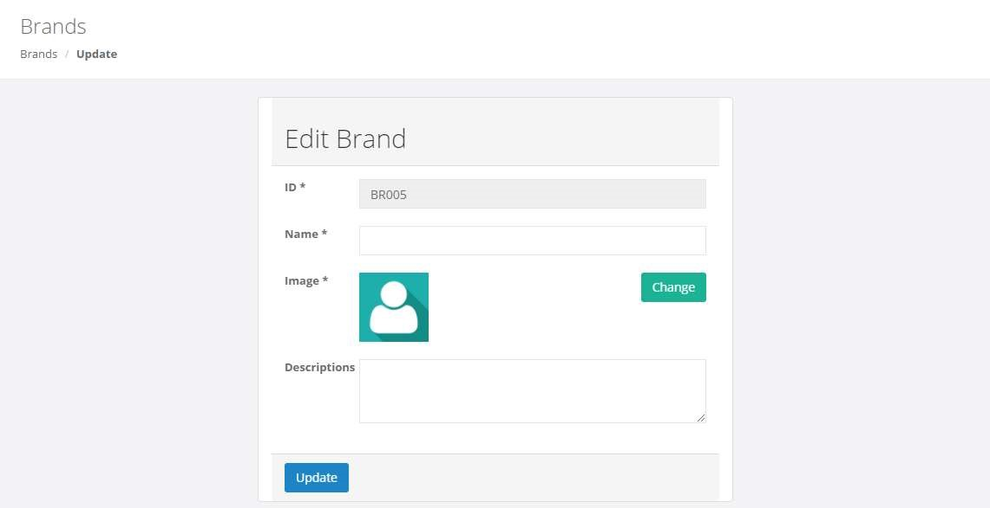

|  |  |  |  |  |  |
| --- | --- | --- | --- | --- | --- |
| No. | Name | Type | Validation | Event | Description |
| 1 | ID | Input Text |  |  | Read only |
| 2 | Name | Input Text | Not null |  |  |
| 3 | Image | Input file | Images, size < 1MB |  |  |
| 4 | Update | Button |  | Click | Update the brand’s info |

* 1. Stores – View

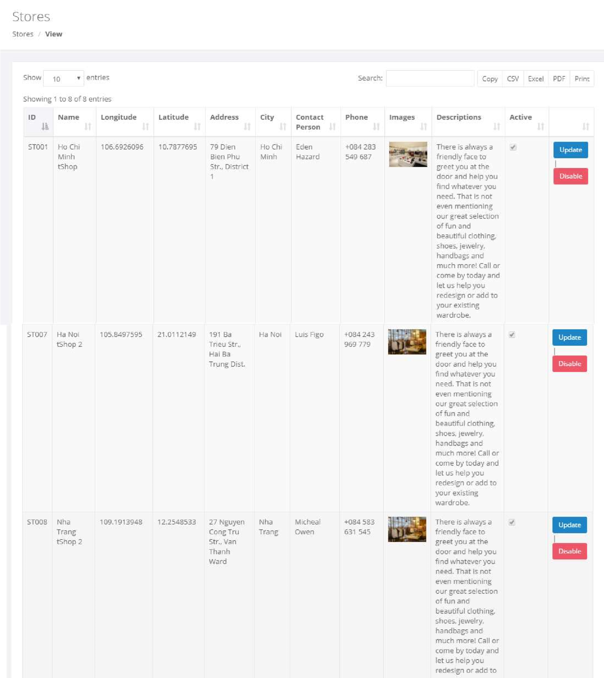

|  |  |  |  |  |  |
| --- | --- | --- | --- | --- | --- |
| No. | Name | Type | Validation | Event | Description |
| 1 | Stores list | Bootstrap Datatable |  |  | Contains all field of Stores table. Use bootstrap datatable libraries with buttons to export data to files |
| 2 | Update | Button |  | Click | Redirect to Update Store page |
| 3 | Disable | Button |  | Click | Disable the store |

* 1. Stores – Create

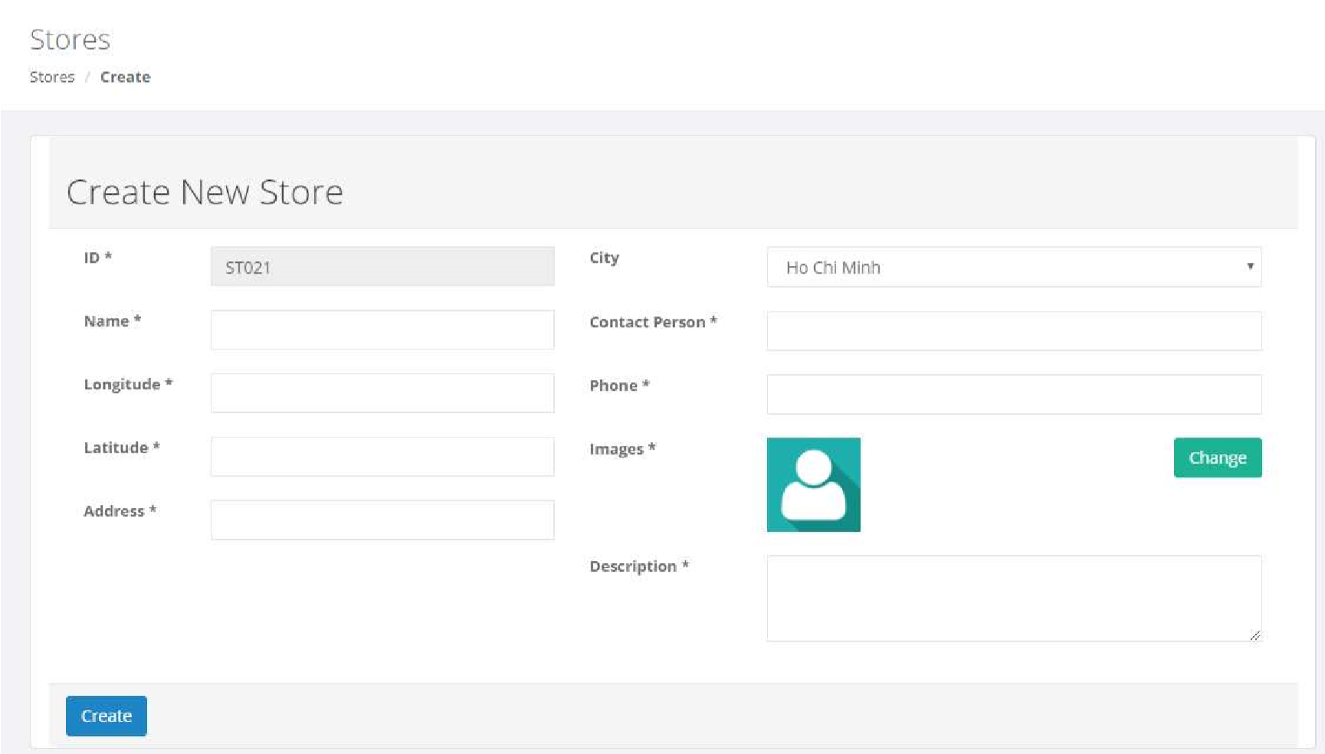

|  |  |  |  |  |  |
| --- | --- | --- | --- | --- | --- |
| No. | Name | Type | Validation | Event | Description |
| 1 | ID | Input Text |  |  | Read only, auto generate value |
| 2 | Name | Input Text | Not null |  |  |
| 3 | Longitude | Input Text | Not null |  |  |
| 4 | Latitude | Input Text | Not null |  |  |
| 5 | Address | Input Text | Not null |  |  |
| 6 | City | Combo box |  |  | Values: Ho Chi Minh, Da  Nang, Nha Trang, Ha Noi |
| 7 | Contact person | Input Text | Not null |  |  |
| 8 | Phone | Input Text | Not null |  |  |
| 9 | Image | Input file | Images, size < 1MB |  |  |
| 10 | Description | Input Textarea | Not null |  |  |
| 11 | Create | Button |  | Click | Create new Store |

26.Stores – Update

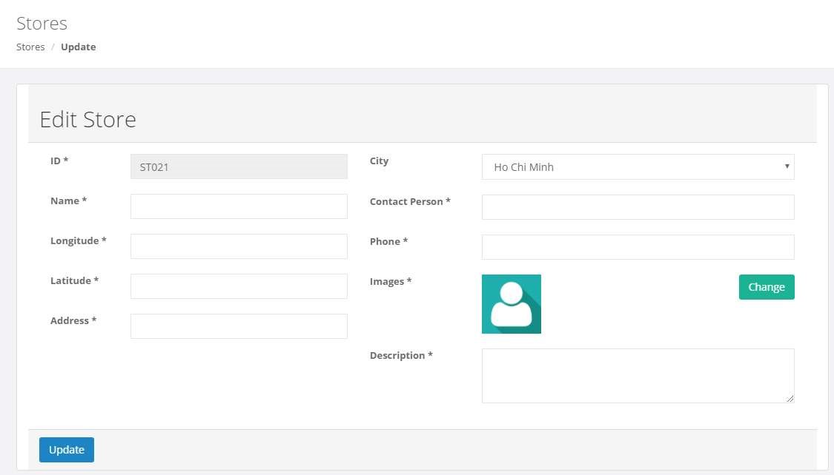

|  |  |  |  |  |  |
| --- | --- | --- | --- | --- | --- |
| No. | Name | Type | Validation | Event | Description |
| 1 | ID | Input Text |  |  | Read only |
| 2 | Name | Input Text | Not null |  |  |
| 3 | Longitude | Input Text | Not null |  |  |
| 4 | Latitude | Input Text | Not null |  |  |
| 5 | Address | Input Text | Not null |  |  |
| 6 | City | Combo box |  |  | Values: Ho Chi Minh, Da  Nang, Nha Trang, Ha Noi |
| 7 | Contact person | Input Text | Not null |  |  |
| 8 | Phone | Input Text | Not null |  |  |
| 9 | Image | Input file | Images, size < 1MB |  |  |
| 10 | Description | Input Textarea | Not null |  |  |
| 11 | Update | Button |  | Click | Update the store’s info |

27.404

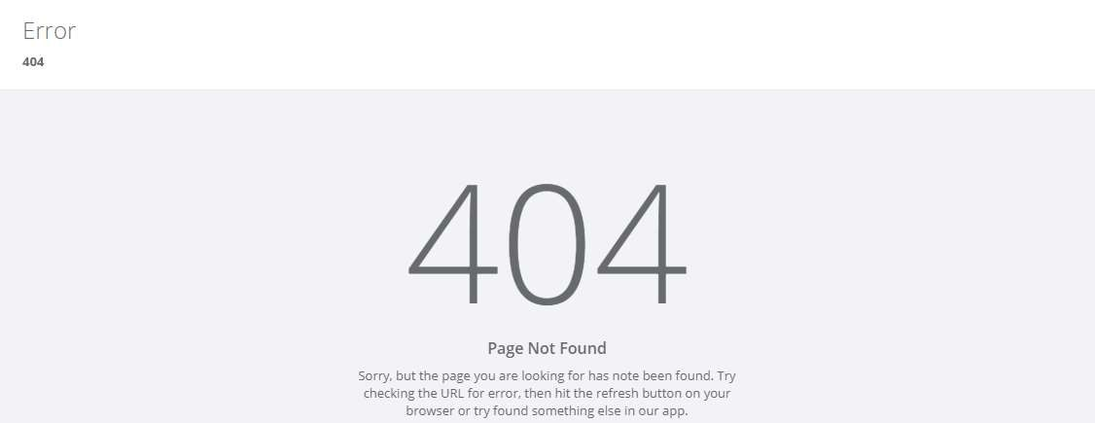

28. Login

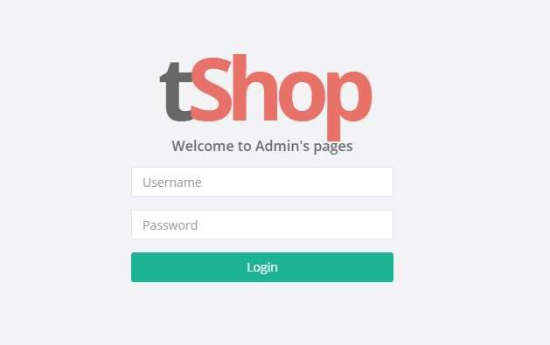

|  |  |  |  |  |  |
| --- | --- | --- | --- | --- | --- |
| No. | Name | Type | Validation | Event | Description |
| 1 | Username | Input Text | Not null |  |  |
| 2 | Password | Input Password | Not null |  |  |
| 3 | Login | Button |  | Click | Check login and redirect to  Recommender System page |

29.My Profile

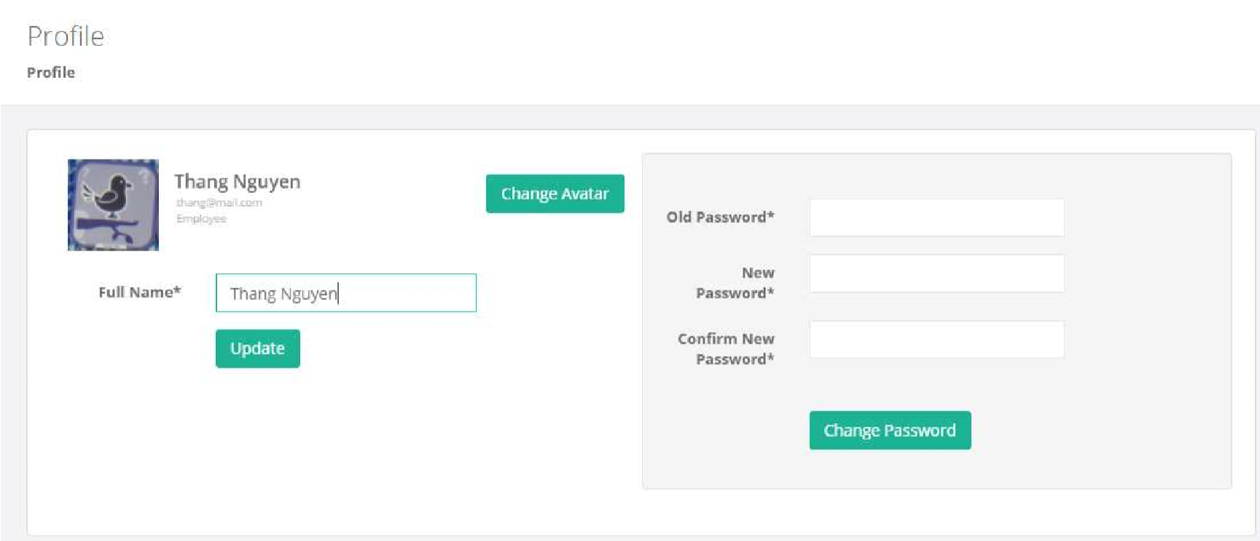

|  |  |  |  |  |  |
| --- | --- | --- | --- | --- | --- |
| No. | Name | Type | Validation | Event | Description |
| 1 | Full name | Input Text | Not null |  |  |
| 2 | Update | Button |  | Click | Update Admin’s full name |
| 3 | Change Avatar | Input file | Images, size < 1MB |  |  |
| 4 | Old Password | Input password | Not null |  |  |
| 5 | New Password | Input password | Not null |  |  |
| 6 | Confirm password | Input password | Not null |  |  |
| 7 | Change password | Button |  | Click | Check if correct: Old password, matched Confirm Password. And update customer’s password |

1. Task Sheet

|  |  |  |  |  |  |
| --- | --- | --- | --- | --- | --- |
| Project  Ref. No. |  | Project Name:  tShop | Date of Preparation of Activity Plan | | |
| Task |  | Description | Start Date | Complete Date | Team member |
|  | 1. Customer’s GUI Design   + Compare  + Checkout  + Order Success  + My Orders  + Single Order  + Terms & Conditions  + About  + Privacy Policy   1. Admin’s GUI Design   + Reports – Income by Brands  + Orders  + Products  + Categories  + Types |  | 18  /04/2018 | 21  /04/2018 | Le Huu Bay |
|  |
|  |
|  |
|  |
|  |
|  |
|  |
|  |
|  |
|  |
|  |
|  |
|  |
| Review 3 |
| 1. Customer’s GUI Design   + Login (Remmember me)  + Sign up  + Account Dashboard  + Personal Information  + Wishlist  + Stores  + 404   1. Admin’s GUI Design |  | Nguyen Thanh Hau |
|  |
|  |
|  |
|  |
|  |
|  |
|  |
|  | + Login |  |  |  |  |
|  | + 404 |  |  |  |  |
|  | + | Reports – Income by Customers |  |  |  |
|  | + Accounts |  |  |  |  |
|  | + Stores |  |  |  |  |
|  | + My profile |  |  |  |  |

No.

01

02

03

04

05

06

07

08

09

10

11

12

13

14

15

16

17

18

19

20

21

22

23

24

25

26

|  |  |  |  |
| --- | --- | --- | --- |
| I. Database Relationship Diagram |  |  |  |
| 1. Table Definition 2. Site Maps 3. Customer’s GUI Design   + Template (search with AJAX, lazy loading)  + Home  + Products (Filter)  +  + Cart | Single Product (Recently viewed, Rating) |  | Nguyen Ngoc Thang |
| + Search Product  V. Admin’s GUI Design |  |  |  |
| + Template |  |  |  |
| + Recommender System |  |  |  |
| + | Report – Income by Categories |  |  |
| + Brands |  |  |  |

27

28

29

30

31

32

33

34

35

36

37

38

39

Signature of Team Leader Signature of Supervisor